# Tutorial – Building circuits & using a multimeter

## Building circuits

### The solderless breadboard

You will be using a breadboard to prepare your electrical circuits. The breadboard is a solderless board that allows you to quickly prepare and test simple electronic circuits. Figure 1a below presents an example of a breadboard while Figure 1b shows the internal connection pattern (the interconnected breadboard holes are indicated by the solid lines).

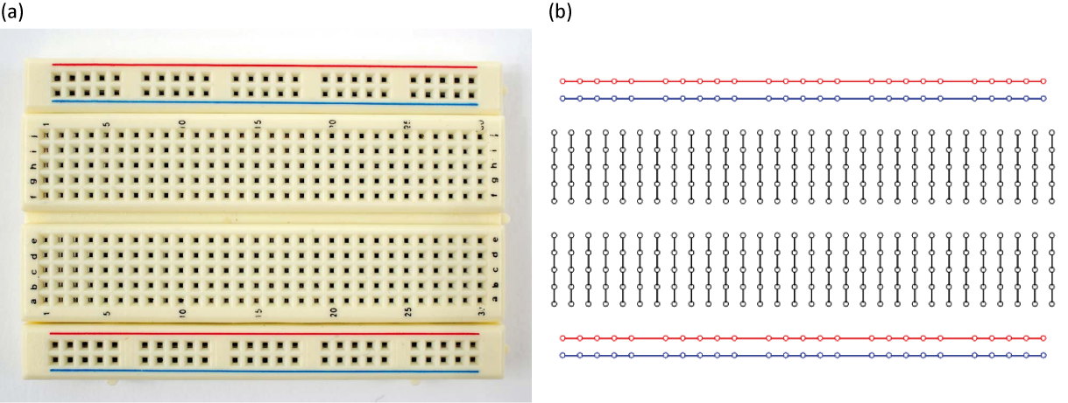

Figure 1 - (a) A solderless breadboard as the one you will use in the physics laboratory. (b) The hidden connection pattern.

Circuits are built on a breadboard simply by inserting wires and components such as resistors or capacitors in the holes of the board. Figure 2 presents an example of a simple circuit and the way it can be reproduced using a breadboard. The red and blue horizontal lines are called bus strips are typically used to connect to the power supply (red is positive and blue is negative or grounded). This way, power can be brought to any part of the breadboard using sort wires to connect the bus lines to the terminal strips (black lines).

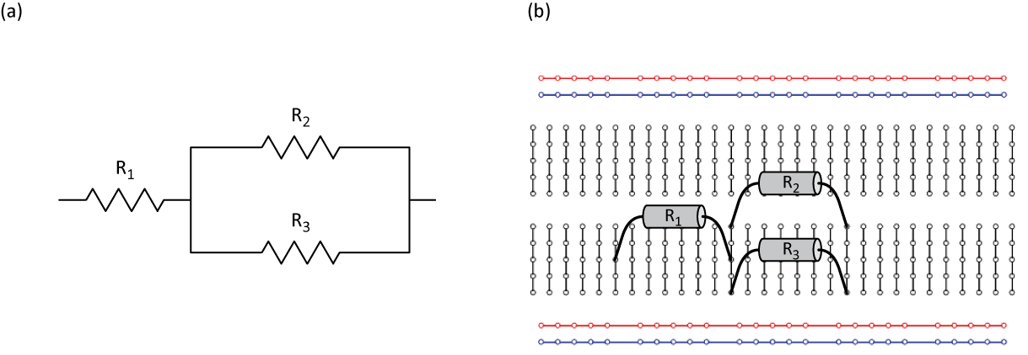

Figure 2 - (a) Circuit diagram of a resistor connected in series with a pair of resistors connected in parallel. (b) How to prepare the circuit presented in (a) using the hidden connections of a breadboard.

### Circuit diagrams

In Figure 2a, we presented the circuit diagram of a resistor connected in series with two other connected in parallel. During your physics labs, you will have to read such circuit diagrams and assemble the corresponding circuits. Figure 3 presents symbols we will use to represent the components (power supply, capacitor and resistor) and the measuring instruments (voltmeter, ammeter and ohmmeter) you will be working with during your physics labs.

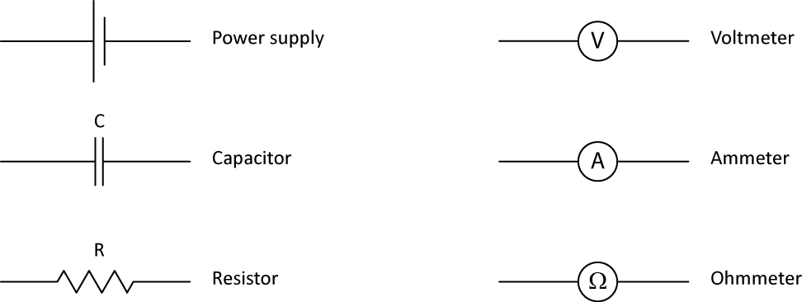

Figure 3 - Components and apparatus used in circuit diagram for the physics labs.

## The multimeter

You might have already seen or worked with a multimeter. It is an electronic measuring device that combines several instruments such as the voltmeter (to measure the voltage) or the ammeter (to measure the current) in one apparatus. The multimeter is usually a standalone instrument that you can carry around to do measurements. However, the multimeter you will use for your physics labs is slightly different than that. It is part of a data acquisition device called myDAQ (from National Instrument, see Figure 4) that features eight commonly used plug-and-play computer-based lab instruments based on LabVIEW including a digital multimeter (DMM), oscilloscope, and function generator. The myDAQ is a small portable data acquisition system, which connects to your computer with a USB cable. These instruments are controlled using software interfaces such as the one presented in Figure 5 (the multimeter). In the following sections, we will show you how to make simple measurements with this multimeter.

|  |  |
| --- | --- |
| http://www.4science.net/Design/item/item_image/29mydaq-3d-view%5b3%5d.jpg | http://ecee.colorado.edu/~mathys/ecen2250/notes/myDAQ/Start_004.png |
| Figure – The myDAQ from National Instrument. | Figure – Screenshot of the virtual digital multimeter of the myDAQ. |

### Measuring the resistance

Figure 6 presents the circuit diagram for measuring the resistance value of a resistor using an ohmmeter. To use the ohmmeter, you need to select it from the list of instruments in the Digital Multimeter window (see Figure 5, it is represented by the $Ω$ symbol).

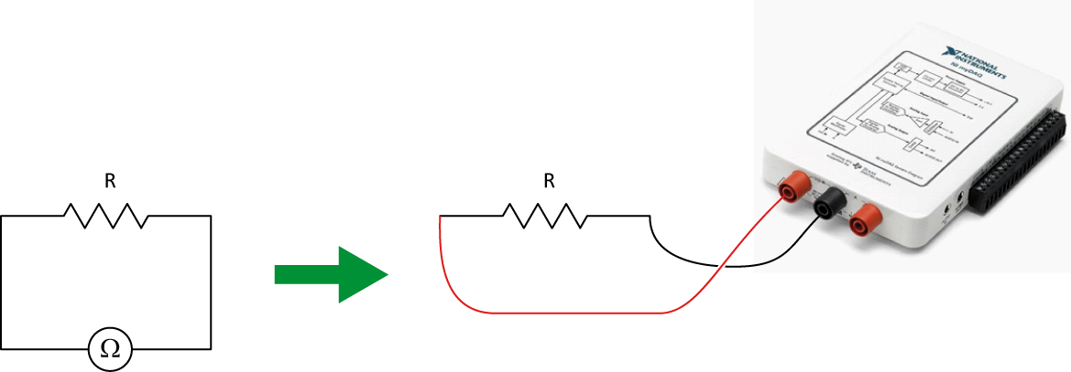

Figure 6 - Using the myDAQ as an ohmmeter

In order to correctly report value measured using the ohmmeter, you need to know the uncertainty on the measurement you are making. This uncertainty will depend on the value you measure and the scale of the instrument for that given measurement. All multimeters have different specification regarding their uncertainties. The specifications of the myDAQ multimeter are posted here: [myDAQ_multimeter_uncertainties.pdf](http://www.phylab.uottawa.ca/specifications/myDAQ_multimeter_uncertainties.pdf).

**Calculation example:**

Your ohmmeter has a reading of 12.06 $kΩ$ (set on the 20.00 $kΩ$ range).

From the [myDAQ specifications](http://www.phylab.uottawa.ca/specifications/myDAQ_multimeter_uncertainties.pdf), you know that the accuracy of that reading is $±$ (0.8% + 30 $Ω$). The percentage part is a percentage of the reading value to which you have to add a constant value of 30 $Ω$ whatever the reading is. This translates as:

$±$ (0.8% + 30 $Ω$) $= ±\left(0.008 ×12.06+0.03\right)kΩ=± 0.12648 kΩ$.

Consequently, your final reading is $\left(12.1 ±0.1\right) kΩ$.

### The resistor colour code

The resistance value of a resistor can is usually indicated on the resistor itself by the manufacturer. It is either indicated as a number (that you can directly read) or using a colour code (that you have to interpret). The resistor colour code uses four bands. Make sure you read the bands on the resistor from the correct side. In most cases the resistor will have either a gold or silver band, which should be the right most band when reading the colors on the resistors. If no such bands exist then you should arrange the resistor in such a way that the right most color band is the widest.

The two first bands represent the significant figures while the third colour band represents the multiplier and the forth colour band is for the tolerance (uncertainty on the resistance’s value specified by the manufacturer). The table below summarizes the resistor colour code.

Table - Resistor colour chart

|  |  |  |  |  |
| --- | --- | --- | --- | --- |
|  | **1st band** | **2nd band** | **3rd band** | **4th band** |
|  | **1st significant figure** | **2nd significant figure** | **Multiplier** | **Tolerance** |
| **Silver** | - | - | 10-2 | 10% |
| **Gold** | - | - | 10-1 | 5% |
| **Black** | - | 0 | 1 | - |
| **Brown** | 1 | 1 | 10 | 1% |
| **Red** | 2 | 2 | 102 | 2% |
| **Orange** | 3 | 3 | 103 | - |
| **Yellow** | 4 | 4 | 104 | - |
| **Green** | 5 | 5 | 105 | 0.5% |
| **Blue** | 6 | 6 | 106 | 0.25% |
| **Violet** | 7 | 7 | 107 | 0.1% |
| **Grey** | 8 | 8 | 108 | - |
| **White** | 9 | 9 | 109 | - |

**Calculation example:**

You have a resistor with the four following bands: red, black, orange and gold.

The first and second significant figures are 2 (red) and 0 (black).

The multiplier is 103 (orange) and the tolerance is 5% (gold).

The resistance value is thus $20 × {10}^{3}$ $Ω ±$ 5% $= \left(20 ±1\right)$ $kΩ$.

### Measuring the voltage

Figure 7 presents the circuit diagram for measuring the voltage value in a simple circuit using a voltmeter. To use the voltmeter from the myDAQ, you need to select it from the list of instruments in the Digital Multimeter window (it is represented by the V symbols). The first one is for direct current and the second one is for alternating currents.

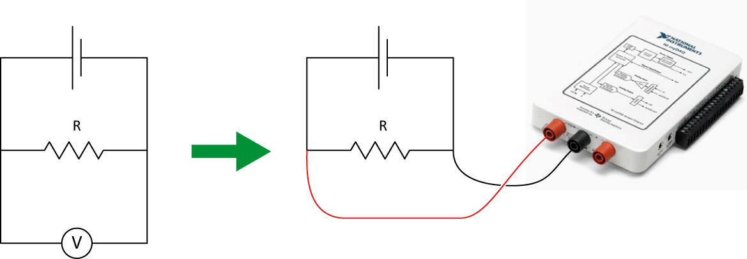

Figure 7 -Using the myDAQ as a voltmeter

**Calculation example:**

Your voltmeter has a reading of 1.276 V (set on the 2.000 V range).

From the [myDAQ specifications](http://www.phylab.uottawa.ca/specifications/myDAQ_multimeter_uncertainties.pdf), you know that the accuracy of that reading is $±$ (0.5% + 2 mV). The percentage part is a percentage of the reading value to which you have to add a constant value of 2 mV whatever the reading is. This translates as:

$±$ (0.5% + 2 mV) $= ±\left(0.005 ×1.276+0.002\right)$ V $=± 0.00838$ V.

Consequently, your final reading is $\left(1.276 ±0.008\right)$ V.

### Measuring the current

Figure 8 presents the circuit diagram for measuring the current passing through a simple circuit using an ammeter. To use the ammeter from the myDAQ, you need to select it from the list of instruments in the Digital Multimeter window (it is represented by the A symbols). The first one is for direct current and the second one is for alternating currents.

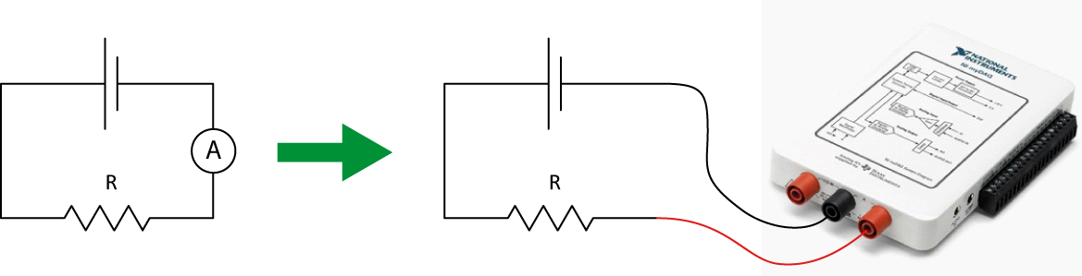

Figure 8 - Using the myDAQ as an ammeter

**Calculation example:**

Your ammeter has a reading of 0.057 A (set on the 1.000 A range).

From the [myDAQ specifications](http://www.phylab.uottawa.ca/specifications/myDAQ_multimeter_uncertainties.pdf), you know that the accuracy of that reading is $±$ (0.5% + 2 mA). The percentage part is a percentage of the reading value to which you have to add a constant value of 2 mA whatever the reading is. This translates as:

$±$ (0.5% + 2 mA) $= ±\left(0.005 ×0.057+0.002\right)$ A $=± 0.002285$ A.

Consequently, your final reading is $\left(0.057 ±0.002\right)$ A.