Tutorial – Using a multimeter

The multimeter
You might have already seen or worked with a multimeter. It is an electronic measuring device that combines several instruments such as the voltmeter (to measure the voltage) or the ammeter (to measure the current) in one apparatus. The multimeter is usually a standalone instrument that you can carry around to do measurements. You will be working with one of these standalone multimeters during your physics labs (like the one shown in Figure 1) but you will also work with a slightly different device that needs to be connected to a computer to work.

This second multimeter is part of a small portable data acquisition device called myDAQ (from National Instrument, see Figure 2) that features eight commonly used plug-and-play computer-based lab instruments including a digital multimeter, an oscilloscope, and a function generator. These instruments are controlled using software interfaces such as the one presented in Figure 3 (the multimeter). In the following sections, we will show you how to make simple measurements with this multimeter.

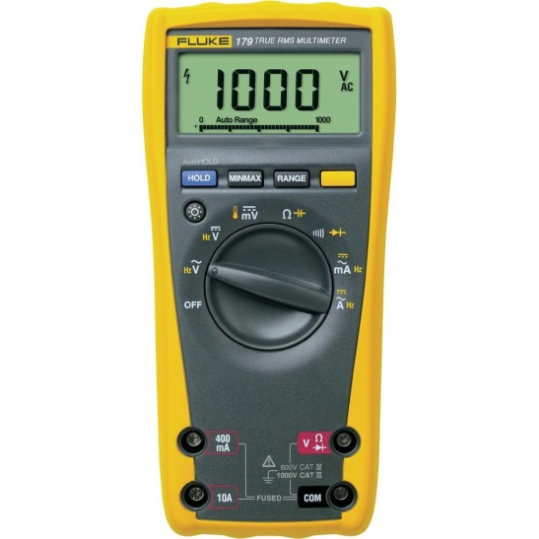
Figure 1 – The Fluke digital standalone multimeter used during the physics labs
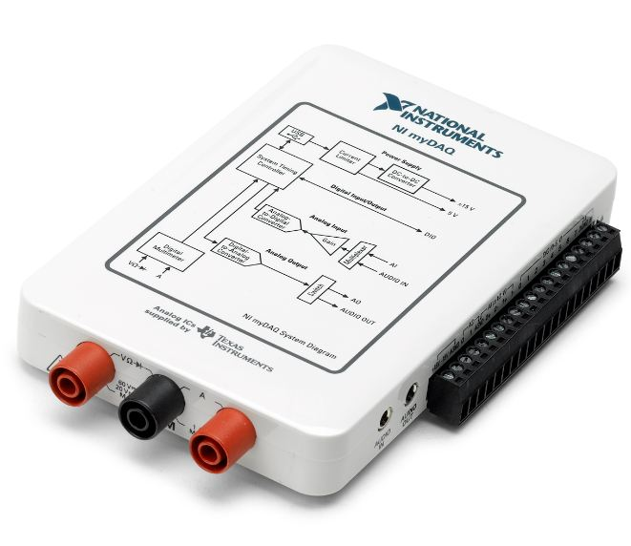 | 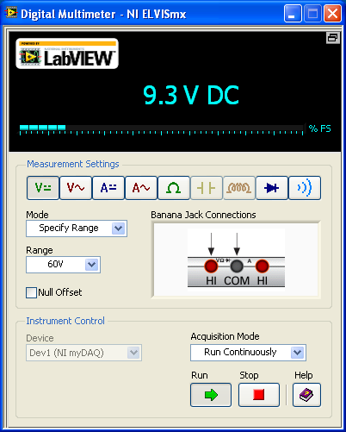
Figure 2 – The myDAQ from National Instrument. | Figure 3 – Screenshot of the virtual digital multimeter of the myDAQ

Measuring the resistance
Figure 4 presents the circuit diagram for measuring the resistance value of a resistor using an ohmmeter. To use the ohmmeter, you need to select it from the list of instruments in the Digital Multimeter window (see Figure 3, it is represented by the $Ω$ symbol).
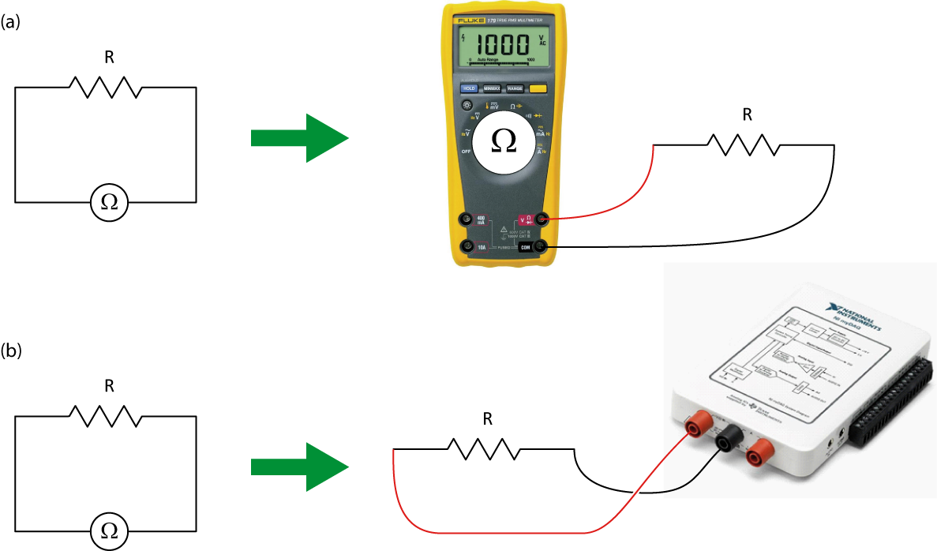

Figure 4 - Using the Fluke multimeter (a) and the myDAQ multimeter (b) as an ohmmeter
In order to correctly report value measured using the ohmmeter, you need to know the uncertainty on the measurement you are making. This uncertainty will depend on the value you measure and the scale of the instrument for that given measurement. All multimeters have different specifications regarding their uncertainties. The specifications of the Fluke and myDAQ multimeters are available in the Appendix 1 – Fluke multimeter specifications and Appendix 2 - myDAQ multimeter specifications at the end of this tutorial.
Calculation example:
Your myDAQ ohmmeter has a reading of 12.06 $kΩ$ (set on the 20.00 $kΩ$ range).
From the Appendix 2 - myDAQ multimeter specifications, you know that the accuracy of that reading is $±$ (0.8% + 30 $Ω$). The percentage part is a percentage of the reading value to which you have to add a constant value of 30 $Ω$ whatever the reading is. This translates as:
$±$ (0.8% + 30 $Ω$) $= ±\left(0.008 ×12.06+0.03\right)kΩ=± 0.12648 kΩ$.
Consequently, your final reading is $\left(12.1 ±0.1\right) kΩ$.

The resistor colour code
The resistance value of a resistor can is usually indicated on the resistor itself by the manufacturer. It is either indicated as a number (that you can directly read) or using a colour code (that you have to interpret). The resistor colour code uses four bands. Make sure you read the bands on the resistor from the correct side. In most cases the resistor will have either a gold or silver band, which should be the right most band when reading the colors on the resistors. If no such bands exist then you should arrange the resistor in such a way that the right most color band is the widest.
The first two bands represent the significant figures while the third colour band represents the multiplier and the forth colour band is for the tolerance (uncertainty on the resistance’s value specified by the manufacturer). The table below summarizes the resistor colour code.
Table 1 - Resistor colour chart
 | 1st band | 2nd band | 3rd band | 4th band
 | 1st significant figure | 2nd significant figure | Multiplier | Tolerance
Silver | - | - | 10⁻² | 10%
Gold | - | - | 10⁻¹ | 5%
Black | - | 0 | 1 | -
Brown | 1 | 1 | 10 | 1%
Red | 2 | 2 | 10² | 2%
Orange | 3 | 3 | 10³ | -
Yellow | 4 | 4 | 10⁴ | -
Green | 5 | 5 | 10⁵ | 0.5%
Blue | 6 | 6 | 10⁶ | 0.25%
Violet | 7 | 7 | 10⁷ | 0.1%
Grey | 8 | 8 | 10⁸ | -
White | 9 | 9 | 10⁹ | -

Calculation example:
You have a resistor with the four following bands: red, black, orange and gold.
The first and second significant figures are 2 (red) and 0 (black).
The multiplier is 10³ (orange) and the tolerance is 5% (gold).
The resistance value is thus $20 × {10}^{3}$ $Ω ±$5% $= \left(20 ±1\right)$ $kΩ$.

Measuring the voltage
Figure 5 presents the circuit diagram for measuring the voltage value in a simple circuit using a voltmeter. To use the voltmeter from the myDAQ, you need to select it from the list of instruments in the Digital Multimeter window (it is represented by the V symbols). The first one is for direct current and the second one is for alternating currents.

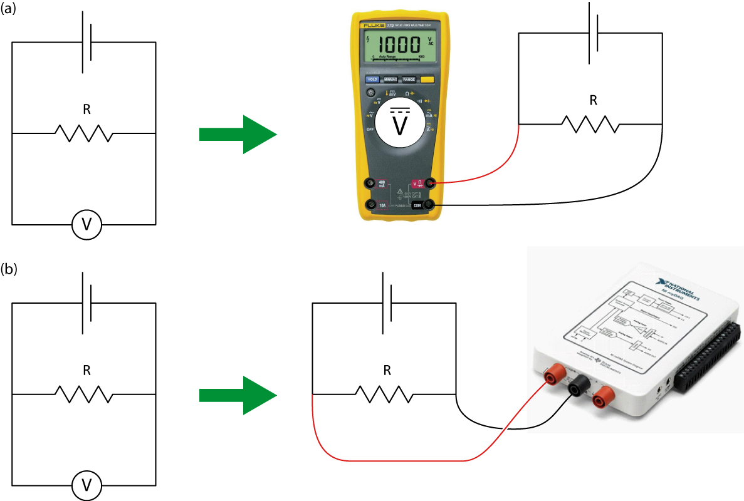

Figure 5 - Using the Fluke multimeter (a) and the myDAQ multimeter (b) as a voltmeter
Calculation example:
Your Fluke voltmeter has a reading of 1.276 V (set on the 4.000 V range).
From the Appendix 1 – Fluke multimeter specifications at the end of this tutorial, you know that the accuracy of that reading is $±$ (0.3% + 0.001 V). The percentage part is a percentage of the reading value to which you have to add a constant value of 0.001 V whatever the reading is. This translates as:
$±$ (0.3% + 0.001 V) $= ±\left(0.003 ×1.276+0.001\right)$ V $=± 0.004828$ V.
Consequently, your final reading is $\left(1.276 ±0.005\right)$ V.

Measuring the current
Figure 6 presents the circuit diagram for measuring the current passing through a simple circuit using an ammeter. To use the ammeter from the myDAQ, you need to select it from the list of instruments in the Digital Multimeter window (it is represented by the A symbols). The first one is for direct current and the second one is for alternating currents.

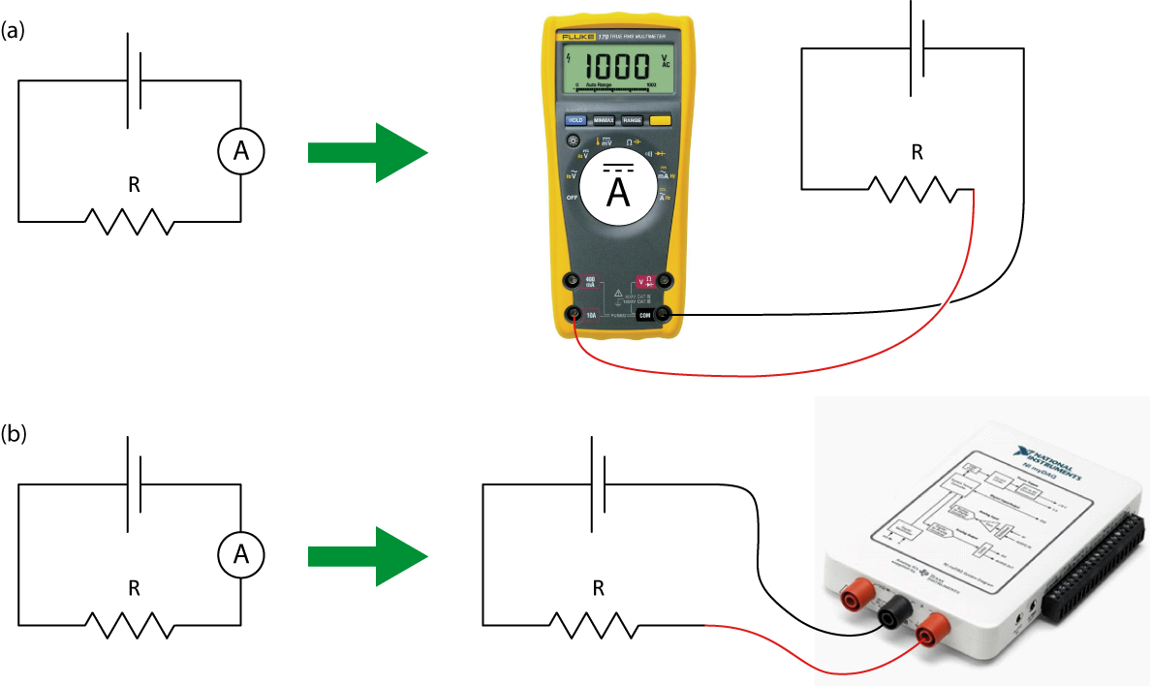

Figure 6 - Using the Fluke multimeter (a) and the myDAQ multimeter (b) as an ammeter

Calculation example:
Your myDAQ ammeter has a reading of 0.057 A (set on the 1.000 A range).
From the Appendix 2 - myDAQ multimeter specifications at the end of this tutorial, you know that the accuracy of that reading is $±$ (0.5% + 2 mA). The percentage part is a percentage of the reading value to which you have to add a constant value of 2 mA whatever the reading is. This translates as:
$±$ (0.5% + 2 mA) $= ±\left(0.005 ×0.057+0.002\right)$ A $=± 0.002285$ A.
Consequently, your final reading is $\left(0.057 ±0.002\right)$ A.

Measuring the capacitance
Figure 7 presents the circuit diagram for measuring the capacitance value of a capacitor using a ohmmeter. To use the ohmmeter, you need to select it from the list of instruments (see Figure 7 below).
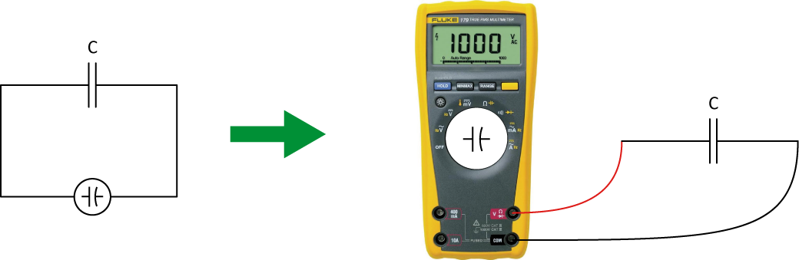

Figure 7 - Using the Fluke multimeter as a Faradmeter

Calculation example:
Your Fluke Faradmeter has a reading of 81.55 nF (set on the 100.00 nF range).
From the Appendix 1 – Fluke multimeter specifications at the end of this tutorial, you know that the accuracy of that reading is $±$ (1.9% + 0.02 nF). The percentage part is a percentage of the reading value to which you have to add a constant value of 0.02 nF whatever the reading is. This translates as:
$±$ (1.9% + 0.02 nF) $= ±\left(0.019 ×81.55+0.02\right)$ nF $=± 1.57$ nF.
Consequently, your final reading is $\left(82 ±2\right)$ nF.

Appendix 1 – Fluke multimeter specifications
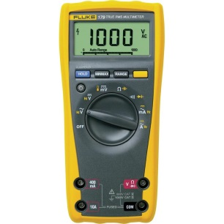 | Resistance measurement  Range Resolution Accuracy ± ([% of reading] + offset  400.0 Ω 0.1 Ω 0.4% + 0.2 Ω  4.000 kΩ 0.001 kΩ 0.4% + 1 Ω  40.00 kΩ 0.01 kΩ 0.4% + 10 Ω  400.0 kΩ 0.1 kΩ 0.6% + 100 Ω  4.000 MΩ 0.001 MΩ 0.4% + 1 kΩ  40.00 MΩ 0.01 MΩ 1% + 30 kΩ  Voltage measurement (DC)  Range Resolution Accuracy ± ([% of reading] + offset  40.00 mV 0.01 mV 0.3% + 0.05 mV  400.0 mV 0.1 V 0.3% + 0.1 mV  4.000 V 0.001 V 0.3% + 0.001 V  40.00 V 0.01 V 0.3% + 0.01 V  400.0 V 0.1 V 0.3% + 0.1 V  1000 V 1 V 0.3% + 1 V  Current measurement (DC)  Range Resolution Accuracy ± ([% of reading] + offset  4.000 A 0.001 A 0.5% + 0.005 A  10.00 A 0.01 A 0.5% + 0.02 A  Capacitance measurement  Range Resolution Accuracy ± ([% of reading] + offset  100.00 nF 0.01 nF 1.9% + 0.02 nF  1000.0 nF 0.1 nF 1.9% + 0.2 nF  10.000 μF 0.001 μF 1.9% + 0.002 μF  100.00 μF 0.01 μF 1.9% + 0.02 μF  1000.0 μF 0.1 μF 1.9% + 0.2 μF  10.000 mF 0.001 mF 10%

Appendix 2 - myDAQ multimeter specifications
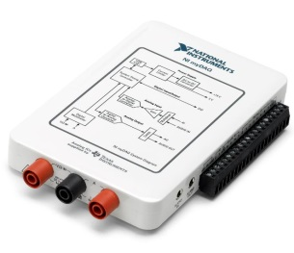 | Resistance measurement  Range Resolution Accuracy ± ([% of reading] + offset  200.0 Ω 0.1 Ω 0.8% + 0.3 Ω  2.000 kΩ 0.001 kΩ 0.8% + 3 Ω  20.00 kΩ 0.01 kΩ 0.8% + 30 Ω  200.0 kΩ 0.1 kΩ 0.8% + 300 Ω  2.000 MΩ 0.001 MΩ 0.8% + 3 kΩ  20.00 MΩ 0.01 MΩ 1.5% + 50 kΩ  Voltage measurement (DC)  Range Resolution Accuracy ± ([% of reading] + offset  200.0 mV 0.1 mV 0.5% + 0.2 mV  2.000 V 0.001 V 0.5% + 2 mV  20.00 V 0.01 V 0.5% + 20 mV  60.0 V 0.1 V 0.5% + 200 mV  Current measurement (DC)  Range Resolution Accuracy ± ([% of reading] + offset  20.00 mA 0.01 mA 1% + 0.02 mA  200.0 mA 0.1 mA 0.5% + 0.2 mA  1.000 A 0.001 A 0.5% + 2 mA

