Tutorial – Repeated measurements
Taking multiple measurements of the same quantity can decrease the amount of uncertainty in your experimental values. The simple statistical quantities (mean, standard deviation, and standard error) described below allow you to check how reproducible your measurements are.

Mean
The mean value ($μ$) of your repeated measurements is also known as the average value and is found by finding the sum of all your measured values and dividing by the number of measurements :
$$μ=\frac{\sum_{i=1}^{n}{x_{i}}}{n}=\frac{x_{1}+x_{2}+…+x_{n}}{n}$$
The mean is an estimate of the “true” value of the measurement. For small sample sizes of measurements that we use in first year physics labs, the mean is also known as the sample mean $\left(\overline{x}\right)$.

Standard deviation
The precision of your measurements depends on the “spread” of the values you take and the number of repeated attempts. This precision can be represented by the standard deviation. Each measurement you take has a deviation from the mean ($\left|x_{i}-μ\right|$). We use the absolute value here to indicate that the sign of the deviation is not taken into account since as we only care about the “distance” from the mean for each measurement.
The standard deviation ($σ$) takes into account the deviation of each measurement and is given by the equation:
$$σ=\sqrt{\frac{1}{n}\sum_{i=1 }^{n}{{\left(x_{i}-μ\right)}^{2}}}$$
For small sample sizes, it is more appropriate to use the sample standard deviation ($s$) which replaces the $n$ with $n-1$ (known as Bessel’s correction) and uses the sample mean in the equation above :
$$s=\sqrt{\frac{1}{n-1}\sum_{i=1}^{n}{{\left(x_{i}-\overline{x}\right)}^{2}}}=\sqrt{\frac{1}{n-1}\left[{\left(x_{1}-\overline{x}\right)}^{2}+{\left(x_{2}-\overline{x}\right)}^{2}+…+{\left(x_{n}-\overline{x}\right)}^{2}\right]}$$
Statistically, this means we are reasonably sure (~70%) that the next repeated measurement we take will be within one sample standard deviation from the mean value.

Standard error
The standard error for your measurements is an estimate of the uncertainty in your mean value and is given by :
$$SE=\frac{s}{\sqrt{n}}$$
Statistically, we are reasonably sure (~70%) that if we re-do the entire experiment with the same number of repeated measurements, the mean of the new data set will be within one standard error of the original mean.

Using a spreadsheet
Students are encouraged to use spreadsheet software (for examples, Microsoft Excel or Google Sheets) to perform their repeated measurement calculations. The three figures below show how to calculate the (sample) mean value, the sample standard deviation and the standard error for an ensemble of 5 data points (entered in cells B1 to B5, or B1:B5) in Excel.
Calculating  the mean:  enter “=AVERAGE(B1:B5)”  in cell B7 | 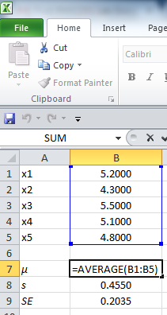 | Calculating  the sample standard deviation:  enter “=STDEV.S(B1:B5)”  in cell B8 | 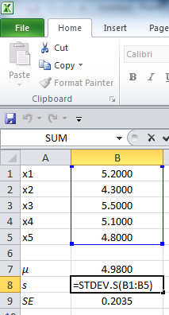 | Calculating  the standard  error:  enter  “=B8/SQRT(5)”  in cell B9 | 