Tutorial – Measuring techniques

Every experiment in the elementary laboratory involves measurement. The kind of measurement will depend on the particular experiment, but there are certain basic measurements which are common to many different experiments. The following notes are intended to be a guide to the correct use of some common laboratory instruments and to suggest good measuring techniques.

Mass measurements
We use electronic balances which are accurate to $±1$ on their last digit ($±0.1$g). Make sure to level and zero the balance before using it.

Time measurements
Time measurements can be made using an electronic timer, which is accurate to 0.01s. When measuring a time interval it is necessary to add an uncertainty of 0.2s to 0.5s. due to the human reaction time. Hence to achieve higher accuracy for a period of oscillation, measurements should be made over many periods (e.g., over 100 periods).

Example: Period of oscillation of a mass-spring system
- Select a mark or position which is in line with a part of the oscillating system when it is at rest. A complete oscillation has taken place when the system returns to this point, moving in the same direction.
- Do not use the end points of the oscillation (where the direction changes) to measure the period, since the amplitude decreases with time.
- The number of oscillations measured will determine the accuracy of the measurement.
- Take at least two independent measurements to find the period.
- Let the oscillating body settle into a rhythm before starting the timer.
- Start counting at zero, i.e., the count is one only after one complete oscillation.

Reading scales

The general rule
When reading a single value on a scale (measuring a position along a ruler or a volume using a graduated cylinder), the reading corresponds to the closest mark on the scale and the error on the measurement is then half of the smallest division.

The exceptions
There are two exceptions to the general rule stated above:
- If the spacing between the marks is too small, then the error on the reading can be increased to the smallest division.
- If the spacing between the marks is large, the position of the reading and its error can be estimated to a more reasonable value.

Examples
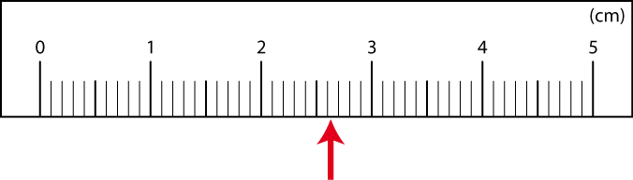 | The general rule: the position indicated by the arrow is between 2.6 cm and 2.7 cm. It is closest to 2.6 cm so the final reading is $(2.60±0.05)$cm.
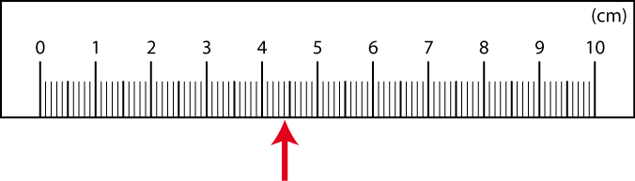 | The first exception: the closest mark to the arrow is at 4.4 cm but the spacing between marks is very small. It is hard to tell exact position is between 4.3 cm en 4.4 cm or between 4.4 cm and 4.5 cm. The final reading is then $(4.4±0.1)$cm.
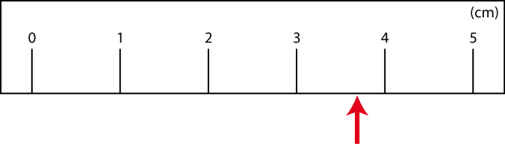 | The second exception: it would not be reasonable to locate the arrow at $(4.0±0.5)$cm as suggested by the general rule. In such case, it would be acceptable to estimate that the arrow is located at $(3.7±0.2)$cm even if the smallest division is 1 cm wide.

Length measurements
In the elementary laboratory the length to be measured may be any distance between a small fraction of a millimeter and several meters. It is neither convenient, nor generally possible to use the same kind of instrument for the whole of this range.

Meter stick or ruler
For distances greater than about 10cm a meter stick or a ruler is useful. The meter stick is divided into 1000 parts. These millimetre divisions are reliable to within $±$0.5mm (half of the smallest division) for each reading if care is taken to avoid parallax errors. When measuring the length of an object, the positions of both ends of the object have to be identified on the meter scale and the error on the length measurement becomes $±$0.7mm (using the propagation of errors).

Figure 1 below presents an example of an object measured using a ruler. The ends of the object are located at 0.20cm and 4.10cm with a $±$0.05cm precision while the total length of the object is given by
$L=(4.10±0.05)$cm$- (0.20±0.05)$cm$=(3.90±0.07)cm$.

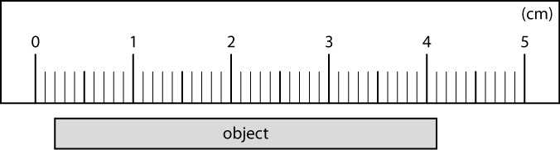

Figure 1 – Example of length measurement using a ruler.

Vernier caliper
For distances between about 1cm and 10cm, vernier calipers are used, (or some device with an attached vernier scale such as a traveling microscope). The vernier scale, as shown in Figure 2, is an auxiliary scale which makes it possible to interpolate between the smallest divisions of the main scale, a process which cannot be performed with reliability by eye.

The most common vernier scale has ten divisions in the same distance as nine divisions of the main scale. Each vernier division is therefore 0.9 of the main division. Vernier scales also exist with different ratios (Figure 2) for example). The same sort of arguments will apply using twentieths instead of tenths.

If the vernier scale were moved to the right by 0.1 of a division, the 1 mark on the vernier scale would line up with the 1 mark on the main scale. In Figure 2 the vernier scale has been moved 7 whole divisions plus a fraction of a division. Since the 3.5 mark on the vernier scale lines up with a main scale mark above it, this means that the total displacement is 7.35 divisions.

In using vernier calipers it is important to check for a possible zero correction. Make sure that the scale reads exactly zero when the jaws are closed, or apply the observed correction to every reading. If a vernier caliper is properly zeroed, the error on the reading is the smallest division of the vernier scale ($±$0.05mm in the example of Figure 2).

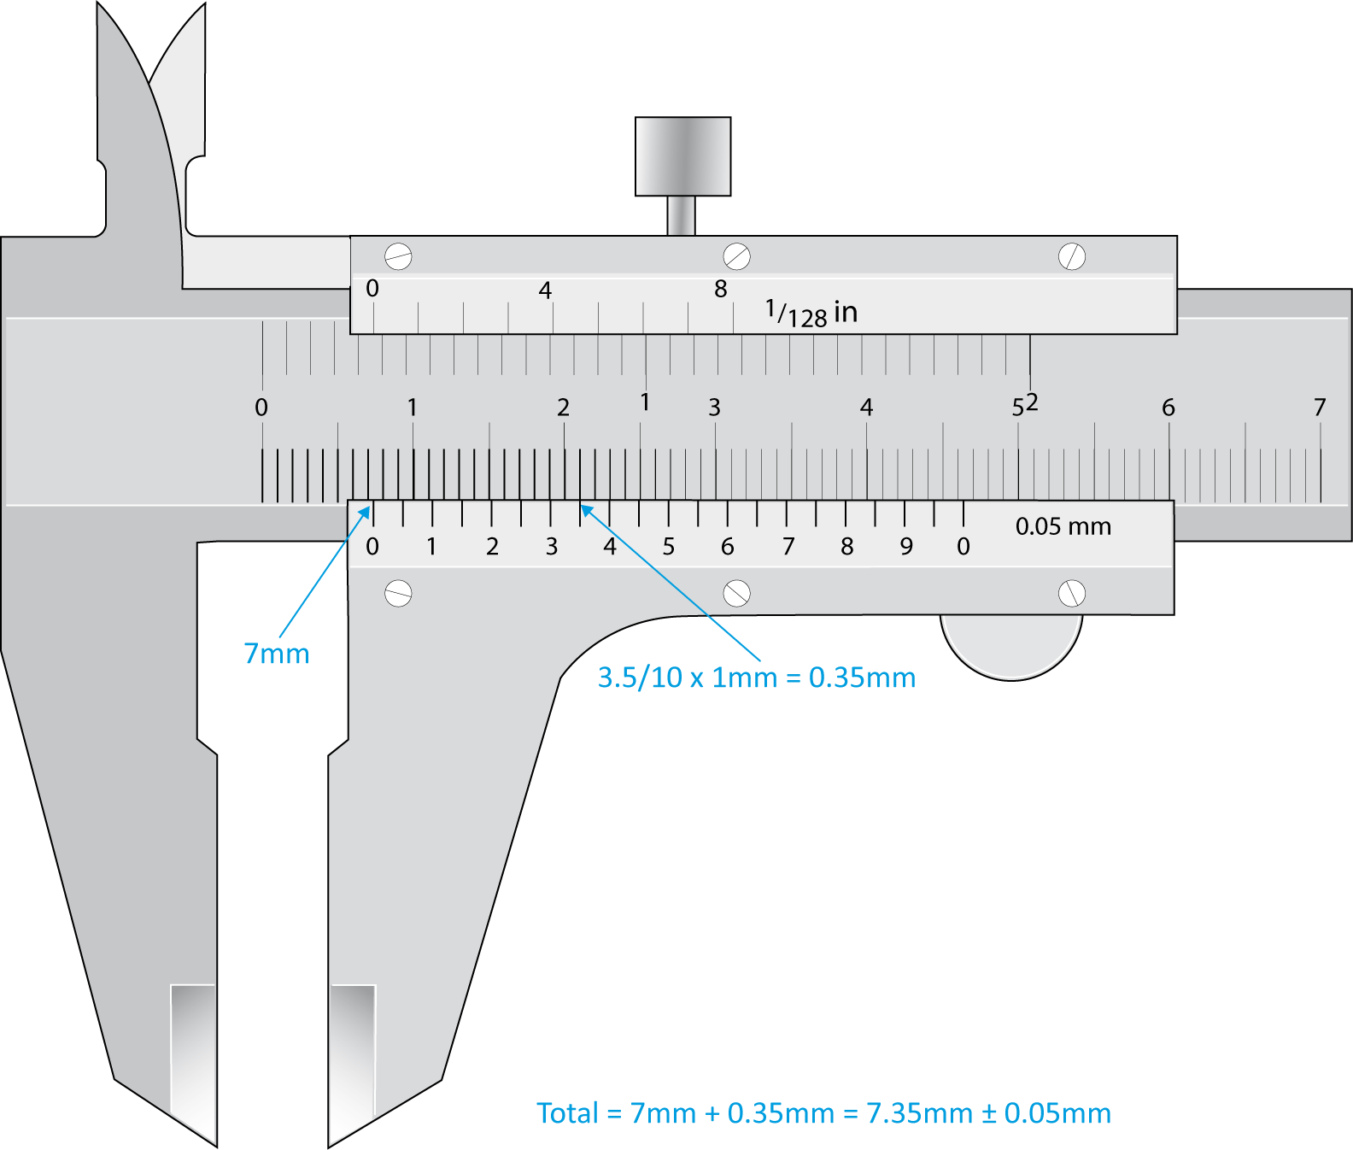

Figure 2 - A vernier caliper with 20 divisions in the same distance as 39 divisions of the main scale.

Micrometer
A micrometer is useful for measuring the dimensions of any object small enough to fit between its jaws, usually 25mm at most. While the vernier calipers give measurements to $±$0.05mm in general, the micrometer can be read to $±$0.01mm.

Two complete revolutions of the thimble are required for a linear movement of 1mm (see Figure 3). Since the edge of the thimble is marked with 50 divisions each division corresponds to 0.01mm. The linear motion of the spindle, which is attached to the thimble, can be seen on the scale 0 to 25mm marked on the sleeve in 0.5mm divisions. A ratchet is provided so that the micrometer will not be strained by being tightened too strongly against the object being measured. A zero reading should always be taken when using a micrometer and the appropriate correction noted and used to correct all measurements.

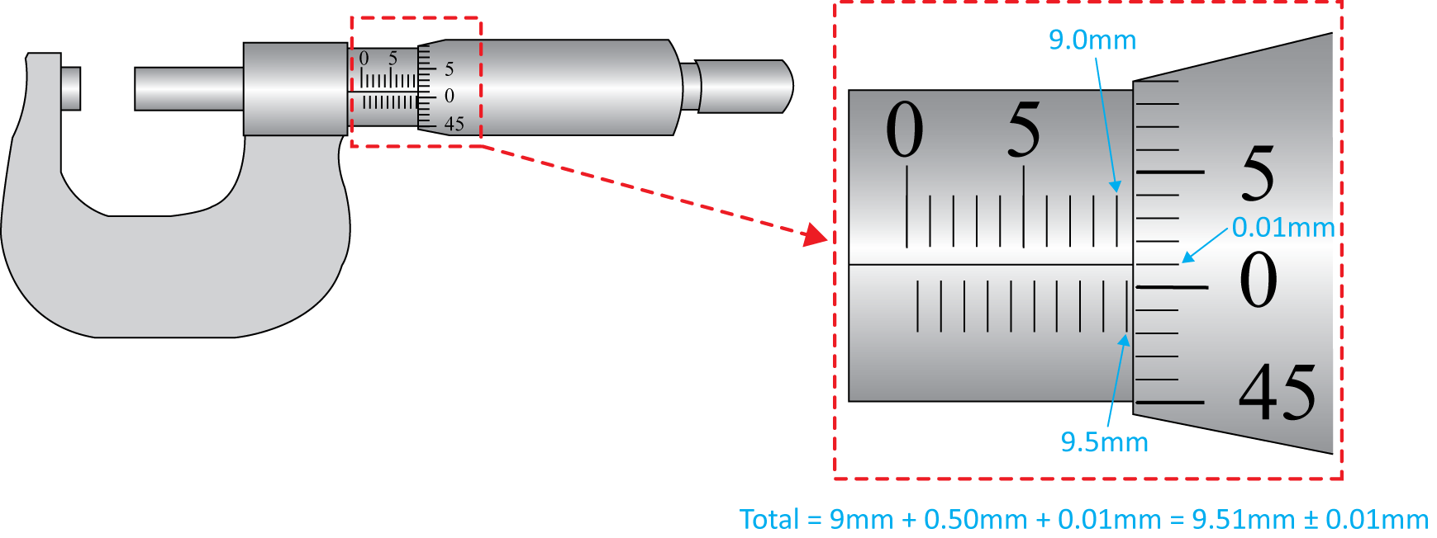

Figure 3 - A micrometer. Two complete revolutions of the thimble are required for a linear movement of 1 mm.

