Tutorial – How to prepare a graph

Preparing a graph
Many experiments are designed to discover what mathematical relationship exists between two quantities. When constructing a graph of one variable in terms of another, it is usually possible to deduce this relationship, or at least to see that the points are not random.

The following is a list the items that must be included on every graph prepared during your physics labs (unless specified otherwise by your lab demonstrator). Please refer to the sample graph presented in Figure 1.

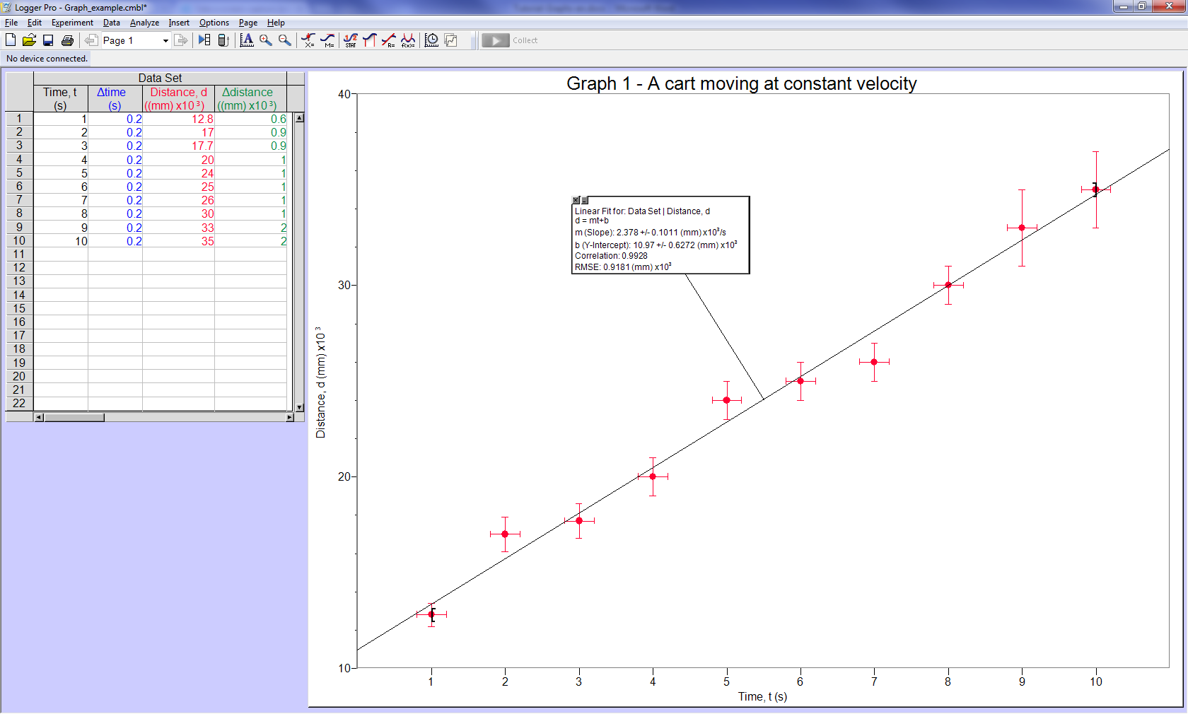
Figure 1 - Example of a proper graph prepared with Logger Pro (including the data table and the result of a linear regression)

Comments on Figure 1:

- Each graph should take up the area of a whole page. If the slope is evaluated by hand, it can be calculated with greater precision when the graph is large. A convenient scale should be chosen such that the data points are spread out throughout the page of the graph.
- The graph should be numbered and have a main title.
- Each axis should be labeled (long and short name of the quantity) and accompanied by the proper units if applicable.
- The graph’s axes do not necessarily have to begin from zero.
- The error bars arise from the uncertainty on your measurements. For example in Figure 1 the magnitude of the vertical error bars represent the uncertainty on the distance, while the horizontal bars represent the uncertainty on the time. Error bars are not always required for the first year labs.
- The magnitude of the error bars could vary from point to point. In the case of Figure 1, the uncertainties on the y-axis are 5% of the distance measurements. Thus the magnitude of the vertical error bars change proportionally to the values for $d$. The x-axis on the other hand remains constant due to the absolute uncertainty of ±0.2 s on $t$.
- The graph presented in Figure 1 was prepared using the Logger Pro software that you will use during your physics labs. This software allows you to perform various types of curve fits under the Analyze/Linear Fit or Analyze/Curve Fit… menus. Figure 1 presents the result of a linear regression with the dialogue box displaying all the information about the fit result. When using such tools, always make sure that the dialogue box is not blocking any data on the graph.

Data analysis using a graph

Straight-line graph
The trend in Figure 1 is clearly linear. From your high school mathematics courses you know that the general equation of a line is given by $y=mx+b$, where $m$ is the slope and $b$ is the y-intercept. In the case of Figure 1 the y-axis is the distance $d$ and the x-axis is the time $t$ leading to a best line equation: $d=mt+b$.

If the theoretical equation for the distance covered by a cart moving at constant velocity is given by $d=vt+d_{0}$; the physical meaning of the slope from the linear regression is the cart’s velocity while the y-intercept represents the position of the cart at time $t=0$ (initial position). According to Figure 1 the initial position of the cart is (11.0 ± 0.6)m relative to a reference point and the constant velocity of the cart is (2.4 ± 0.1)m/s. The uncertainty reported here are the ones obtained from the linear regression dialogue box.

Transforming data to a straight-line graph
Since the straight line graphs are simpler to analyse, it is often possible to obtain a straight-line graph using data which, if plotted directly, would not yield a straight line. For example, from the simple pendulum equation $T=2π\sqrt{L/g}$ may be rewritten as $T^{2}={4π^{2}L}/g$ in order to get a linear relationship between the period squared $T^{2}$ of the pendulum and the pendulum’s length $L$. In this case, one can determine the gravitational acceleration using $g={4π^{2}}/m$, where $m$ is the slope for $T^{2}$ vs. $L$.

Another example is the relationship between the object distance $p$ and the image distance $q$ for a thin lens given by

$$\frac{1}{p}+\frac{1}{q}=\frac{1}{f} .$$

A graph of $p$ as a function of $q$ is not very informative. On the other hand, a plot showing $1/q$ as a function of $1/p$ will produce a linear graph with a negative slope of $m=-1$ and an y-intercept equal to $1/f$.

Power laws such as $y=Ax^{B}$ (where $A$ and $B$ are constants) can be linearized using log-log graphs. In such case, we simply need to plot the logarithm of one variable against the logarithm of the other. In this example, we can take the logarithm of both sides of the equation to obtain

$$\log{y}=\log{A+B\log{x}} .$$

This is the equation of a linear graph between $\log{y}$ and $\log{x}$ with a slope equal to $B$ and a y-intercept given by $\log{A}$.

