Tutorial – Experimental errors

Content
Tutorial – Experimental errors 1
Content 1
Precision vs. Accuracy 1
Types of Errors 2
Statement of a measurement 3
Quantitative comparisons 4
Significant figures 5
Precision of errors 6

Precision vs. Accuracy
In ordinary conversation we tend to use the terms accuracy and precision interchangeably, but in the context of scientific measurement, they give very different meanings. They are actually two different ways of expressing the uncertainty of experimental data.

Accuracy: Refers how closely a measured value of a quantity corresponds to its true value.
Precision: Expresses the degree of reproducibility of a result when the experiment is repeated under the same conditions. In other words precision refers to how closely individual measurements agree with each other.

A result can be measured precisely yet still be inaccurate.
An imprecise result can be accurate.

In order to better understand the difference between accuracy and precision, let us take the example of an archer shooting a total of thirteen arrows at a target. From the archer’s first results (shown in Figure 1a), we can conclude that on average the archer is accurate but no precise since all the arrows have a large deviation with respect to each other.

Several months before the next competition the archer has went through rigorous training and have increased his precision considerably. During a practice session on the eve of her second competition, the archer calibrates the sights on her bow and hits the bull’s-eye of the target 10 of 13 times. The morning of the competition the wind conditions have changed; due to her lack of experience the archer fails to readjust (or recalibrate) the sights on her bow to compensate for the wind factor. Her arrows end up hitting a localized region in the top left-hand corner of the target (see Figure 1b). The results show an improvement in precision relative to her first competition, but unfortunately her shots are all inaccurate.

In her next competition the more experienced archer made sure to properly calibrate the sights of her bow moments before her competition in order to compensate for the current weather conditions. As a result all of her arrows hit the target near the bull’s-eye (as shown in Figure 1c) demonstrating high precision as well as high accuracy.

Trying to hit the bull’s eye of a target with the use of a bow and an arrow is analogous to making a measurement in the goal of obtaining to the true value of a quantity within an acceptable range of uncertainty. A quantity’s true value is the value that would be obtained in the absence of errors. An archer’s precision can be improved through training, while a scientist can improve the precision of his/her measurements with the use of a better experimental technique and/or the use of a measuring instrument having a greater precision. However, each instrument has a precision limit that cannot be overcome, i.e., independent of the amount of training spent by the archer she will never be able to hit the target at precisely the same spot thirteen times in a row due to random wind fluctuations. Similarly, a scientist will always encounter random fluctuations during experiments that cannot be eliminated. As in the case of the archer who readjusted the sights on her bow, the inaccuracy of measurements can be improved with the proper calibration of measuring instruments.

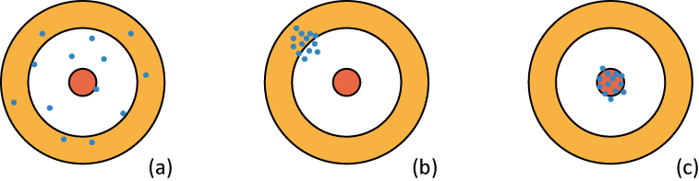

Figure 1 - Archer shooting 13 times at a target. (a) Accurate (the average is accurate) but not precise. (b) Precise not accurate. (c) Accurate and precise.

Types of Errors
It is impossible to obtain an exact measurement due to the lack of precision of instruments and the experimental techniques.

Here are the two types of errors an experimentalist can encounter:

Random errors
Random errors are those which come up differently each time a reading is taken. They are statistical in origin and can be treated using statistical methods. Repeated readings of the same quantity will give a statistical sample and this serves both to provide a better answer and to estimate the random error. Random errors are seen as deviations between the measured values and the mean value (see Figure 2).

Random errors affect the precision of measurements not its accuracy.

Systematic errors
These are deviations between the mean of a large number of measured values and the true value. This type of error is due to limitations of the measurement equipment or improper calibration. These types of errors will shift all the measurements relative to the true value (see Figure 2). Examples of such errors are the displacement of the zero point on a micrometer, the unaccounted loss of heat during a calorimeter experiment or a meter scale drawn with slightly wrong spacing.

Systematic errors affect the accuracy of measurements not its precision.

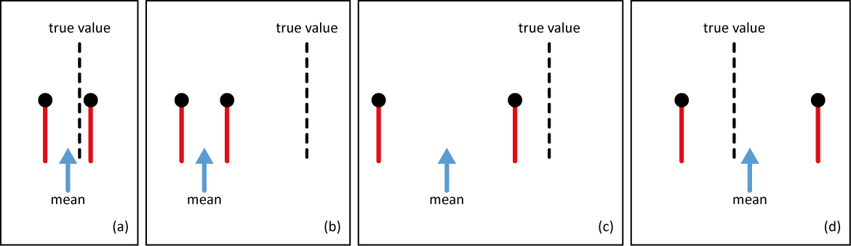

Figure 2 - The red bars with a dot at the top represent the error bars of the mean value of a measured quantity. (a) Low systematic error (high accuracy) and low random error (high precision) are ideal conditions for doing an experiment. (b) Low random error (high precision) but a large systematic error (low accuracy). All the measurements are shifted to one side (left) of the true value indicating the use of an improperly calibrated measuring instrument. (c) The combination of a large systematic error (low accuracy) and large random error (low precision) is the worst experimental condition. (d) Large random error (low precision) probably due to the use of a relatively low precision instrument for the particular type of measurement. However the low systematic error (or high accuracy) indicates that the instrument is well calibrated. Considering the conditions (low precision) our experimentalist has been quite lucky to obtain a mean value relatively close to the true value.

Statement of a measurement
A complete statement of any measured quantity involves three distinct parts:
- A specific description of what has been measured;
- A number giving the magnitude of the measured quantity and a statement of the units in which it is expressed;
- An indication of the reliability of the measurement.

The reliability indication usually takes the form of an estimate of the range of values within which the true value probably lies, and is called the error on the measurement. As an example, the complete statement for the measurement of the length $L$ of a cylinder is $L = (4.90 ± 0.05)$mm.

There exists two different ways of expressing the uncertainty of a measurement:

- Absolute uncertainty: The uncertainty (or error) is given in the same units as the measured quantity. Ex. (5.4 ± 0.3)A
- Relative uncertainty: The uncertainty (or error) is expresses as a fraction or a percentage of the
measured quantity. Ex. 5.4A ± 6%

These uncertainties arise from the precision limit the measurement instrument. It is common practice to express the uncertainty in absolute form in a data table.

The uncertainty establishes the limits in which the true value lies. For example, $m = (41.5610 ± 0.0005)$g means that $41.5605$g$≤ m ≤ 41.5615$g.

On a graph, the uncertainty on a measurement is represented by error bars. Let’s take the example of a data point where $(x, y) = (0.6 ± 0.1, 0.5 ± 0.2)$ as illustrated in Figure 3. The value of the data point, (0.6, 0.5), is shown by the dot, and the lines show the values of the errors. For example the error bar on the y-axis has a magnitude of 0.4, +0.2 and -0.2, which reflects the uncertainty of ±0.2 on the measurement of 0.5.

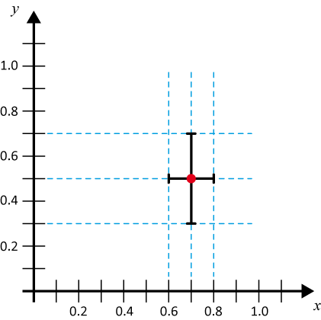
Figure 3 – Graphical representation of the data point $(x, y) = (0.7 ± 0.1, 0.5 ± 0.2)$.

Quantitative comparisons
Let’s consider the comparison between three values for the gravitational constant; two measured values and the accepted value:

- $g$ : the accepted value of (9.81 ± 0.01)m/s²
- $g$_{exp.1} : the first experimental value of (9.74 ± 0.08)m/s²
- $g$_{exp.2} : the second experimental value of (9.86 ± 0.02)m/s²
The diagram below demonstrates the range of each value:

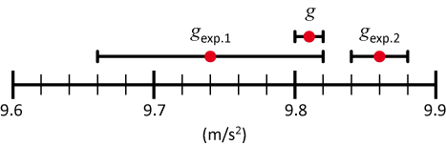

The value of $g$_{exp.1} corresponds to the accepted value $g$. Therefore we say that $g$_{exp.1} $= g$ and that experimentalist #1 was able to measure the gravitational constant. The value is within the resolution (uncertainty range) of the instruments used.

However, the value $g$_{exp.2} does not correspond to either $g$ or $g$_{exp.1}. With instruments having a combined resolution (precision) of four times that of experimentalist #1, experimentalist #2 is unable to measure the correct value for the gravitational constant. Since the value $g$_{exp.2} is shifted with respect to the true value due to systematic errors. Experimentalist #2 either uses a poor experimental technique or improperly calibrated instruments.

Significant figures

Rounding off
If a number (the one that causes the rounding) is GREATER or EQUAL to 5 then you ROUND UP otherwise you ROUND DOWN.

Ex. Round off 44.68 to the first decimal place. Answer: 44.7

Ex. Round off 13.96 to the first decimal place. Answer: 14.0

Ex. Round off 0.0034 to the third decimal place. Answer: 0.003

Ex. Round off 123.545 to 2 decimal places. Is it closer to 123.54 or 123.55?

This last example is the only slightly tricky situation. There are various approaches to rounding off numbers ending with 5. To avoid being bias when dealing with a large number of measurements we use the following rule: if the number preceding the 5 is even we round down; if the number preceding the 5 is odd we round up (or vice versa). When dealing with a small number of measurements as in the case of first year labs the latter rule is irrelevant. For simplicity we stick with the first rule mentioned above which states that if the number causing the rounding is greater or equal to 5, you round up regardless of the preceding number’s value. This is especially important when rounding off uncertainties to avoid under estimating the uncertainty.

- Therefore the answer that we want is 123.55.

Rules for significant figures
- All nonzero digits are significant.
Ex.: 127.34 has 5 significant digits.
- All zeros between nonzero digits are significant.
Ex.: 120.000 has 6 significant digits.
- Zeroes to the left of the first nonzero digits are not significant; such zeroes merely indicate the position of the decimal point.
Ex.: 0.0012 has 2 significant digits.
- Zeroes to the right of a decimal point in a number are significant.
Ex.: 0.400 has 3 significant digits.
- When a number ends in zeroes that are not to the right of a decimal point, the zeroes are not necessarily significant.
Ex.: 1900 may have 2, 3 or 4 significant digits.
To eliminate this ambiguity express your value in terms of scientific notation.
Ex.: 1.900×10³ has 4 significant digits.
Ex.: 1.90×10³ has 3 significant digits.
Ex.: 1.9×10³ has 2 significant digits.

Precision of errors
The uncertainty on a measurement should only have ONE significant digit.

Example 1: Suppose a relative uncertainty of $0.5\%$ on the gravitational acceleration: $g = 978.325$cm/s² $± 0.5\%$.
Step 1: Multiply the measurement by $0.5\%$:
$(978.325 ± 4.891625)$cm/s².
Step 2: Round off the uncertainty to ONE significant digit:
$(978.325 ± 5)$cm/s².
Step 3: Round off the measured value such that it has the same degree of precision as the
uncertainty:
$(978 ± 5)$cm/s².
A measurement can never have a greater precision than the uncertainty.

Example 2: Suppose a relative uncertainty of $2\%$ on a measurement: $x = 0.857$mm $± 2\%$.
Step 1: Multiply the measurement by $2\%$:
$(0.857 ± 0.01714)$mm.
Step 2: Round off the uncertainty to ONE significant digit:
$(0.857 ± 0.02)$mm.
Step 3: Round off the measured value such that it has the same degree of precision as the
uncertainty:
$(0.86 ± 0.02)$mm.

Example 3: Suppose a relative uncertainty of $5\%$ on a measurement: $y = 2531$m $± 5\%$.
Step 1: Multiply the measurement by $5\%$:
$(2531± 126.55)$m.
Step 2: Round off the uncertainty to ONE significant digit:
$(2531 ± 100)$m.
Step 3: Round off the measured value such that it has the same degree of precision as the
uncertainty:
$(2.5 ± 0.1)$km.

