# Standing waves in a string

## Introduction

When you shake a string, a pulse travels down its length. When it reaches the end, the pulse can be reflected. A series of regularly occurring pulses will generate traveling waves that, after reflection from the other end, will interfere with the oncoming waves. When the conditions are right, the superposition of these waves traveling in opposite directions can give rise to something known as a “standing wave.” That is, there appear to be stationary waves on the string with some parts of the string hardly moving at all and other regions where the string experiences a large displacement. In this lab you will investigate the various factors that give rise to this phenomenon.

### Part 1 - Wavelength and frequency

The general appearance of waves can be shown by means of standing waves in a string. This type of wave is very important because most vibrations of extended bodies, such as the prongs of a tuning fork or the strings of a piano, are standing waves. In this experiment you will discover how the speed of the wave in a vibrating string is affected by the density of the string, the stretching force and the frequency of the wave.

Standing waves (stationary waves) are produced by the interference of two traveling waves, both of which have the same wavelength, speed and amplitude, but travel in opposite directions through the same medium (see the following animation at <http://en.wikipedia.org/wiki/File:Standing_wave_2.gif> to better understand the formation of standing wave patterns). The necessary conditions for the production of standing waves can be met in the case of a stretched string by having waves set up by some vibrating body, reflected at the end of the string and then interfering with the oncoming waves.

A stretched string has many natural modes of vibration (one example is shown in Figure 1). If the string is fixed at both ends then there must be a node at each end. It may vibrate as a single segment (see $n=1$ in Figure 2), in which case the length ($L$) of the string is equal to $1/2$ the wavelength ($λ$) of the wave. It may also vibrate in two segments with a node at each end and one node in the middle; then the wavelength is equal to the length of the string. It may also vibrate with a larger integer number of segments. In every case, the length of the string equals some integer number of half wavelengths.

If you drive a stretched string at an arbitrary frequency, you will probably not see any particular mode; many modes will be mixed together. But, if the driving frequency, the tension and the length are adjusted correctly, one vibrational mode will occur at a much greater amplitude than the other modes.

For any wave with wavelength $λ$ and frequency $f$, the speed, $v$, is

|  |  |  |
| --- | --- | --- |
|  | $$v=λf .$$ |  |

In this experiment, standing waves are set up in a stretched string by the vibrations of an electrically-driven string vibrator. The arrangement of the apparatus is shown in Figure 1. The tension in the string equals the weight of the suspended masses (*F* = *mg*). You can alter the tension by changing the mass. You can adjust the amplitude and frequency of the wave by adjusting the output of the Function Generator, which powers the string vibrator.

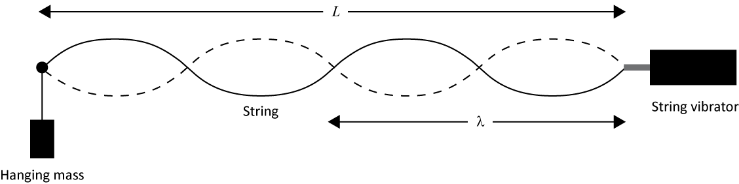

Figure 1 – String vibrator setup.

### Part 2 - Wave speed and string density

As stated in Equation 1, the speed of any wave is related to the wavelength and the frequency. For a wave on a string, the speed is also related to the tension ($T$) in the string, and the linear density ($μ$) of the string, as shown by

|  |  |  |
| --- | --- | --- |
|  | $$v=\sqrt{\frac{T}{μ}} ,$$ |  |

The linear density ($μ$) is the mass per unit length of the string. The tension ($T$) is applied by the hanging a mass ($m$), and is equal to the weight ($mg$) of the hanging mass.

To produce standing waves, the length $L$ of the string must be an integer number of half the wavelength

|  |  |  |
| --- | --- | --- |
|  | $$L=n\frac{λ}{2} .$$ |  |

We refer to the fundamental mode using the number $n$. Figure 2 shows examples of the first four modes.

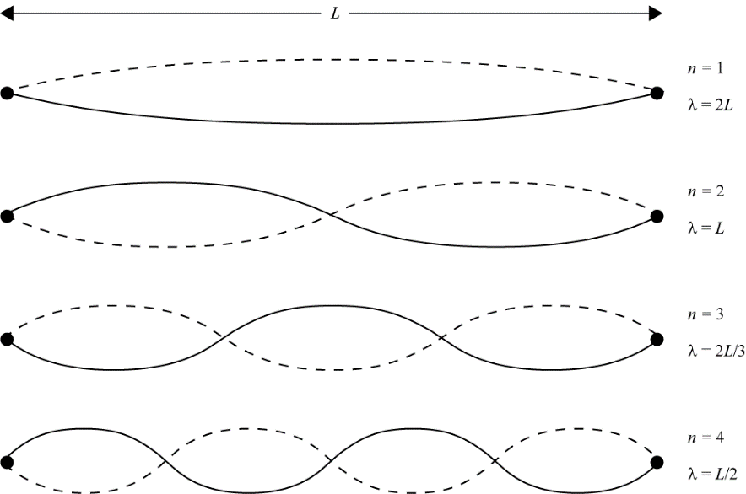

Figure 2 – The first four fundamental modes of the vibrating string.

### Suggested reading

|  |  |  |
| --- | --- | --- |
| **Students taking** | **Suggested reading** | |
| PHY 1322 | Section 18.1 to 18.4 | Young, H. D., Freedman, R. A., *University Physics with Modern Physics, 13th edition*. Addison-Wesley (2012). |

## Objectives

### Part 1 - Wavelength and frequency

* Adjust the frequency of the driver so that the string vibrates in the fundamental mode.
* Set up other standing wave patterns on the string.
* Relate the frequency of the various harmonics to that of the fundamental mode of vibration.
* Describe the terms amplitude, frequency, wavelength, node, and antinode as they relate to vibrating strings.

### Part 2 - Wave speed and string density

* Determine the velocity of waves in the string.
* Relate wave velocity to the tension of the string and its linear density.

## Materials

* Meter stick
* Computer equipped with *Logger Pro* and a Vernier computer interface
* Computer equipped with the National Instrument *myDAQ* virtual instruments
* National Instrument *myDAQ* data acquisition system and amplifier
* Two table C-clamp with short rods and a pulley
* String vibrator and string
* Mass hanger and slotted masses set (3 x 100 g)
* Electronic balance (one per classroom)

## Safety warnings

Be careful not to drop the mass on your foot (you should always be wearing covered shoes in a lab).

## References for this manual

* *Sine Wave Generator*. PASCO scientific.
* Dukerich, L., *Advanced Physics with Vernier – Beyond mechanics*. Vernier software and Technology (2012).

## Procedure

### Preliminary manipulations and calculations

1. Turn on your computer and launch the Logger Pro program. Also launch the Function generator program (this program should be available from the computer’s desktop).
2. Install the C-clamp with string vibrator about 1 m away from the other C-clamp (the one with the pulley that is already installed at the end of the table).
3. Run the string attached to the string vibrator over the universal clamp screw and over the pulley. Hang about 350 g of mass from it (3 times 100 g plus the support that is about 50 g). Measure the suspended mass and enter the value in Table 1.
4. Move the string vibrator C-clamp in order to have a string length $L$ of 1 m from the knot where the string attach to the string vibrator to the contact point on the universal clamp screw (the part of the string that will be vibrating). Measure the length $L$ and estimate the uncertainty.
5. Using the string sample on the professor’s desk, calculate the linear density of the string in kg/m.
6. Using equations 1, 2 and 3, derive the formula to calculate the frequency as a function of the mode number $n$, the string length $L$, the tension $T$ and the string linear density $μ$.
7. Use your formula to predict the fundamental frequencies for modes $n=$ 2 to 5 for 150g, 250g and 350g. Fill the second and fourth columns of Table 1.

### Part 1 - Wavelength and frequency

1. Make sure the connections between the myDAQ Function Generator, the amplifier and the string vibrator look like the figure below. Basically, we will drive the string vibrator using a sinusoidal wave current generated from the myDAQ unit that we amplify before sending to the string vibrator.

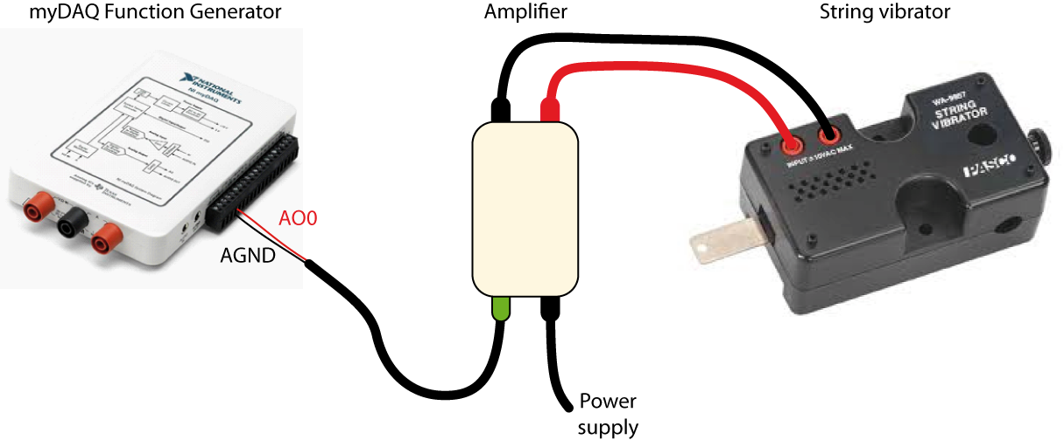

1. Make sure you should still have 350 g hanging over the pulley.
2. Set the function generator as follow:

|  |  |
| --- | --- |
|  | * Select the sin wave. * Set the Frequency to the value you calculated for the second mode you calculated for that tension. * Set the Amplitude to 0.2 V. * Make sure DC Offset is set to 0 V. * Click Run. |

1. Adjust the frequency to obtain a large-amplitude wave and three stable nodes. There should be one of these nodes along the string but also check the end of the vibrating blade; the point where the string attaches should be a node. It is more important to have a good node at the blade than it is to have the largest amplitude possible. However, it is desirable to have a large amplitude while keeping a good node. When adjusting the frequency, start incrementing the frequency by ± 1 s-1, then by 0.5 s-1 or 0.1 s-1 (don’t use smaller increments than 0.1 s-1). Don’t expect the experimental value of the frequency to be equal to the calculated one, it can be a few s-1 off.
2. Record the frequency. How much uncertainty is there in this value? How much can you change the frequency before you see an effect?
3. Try touching the string at an anti-node. What happens? Try touching the string at the central node. Can you hold the string at the node and not significantly affect the vibration?
4. While the string is still vibrating for $n=2$, remove 100 g from the mass hanger. Describe and explain what happens then.

### Part 2 - Wave speed and string density

1. You will now complete the last column of Table 1. To do so, hang 150 g to the pulley, set the frequency generator to your calculated frequency for $n =$ 2. Fine tune the frequency to find the experimental frequency for that mode. Evaluate the uncertainty by varying the frequency up and down about the experimental value. Record your value in the fifth column of Table 1.
2. Repeat the last step to complete Table 1. When you are done, click Stop to turn off the function generator.
3. Using the data from Table 1, explain how you can prepare a graph for which the slope will be the linear density, $μ$, of the string.
4. Using Logger Pro, prepare a graph (Graph 1) and obtain the linear density, $μ$, of the string from a linear regression. **Print** your Graph 1 to a pdf file. Make sure to select the CutePDF as the printer.
5. We strongly recommend that you save all the work you do during the lab in case you need to review it later. Click File 🡪 Save As… to save your experiment file (suggested name: *waves_YOUR_NAMES.cmbl*). You can either send the file to yourself by email or save it on a USB key.

### Cleaning up your station

1. Submit your graph in Blackboard Learn. If you locally saved your files, send them to yourself by email. Pick up your USB key if you used one to save your files. Turn off the computer.
2. Put back the masses and the hanger on the table. Move the string vibrator C-clamp back close to the other C-clamp.
3. Recycle scrap paper and throw away any garbage. Leave your station as clean as you can.
4. Push back the monitor, keyboard and mouse. Also please push your chairs back under the table.