# Simple measurements & buoyancy force

## Introduction

The purpose of this experiment is to practice basic experimental measurements, calculation techniques and result presentation methods (tables, graphs, etc.) that will be useful during the whole semester. Most of the subjects covered during this experiment are presented in the following tutorials:

* *Measuring techniques*
* *Experimental errors*
* *Propagation of errors*
* *Repeated measurements*
* *How to present a calculation example*
* *How to prepare a graph*
* *How to prepare a table*

These documents are available in the *Tutorial* section at the [BbLearn physics laboratory website](https://uottawa.blackboard.com/). Students should read these tutorials before coming to their lab session.

### Part 1 – Length measurement

In this part, you will make length measurements using a meter stick and a vernier caliper. You will learn how to report the uncertainty of your measurements and how to use them to perform error calculations when calculating the density of some unknown materials.

### Part 2 – Time measurement

For this part, you will carry out several time measurements of the period of oscillation of a pendulum. You will use these repeated measurements to calculate statistical quantities such as the average, the standard deviation and the standard error.

### Part 3 – The buoyancy force

In this last part, you will investigate Archimedes’ principle which states that the buoyant force, $F_{b},$ exerted on an object partially or fully submerged in a fluid will be equal to the weight of the fluid displaced by the object:

|  |  |  |
| --- | --- | --- |
|  | $$F_{b}=ρVg ,$$ |  |

where $ρ$ is the density of the fluid, $V$ is the volume of fluid displaced by the object, and $g$ is the gravitational acceleration of 9.81 m/s2­. You will use a suspended force sensor to measure the buoyancy force experienced by an object that is gradually immersed in water. You will plot a graph of buoyancy force vs. the volume of displaced liquid and, by using a linear regression tool, you will determine the value of the density of water, $ρ$.

### Suggested reading

|  |  |  |
| --- | --- | --- |
| **Students taking** | **Suggested reading** | |
| PHY 1122 | Section 12.3 | Young, H. D., Freedman, R. A., *University Physics with Modern Physics, 13th edition*. Addison-Wesley (2012). |

## Objectives

### Part 1 – Length measurement

* Familiarize yourself with different measuring instruments such as the meter stick and the vernier caliper.
* Determine the uncertainty on each measurement and perform some error calculations based on length measurements.
* Prepare a proper table to report measurements.
* Calculate the density of a metallic object and determine its metal types from a table.

### Part 2 – Time measurement

* Calculate the period of oscillation of a pendulum.
* Calculate the average, the standard deviation and the standard error of several measurements.
* Learn how to describe and account for variation in a set of measurements.
* Learn how to describe a range of experimental values.

### Part 3 – The buoyancy force

* Determine the value of the density of a liquid using a force sensor to measure the buoyancy of an object gradually being submerged in water.
* Prepare a proper graph using Logger Pro and use the linear regression tool.
* Compare your value with the accepted value for this quantity.

## Materials

* Meter stick and vernier caliper
* Solid cylinder to measure the dimensions
* Stopwatch
* Pendulum
* Electronic balance (one per classroom)
* Computer equipped with *Logger Pro* and a Vernier computer interface
* Force sensor
* Lab jack with universal support and clamp holders
* String and masses (2 x 200 g, 1 x 100 g)
* Graduated cylinder

## Safety warnings

Be careful not to drop the mass from the pendulum on your foot (you should always be wearing covered shoes in a lab). Be careful to not spill water.

## References for this manual

* *Density set*. PASCO scientific (1992).

## Procedure

### Part 1 – Length measurement

Your T.A. will give a demonstration of the correct use of the different instruments at the beginning of the class. Refer to the tutorial *Measuring techniques* for further instructions on how to properly use each measuring instrument. Refer to the tutorial *Experimental errors* to learn how to perform error calculations.

1. Measure the mass of the cylinder.
2. Using the meter stick and the vernier caliper, measure the length and the diameter of the cylinder (record your measurements in Table 1).

### Part 2 – Time measurement

1. Prepare a pendulum using a 100 g mass and the string attached to the force sensor. Measure the total time for 10 oscillations. Keep the amplitude of your oscillations small (a few cm).
2. Repeat this measurement 5 times and complete Table 2.

### Part 3 – The buoyancy force

In this experiment, you will use a force sensor to measure the apparent weight of an object as you will immerse it in water. More precisely, the force sensor used here acts like a suspended scale that gives you the force needed to hold the suspended object. As you immerse the object in a graduated cylinder (partially filled with water), the object will displace a certain amount of water (measured using the cylinder graduation) and the force needed to hold the object will change as well (see Figure 1).

1. Turn on your computer and launch the Logger Pro program. The computer login and password are labeled on your monitor.
2. Click Experiment 🡪 Data Collection… then select the mode Events With Entry. Check the small square at the bottom of the window, i.e. Use 10 s Average. When you click this square the computer will take 10 data points and average them each time you click Keep. In the table type the new title at Column Name: « Volume », the Short Name: « V » and the Units: « L » (for litres). Click Done.
3. Suspend 3 masses (2 × 200 g and 1 × 100 g) to the force sensor mounted on the adjustable lab jack as presented in Figure 1a. Using a dry cylinder, test that the setup allows you to lower the masses in such a way that the lowest mass can reach the 100 ml mark in the cylinder.
4. Raise the platform back up and pour 250 ml of water in to the graduated cylinder. Your setup should now look like Figure 1a.
5. Make sure the force sensor switch is set to 10 N. Click Experiment 🡪 Zero… to zero the force sensor. Once the sensor is zeroed, any force experienced by it as you immerse the masses will directly correspond to the buoyancy force, $F_{b}$.
6. Click Collect and slowly lower the lab jack until the water level increases by 10 ml. Let the system relax and click Keep to collect your first data point. Enter the displaced volume in litres when the force value is recorded.
7. Repeat the last step increasing the displaced volume by 10 ml every time until all the masses are completely covered with water as in Figure 1b. You should be able to collect 5 to 6 data points. Click Stop when you are done collecting data.
8. Prepare a graph of the Force vs. Volume (the buoyancy force vs. the displaced volume). This is your Graph 1. Arrange your graph to get a proper display according to the tutorial *How to prepare a graph*.
9. Perform a linear fit of Graph 1. Select the graph, click Analyze then Linear Fit.
10. Save your Graph 1.

* Click File then Page Setup… and select the Landscape orientation. Click OK.
* Select File then Print Graph…. When the printing options windows opens, add your name and the one of your partner(s) in the field Name:. Click OK.
* Make sure to select the CutePDF as a printer and click OK again.
* Save your graph on the computer. You will need to print this graph before submitting your report, so you should either send the file to yourself by email or transfer it to a USB key.

1. We strongly recommend that you save all the work you do during the lab in case you need to review it later. Click File/Save As… to save your experiment file (suggested name: *Buoyancy_YOUR_NAMES.cmbl*). You can either send the file to yourself by email or save it on a USB key.

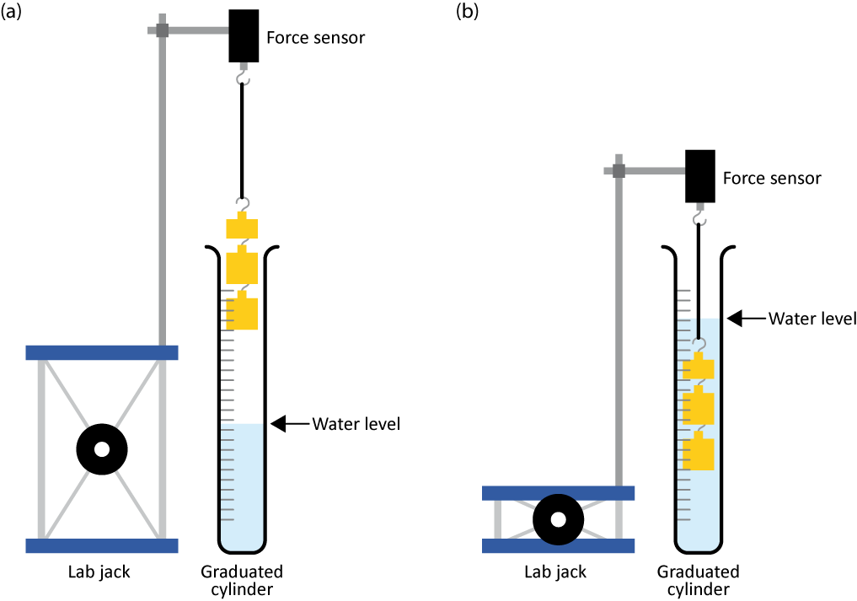

Figure - (a) A series of masses are suspended to a force sensor above a graduated cylinder partially filled with water. (b) As the masses are immersed into the water, the volume of displaced water and the apparent weight can be measured.

For the next few steps, there is only one setup per classroom. **Your TA will do a quick (less than 1 min) and very simple measurement for you.** This setup simply consists of a mass of 500 g suspended above a beaker of water on top of an electronic balance You need to understand what is going on and to record the mass value indicated by the balance.

1. With the mass above the water level and the beaker of water on the balance, zero the balance.
2. Lower the mass until it is completely covered with water but not touching the bottom of the beaker.
3. Let the mass equilibrate and record the value on the balance. You will use this value to calculate the volume of the mass, which is irregular and difficult to measure otherwise.

### Cleaning up your station

1. If you locally saved your files, send them to yourself by email. Pick up your USB key if you used one to save your files. Turn off the computer.
2. Put back the cylinder and measuring instruments all together on your table.
3. Throw away the water in your graduated cylinder in the sink in front of the classroom. Let your cylinder dry near the sink. Use brown paper to dry the suspended masses.
4. Recycle scrap paper and throw away any garbage. Leave your station as clean as you can.
5. Push back the monitor, keyboard and mouse. Also please push your chairs back under the table.