# Simple measurements & free fall

## Introduction

The purpose of this experiment is to practice basic experimental measurements, calculation techniques and result presentation methods (tables, graphs, etc.) that will be useful during the whole semester. Most of the subjects covered during this experiment are presented in the following tutorials available in the *Tutorial* section on the virtual campus ([Brightspace physics laboratory website](https://uottawa.blackboard.com/)):

* *Measuring techniques*
* *Experimental errors*
* *Propagation of errors*
* *Repeated measurements*
* *How to present a calculation example*
* *How to prepare a graph*
* *How to prepare a table*

### Part 1 – Length measurement

In this part, you will make length measurements using a meter stick and a vernier caliper. You will learn how to report the uncertainty of your measurements and how to use them to perform error calculations when calculating the density of some unknown materials.

### Part 2 – Time measurement

For this part, you will carry out several time measurements of the period of oscillation of a mass-spring system. You will use these repeated measurements to calculate statistical quantities such as the average, the standard deviation and the standard error.

### Part 3 – Picket fence free fall

In this last part, you will use automated data acquisition to determine the velocity of a free falling object as a function of time ($v\left(t\right)=v_{o}+at$). We say an object is in free fall when the only force acting on it is the Earth’s gravitational force. No other forces can be acting; in particular, air resistance must be either absent or so small as to be ignored. When the object in free fall is near the surface of the earth, the gravitational force on it is nearly constant. As a result, an object in free fall accelerates downward at a constant rate. This acceleration is usually represented with the symbol $g$ and has a value of 9.81 m/s2­.

In this experiment, you will have the advantage of using a very precise timer connected to the computer and a photogate (see Figure 1). The photogate has a beam of infrared light that travels from one of its arms to the other. The Logger Pro software can detect whenever this beam is blocked. You will drop a piece of clear plastic with evenly spaced black bars on it, called a *Picket Fence*, through the photogate. As the Picket Fence passes through the photogate’s arms, the computer will measure the time from the leading edge of one bar blocking the beam until the leading edge of the next bar blocks the beam. This timing continues as all eight bars on the fence pass through the photogate. From these measured times, the software will calculate the velocities and accelerations for this motion. Using a graph of $v$ vs. $t$, you will analyse your data and use a linear regression tool to determine the value of the gravitational acceleration $g$.

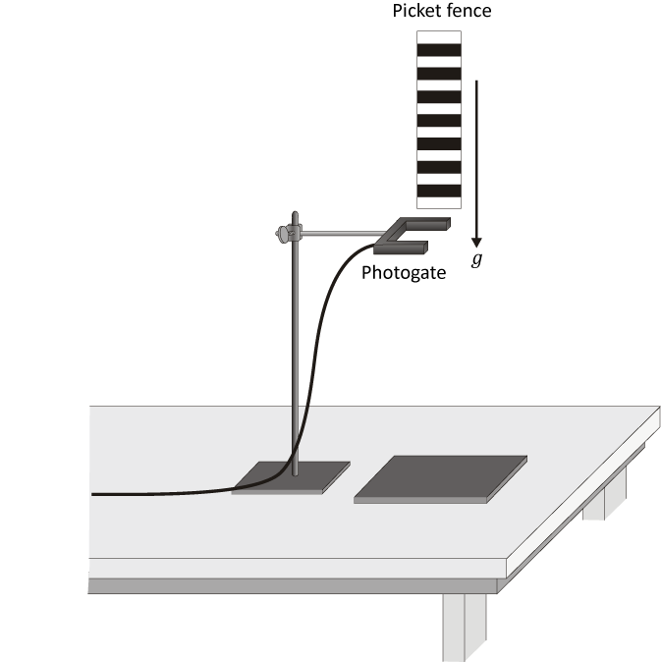

Figure - Picket fence free falling through a photogate

### Suggested reading

|  |  |  |
| --- | --- | --- |
| **Students taking** | **Suggested reading** | |
| PHY 1121 | Chapter 2 | Young, H. D., Freedman, R. A., *University Physics with Modern Physics, 14th edition*. Addison-Wesley (2014). |
| PHY 1321-1331 PHY 1124 | Chapter 2 | Serway, R. A., Jewett, J. W., *Physics for Scientists and Engineers with Modern Physics, 9th edition*. Brooks/Cole (2013). |

## Objectives

### Part 1 – Length measurement

* Familiarize yourself with different measuring instruments such as the meter stick and the vernier caliper.
* Take measurements with associated uncertainties then perform some error calculations based on length measurements (including propagations of error).
* Prepare a proper table to report measurements and results.
* Form a conclusion based on your experimental results by calculating the densities of metallic objects and determining their metal types from a table.

### Part 2 – Time measurement

* Calculate the period of oscillation of a mass-spring system.
* Calculate the average, the standard deviation and the standard error of repeated measurements.
* Learn how to describe and account for variation in a set of measurements.
* Learn how to describe a range of experimental values.

### Part 3 – Picket fence free fall

* Determine the value of the acceleration of a freely falling object using a picket fence and a photogate.
* Prepare a proper graph using Logger Pro and use the linear regression tool.
* Compare a measured value with the accepted value.

## Materials

* Meter stick and vernier caliper
* Objects to measure the dimensions (rectangular prism and hollow cylinder)
* Stopwatch
* Mass-spring system (200 g mass)
* Electronic balance (one per classroom)
* Computer equipped with *Logger Pro* and a Vernier computer interface
* Photogate, picket fence and foam mat
* Universal support and clamp holders

## Safety warnings

Be careful not to drop the mass on your foot (you should always be wearing covered shoes in a lab). Do not overstretch the spring to prevent the mass from falling. The spring can easily be damaged with carelessness. Be careful when dropping the picket fence as it can bounce off the table and strike you.

## References for this manual

* Gastineau, J., Appel, K., Bakken, C., Sorensen, R., Vernier, D., *Physics with Vernier*. Vernier software and Technology (2007).
* Dukerich, L., *Advanced Physics with Vernier – Mechanics*. Vernier software and Technology (2011).

## Procedure

### Part 1 – Length measurement

Your T.A. will give a demonstration of the correct use of the different instruments at the beginning of the class. Refer to the tutorial *Measuring techniques* for further instructions on how to properly use each measuring instrument. Refer to the tutorial *Experimental errors* to learn how to perform error calculations.

1. Measure the mass of the rectangular prism. Record it in Table 1.
2. Record the dimensions of a rectangular prism using two different instruments in Table 2.
3. Using the vernier caliper, measure the length, the outer diameter and the inner diameter of the hollow cylinder (Table 3). Measure its mass (Table 1).

### Part 2 – Time measurement

1. Using a spring and a 200 g mass, measure the total time for 10 oscillations. Keep the amplitude of your oscillations small (a few cm).
2. Repeat this measurement 5 times and complete Table 4.

### Part 3 – Picket fence free fall

In this experiment, you will use the Logger Pro software to record the elapsed time between some regularly occurring events. As illustrated in Figure 1, a picket fence (a strip of clear plastic with evenly spaced dark bands) is free falling through a photogate, a device that notes when the infrared beam of the photogate is blocked by a dark band and measures the time elapsed between successive blocked states. The software uses these times and the known distance from the leading edge of a dark band to the next to determine the velocity of the picket fence as it falls through the photogate. You will be trying to figure out how the elapsed time from blocked state to blocked state changes as the picket fence accelerates in free fall through the photogate.

1. Launch the Logger Pro program.
2. Check to see if the sensor is working by passing your hand between the infrared LED and the detector. The “GateState” should change from Unblocked to Blocked. This is shown near the top left of your screen.
3. Make sure that the arms of the photogate are horizontal as in Figure 1.
4. Set up data collection. Choose Experiment 🡪 Data Collection… from the menu. In the Mode list, select Digital Events. End timing after 16 Events. Choose File 🡪 Preferences… from the menu and set the Default Precision for automatic curve fits to four decimal places.
5. Change the graph setup to view only the velocity vs*.* time graph. Arrange your graph to get a proper graph according to the tutorial *How to prepare a graph*.
6. Make sure to align the foam mat with the photogate to cushion the picket fence as it strikes the surface.
7. Hold the picket fence vertically just above the photogate, press Collect, and release the picket fence. Make sure that it does not strike the photogate as it passes through the arms. Repeat if necessary until you get an acceptable data set.
8. Perform a linear fit on the graph of velocity vs. time. Select the graph, click Analyze then Linear Fit. Right-click on the linear fit information box and select Linear Fit Options…. Check the box: Show Uncertainty and click OK. Use the uncertainty from the information box to report your fit results. Arrange your graph with the fit results clearly displayed.
9. Examine your data in the table and try to understand how the velocity is calculated.
10. Save your Graph 1.

* Click File then Page Setup… and select the Landscape orientation. Click OK.
* Select File then Print Graph…. When the printing options windows opens, add your name and the one of your partner(s) in the field Name:. Click OK.
* Make sure to select the CutePDF as a printer and click OK again.
* Save your graph on the computer. You will need to print this graph before submitting your report, so you should either send the file to yourself by email or transfer it to a USB key.

1. We strongly recommend that you save all the work you do during the lab in case you need to review it later. Click File/Save As… to save your experiment file (suggested name: *FreeFall _YOUR_NAMES.cmbl*). You can either send the file to yourself by email or save it on a USB key.
2. Write down the slope and y-intercept from your linear regression in Table 5 (trial 1). Click Experiment then Store Latest Run. Repeat the experiment 4 more times to complete Table 5. You do not have to print a graph for all five trials but you should store each run and save your experiment.

### Cleaning up your station

1. If you locally saved your files, send them to yourself by email. Pick up your USB key if you used one to save your files. Turn off the computer.
2. Put back the objects and measuring instruments all together on your table. Put the 200 g mass back on your table. Put back the picket fence and the foam mat where they were at the beginning of the lab session.
3. Recycle scrap paper and throw away any garbage. Leave your station as clean as you can.
4. Push back the monitor, keyboard and mouse. Also please push your chairs back under the table.