determines the rate at which the electrical charges move (current).

The amount of droplets passing a given point in one second is analogous to the electrical current, which corresponds to the number of electrons (with a total charge measured in Coulombs) that pass a given point in one second. The unit of current is Amperes. The diameter of the water pipe can relate to the resistance of an electrical component. The larger the diameter of the pipe, the greater the flow rate of water is (the smaller the diameter, the smaller is the flow rate). Assuming the applied voltage is the same, thicker wires of the same material can carry more current. The resistance is the ability to restrict the current flow which is measured in Ohms ($Ω$).

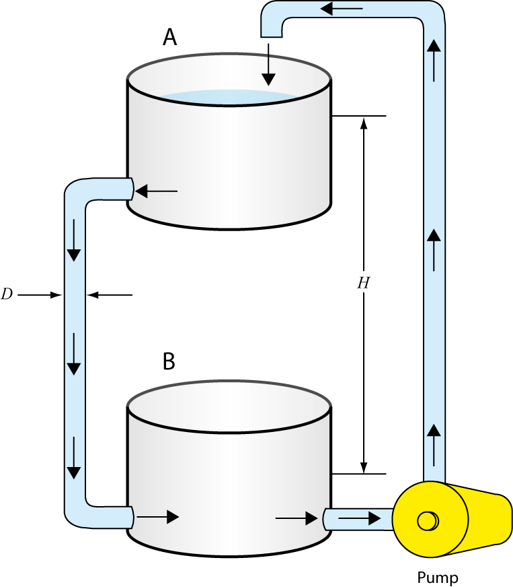  
Figure - Analogy of water flow and electric current for a resistor

### Current convention

In the wires of electrical circuits, negatively-charged electrons carry the current. However, in other devices such as batteries, positively-charged ions may also contribute to the current. Positive charges move in the opposite direction to that of the electrons. Historically, the direction of electrical current is taken to be that of positive charges.

### Ohm’s law

Ohm’s law describes the relationship between electric potential, current, and resistance. In this experiment, you will examine how combinations of voltages and resistors affect both the energy and the flow rate of charge in electrical circuits. Ohm’s law states that the voltage difference, $∆V$, across two points of an element is directly proportional to the current, $I$, going through the element:

|  |  |  |
| --- | --- | --- |
|  | $$∆V=RI ,$$ |  |

with $R$ being the resistance of the element as discussed above. Ohm’s law implies that a plot of voltage as a function of current in a circuit can be used to determine the resistance (the slope of the straight line graph equals the resistance). The resistance value of commercial resistor can be obtained from colored bars printed on it (see the *Tutorial - Using a multimeter*) or measured using an Ohmmeter. For combinations of more than one resistor, methods for calculating the total resistance will be investigated during this experiment.

### Kirchhoff’s rules

We can analyse a simple circuit using Ohm’s law and the rules for series and parallel combinations of resistors. For more complex circuits we use Kirchhoff’s rules. These two rules allow one to set up sets of equations which can be algebraically manipulated to solve for the unknown quantities (usually the current through all parts of a circuit).

***The Junction Rule (Conservation of Charge):***

*The sum of the currents entering any junction must equal the sum of the currents leaving that junction. A junction is any point in a circuit where the current is split or is re-joined. This first rule is a statement of conservation of charge. Whatever current enters a given point in a circuit must leave that point because charge cannot build or disappear.*

***The Loop Rule (Conservation of Energy):***

*The sum of the potential energy differences (voltage changes) across each element around any closed circuit loop must be zero.*

The initial step in applying Kirchhoff’s rules is to choose the direction of flow for all the currents of the circuit. In the example shown in Figure 2, we can be certain of these directions of flow. In more complex circuits the directions must be “guessed” and if a final result leads to a negative current, then the magnitude is still correct but we know the direction must be changed. If we apply the junction rule to the example circuit shown, we find at the junction labelled by point “*c”* we get;

|  |  |  |
| --- | --- | --- |
|  | $I_{1}=I_{2}+I_{3}$. |  |

We know that at point “*d”* the two currents re-join and should be equal to $I_{1}$. Applying the junction rule at point “*d”* would just give the same equation and thus no new information. The Loop Rule will be needed to continue. The second rule is equivalent to the law of conservation of energy. Any charge that moves around a closed loop in a circuit, on returning to its original point will have the same potential energy or V (voltage) with which it started. It must gain as much energy as it loses.

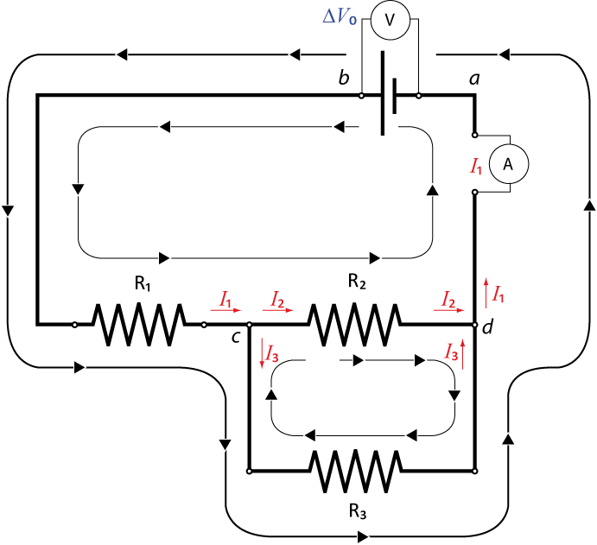

Figure – Currents in a mixed circuit to analyze it using Kirchhoff’s rules

A charge’s energy may decrease across a resistor by $∆V= -IR$ or increase by flowing through a power source such as a battery from negative (–) to positive (+). However, when the charge reaches the starting point of a loop, its energy will be back to its original level.

In the circuit shown in Figure 2, there are three possible loops that could be used to build conservation of energy equations. However since we have three unknowns to find ($I_{1}$, $I_{2}$, $I_{3}$) and already have one independent equation (from the Junction Rule, $I_{1}=I_{2}+I_{3}$), we only need two additional loops to get two more equations. (i.e. with three independent equations one can algebraically solve for three unknowns). Thus two loops are chosen as indicated in the Figure 2 (the loops are shown inside the circuit).

For the larger loop, one starts at point “*a”* at zero potential and travels through the power source from negative (–) to positive (+), giving a voltage rise of ${∆V}_{0}$. Passing through the first resistor gives a voltage drop that depends on $I_{1}$ namely, $∆V = -R_{1}I_{1}$. In this loop the next resistor to go through gives the final voltage drop of $∆V = -R_{2}I_{2}$ and then we return back to point “*a”*. Thus the second equation is:

|  |  |  |
| --- | --- | --- |
|  | $${∆V}_{0}-R_{1}I_{1}-R_{2}I_{2}=0.$$ |  |

The second loop chosen has no source of potential but if we examine the behaviour of a test charge forced around this loop, its potential will drop when passing through a resistor in the same direction as the current OR will rise if going the opposite direction of the current (like going up or down a waterfall). Thus if we pick point “*c”* as the starting point then we are traveling with the current through resistor $R_{2}$ (voltage drops) and go against the current through resistor $R_{3}$ (voltage rises) and we return back to “*c”*. This gives the equation:

|  |  |  |
| --- | --- | --- |
|  | $$-R_{2}I_{2}+R_{3}I_{3}=0.$$ |  |

We now have three equations (eqs. 2, 3, and 4) and three unknowns ($I_{1}$, $I_{2}$, $I_{3}$). You can now choose any way to solve the three equations and determine the unknown currents.

## Capacitors in circuits

### Analogy to the capacitor in electrical circuit

An example of a capacitor (shown in Figure 3), is a hollow sphere which is divided into two equal volumes, A and B, with a flexible rubber circular sheet separating them. The sphere is filled with water and it has two valves. The two valves are connected to a pump. When you turn on the pump, it pulls water from division A and pushes it into division B. As a result of the work done on the water, the rubber sheet is distorted and an elastic energy is stored in it. Divisions A and B are analogous to the two plates of the capacitor. The pump is analogous to the battery. The rubber sheet is analogous to the dielectric material between the plates. The elastic energy stored in the rubber sheet is analogous to electrical energy stored in the capacitor. It is important to mention that we did not add water to the sphere; we transfer water from A to B. The result is storing elastic energy. Similarly, we do not add charges to the capacitor when we “charge” it, we simply transfer charges from one plate to the other. The result is storing electrical energy in the capacitor.

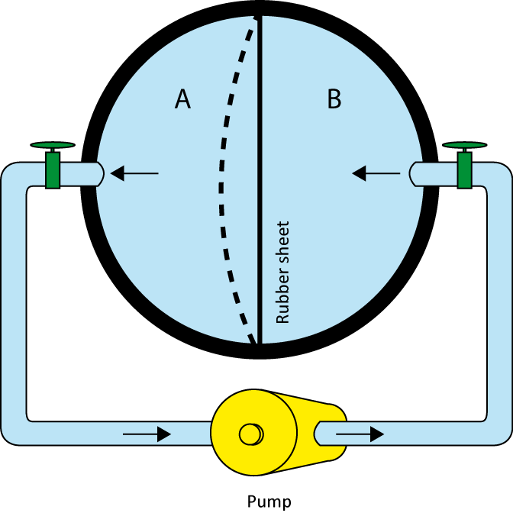  
Figure - Analogy of water and electric current for a capacitor

### RC circuit (resistor-capacitor)

In this experiment we investigate the behaviour of circuits containing a resistor and a capacitor in series. The rate of decrease of charge in the capacitor at any instant is proportional to the charge remaining at that time. The only function having the property that its rate of change (i.e., its derivative) is proportional to the function itself is the exponential function. If the initial charge is $Q_{0}$, then we can express the instantaneous charge in the capacitor using an exponential function:

|  |  |  |
| --- | --- | --- |
|  | $$Q=Q_{0}e^{{-t}/{RC}} ,$$ |  |

where $t$ is the time, $R$ is the resistance of the resistor, and $C$ is the capacitance of the capacitor (measured in Farads). The product $RC$ is called the time constant, or relaxation time of the circuit. As equation (5) shows, after a time $t_{0}$ equal to $RC$, the charge has dropped to a fraction $Q/{Q_{0}}=e^{-1}=0.368=36.8\%$ of its original value. The charge continues to drop by this ratio over any subsequent interval of time $t_{0}$.

### Suggested reading

|  |  |  |
| --- | --- | --- |
| **Students taking** | **Suggested reading** | |
| PHY 1122 | Section 24.2, Chapters 25 and 26 | Young, H. D., Freedman, R. A., *University Physics with Modern Physics, 13th edition*. Addison-Wesley (2012). |
| PHY 1322 | Section 26.3, Chapters 27 and 28 | Serway, R. A., Jewett, J. W., *Physics for Scientists and Engineers with Modern Physics, eight edition*. Brooks/Cole (2010). |
| PHY 1124 | Section 25.4, Chapters 26 and 27 | Halliday, D., Resnick, R., Walker, J., *Fundamentals of Physics, 9th edition*. Wiley (2011). |

## Objectives

### Part 1 – Measuring a resistance value

* Read the colour coded value of a resistor.
* Use an Ohmmeter.

### Part 2 – Ohm’s law

* Prepare circuits on a solderless breadboard.
* Use a voltmeter and an ammeter.
* Investigate all variables involved in the Ohm’s law relationship.

### Part 3 – Combination of resistors

* Investigate simple electrical circuits: series, parallel, and mixed.
* Understand the effective resistance concept.

### Part 4 – Voltages and currents in circuits (Kirchhoff’s rules)

* Experimentally verify the Kirchhoff’s rules of circuit analysis for a simple example.

### Part 5 – Combinations of capacitors & RC circuits

* Understand the effective capacitor concept.
* Observe how capacitors behave in RC circuits.
* Familiarize yourself with the use of an oscilloscope.

## Materials

* Computer equipped with *Logger Pro*
* Computer equipped with the National Instrument *myDAQ* virtual instruments
* National Instrument *myDAQ* data acquisition system
* Wire kit and breadboard
* Resistors (470 Ω, 1 kΩ and 3.3 kΩ) and capacitors (0.1 μF and 0.22 μF)

## Safety warnings

You should always disconnect your circuit from the power source to use the Ohmmeter. You should also always double check your circuit before adding the power source. In case of doubt, ask your TA to verify your circuit.

## References for this manual

* Dukerich, L., *Advanced Physics with Vernier – Beyond mechanics*. Vernier software and Technology (2012).
* *Basic Electricity*. PASCO scientific (1990).
* [User guide and specifications for the NI myDAQ](http://www.ni.com/pdf/manuals/373060e.pdf)

## Procedure

### Part 1 – Measuring a resistance value

1. Based on the colour codes in Table 1, identify the three resistors $R_{1}$, $R_{2}$ and $R_{3}$.
2. Using the resistor colour chart in the *Tutorial - Using a multimeter*, identify the resistance values of the three resistors and complete columns 3, 4 and 5 of Table 1.
3. Using the Fluke multimeter (the yellow one), measure the resistance values of the three resistors.   
    - Select the Ω symbol.   
    - Connect the black and red cable with alligator clips to both branches of one resistor.

- Record the resistance value and complete columns 6 and 7 of Table 1. Use an uncertainty of 1% to complete column 7.

1. Compare the colour coded value with your measurement and complete the last column of Table 1.

### Part 2 – Ohm’s law

1. Turn on your computer and launch the Digital Multimeter and the DC Level (power supply) programs (these programs should be available in the NIElvis folder from the computer’s desktop).
2. Assemble the circuit below using your 1 kΩ resistor, the Fluke multimeter as a voltmeter and the myDAQ multimeter as an ammeter. The power supply is the red and black wires labelled **AO0** and **AGND** coming out of your myDAQ unit. Refer to the tutorials in order to make the proper connections. Optional: Ask your TA to verify your circuit before going to the next step.

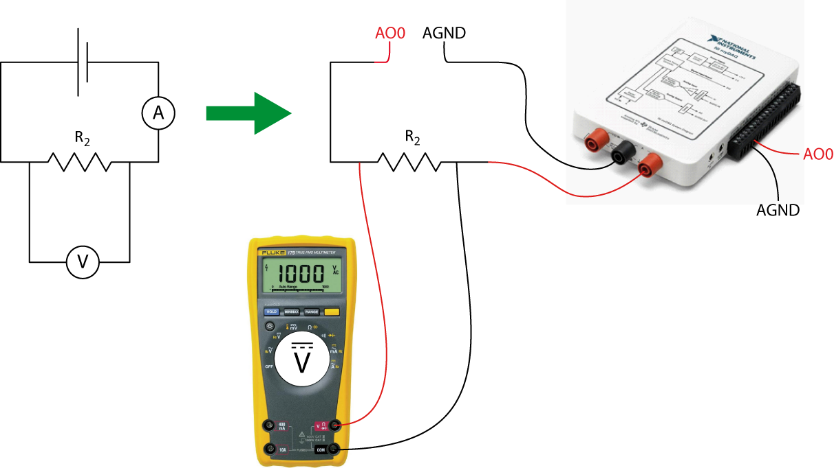

1. Select the DC current ammeter in the myDAQ multimeter window (third button in the Measurement Settings section). Select Auto in the Mode menu. Click Run to start making measurements.
2. Set the Voltage Level of the power supply to 0.25 V. Make sure the Channel Settings is set to myDAQ1/ao0. Click Operate then Run to turn the power on. Read the voltage and the current. Enter the values in Table 2.
3. Increase the voltage to by 0.25 V. Repeat the measurements and complete Table 2. Click STOP to turn off the power supply.
4. Launch the Logger Pro program. Prepare a graph of the Voltage at the resistor (in V) vs. Current (in A). This is your Graph 1. Arrange your graph to get a proper display according to the tutorial *How to prepare a graph*.
5. Perform a linear fit of Graph 1. Select the graph, click Analyze then Linear Fit.
6. Save your Graph 1.

* Click File then Page Setup… and select the Landscape orientation. Click OK.
* Select File then Print Graph…. When the printing options windows opens, add your name and the one of your partner(s) in the field Name:. Click OK.
* Make sure to select the CutePDF as a printer and click OK again.
* Save your graph on the computer.

1. We strongly recommend that you save all the work you do during the lab in case you need to review it later. Click File/Save As… to save your experiment file (suggested name: *Ohm_YOUR_NAMES.cmbl*). You can either send the file to yourself by email or save it on a USB key.

### Part 3 – Combination of resistors

1. Using the ohmmeter, measure the effective resistance of various combinations of resistors in series to complete Table 3. Assemble your resistors in series using the breadboard.
2. Using the ohmmeter, measure the effective resistance of various combinations of resistors in parallel to complete Table 4. Assemble your resistors in parallel using the breadboard.
3. Using the ohmmeter, measure the effective resistance of resistor 1 in series with resistors 2 and 3 in parallel (see below). Assemble this mixed circuit using the breadboard.

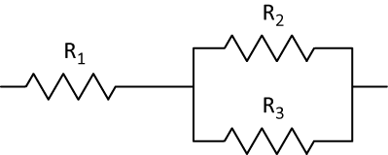

### Part 4 – Voltages and currents in circuits (Kirchhoff’s rules)

1. Add a power supply to the mixed circuit you just worked with. Set the power supply to 2 V, turn it on and measure the voltage drops (${∆V}_{0}$, $∆V_{1}$ and $∆V_{2//3}$) and the currents ($I_{1}$, $I_{2}$ and $I_{3}$) going through each branch of the circuit as labelled below. As before, use the Fluke voltmeter for your voltage measurements and the myDAQ ammeter to measure your currents. Turn off the power supply when you are done.

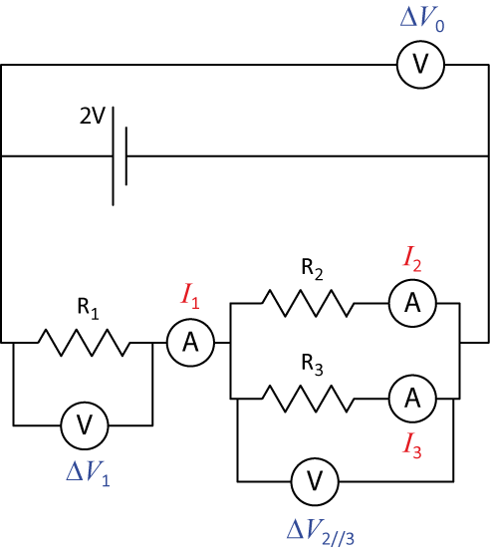

### Part 5 – Combinations of capacitors & RC circuits

1. Using the Fluke multimeter, measure the capacitance values of the two capacitors provided ($C_{1}$: 0.1 μF and $C_{2}$: 0.22 μF). Enter the values in Table 5.
2. Measure the effective capacitance of these two capacitors connected in series or in parallel. Assemble your capacitors using the breadboard and complete Table 5.
3. Make sure the DC Level power supply and the multimeter windows are turned off on your computer. Launch the Function generator and the Oscilloscope programs (these programs should be available from the NIElvis folder on the desktop).
4. Assemble the RC circuit below using your 1 kΩ res­­istor and the 0.22 μF capacitor.

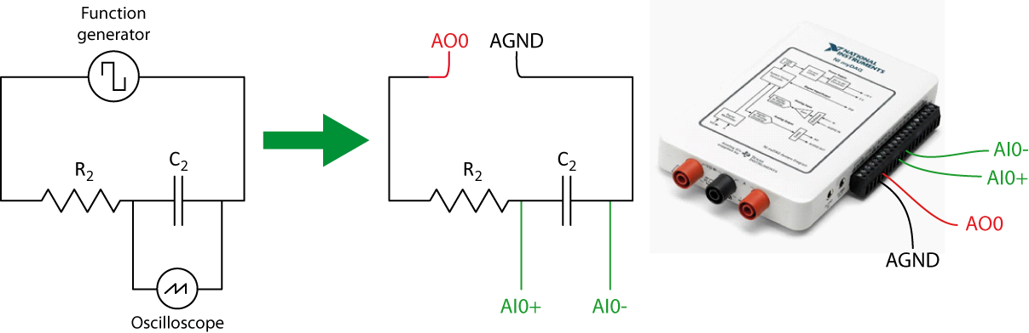

1. Set the function generator as follow:

|  |  |
| --- | --- |
|  | * Select the square wave. * Set the Frequency to 250 Hz. * Set the Amplitude to 0.8 V. * Set the DC Offset to 0.4 V. * Click Run. |

This means that the signal generator is applying a voltage of 0.8 V for the first half of each cycle (charging the capacitor) and a null voltage for the second half (discharging the capacitor).

1. Set the oscilloscope as follow:

|  |  |
| --- | --- |
|  | * Set the Scale Volts/Div to 200 mV. * Set the Time/Div to 500 μs. * Set the Trigger Type to Edge. * Select the negative slope and set the Level (V) to 0.4. * Click Run.   You should observe a complete cycle of charge and discharge of the capacitor as in the example on the left. |

1. Click Stop then click on the Log button in the bottom right corner of the oscilloscope to export the Voltage vs. Time data displayed on the oscilloscope.
2. **Download and open the Logger Pro template from Brightspace**. Click File/Import From/Text File…. Select the file you just exported from the oscilloscope. You should now see you charge/discharge voltage cycle.
3. The y-axis represents a voltage but the x-axis must be formatted. The values for the time axis have been created for you in the template (Data Set - Time). To change the x-axis of your graph to the Time column, click on the x-axis on your graph and select more. In the pop-up window select Time (seconds) for the axis. Under scaling, select Autoscale then press OK.
4. **Select only the discharge region on your graph**. Click Analyze/Curve Fit…. In the list of general equations, select A*exp(-Ct)+B. Click Try Fit then OK.
5. Record the value of the C parameter from your fit. Note that “C” does not refer to the capacitance; it is just a fit parameter as A and B used in the fit formula. You do not have to print that graph but you should show it to your TA to make sure you did the right manipulation of the data.
6. Use the C parameter and equation 5 to calculate the capacitance value of the capacitor in your circuit.

### Cleaning up your station

1. Submit your graph in Brightspace. If you locally saved your files, send them to yourself by email. Pick up your USB key if you used one to save your files. Turn off the computer.
2. Turn off the Fluke multimeter. Disassemble your circuit and put all wires, the three resistors, and the two capacitors back into your wire kit.
3. Please recycle scrap paper and throw away any garbage. Please leave your station as clean as you can.
4. Push back the monitor, keyboard and mouse. Also please push your chairs back under the table.