# Exp. 5 – Rotational dynamics

## Introduction

### Part 1 – Measuring the moment of inertia

When you studied Newtonian dynamics, you learned that when an object underwent some form of translational motion (whether in a straight line, parabolic, or circular path), the net force applied to the object is proportional to the acceleration. The constant of proportionality is the mass of the accelerating object. When a torque (the rotational analogue to force), is applied to an object that is free to rotate, the object will undergo rotational acceleration. In this experiment, you will investigate the relationship between torque, $τ$, and angular acceleration, $α$:

$$τ=Iα ,$$

where $I$ is the moment of inertia of the rotating object. For a cylinder rotating around its central axis, we have that $I={MR^{2}}/2$ with $M$ and $R$ being the mass and the radius of the cylinder, respectively.

We can experimentally measure the moment of inertia by applying a known torque on an object and by measuring the resulting angular acceleration. In this experiment, we will apply a series of torques and measure a series of corresponding angular accelerations to graphically determine the proportionality constant between the two, i.e., the moment of inertia.

The device you will use in this experiment, a rotary motion sensor, can directly measure the angle of a rotating platform as a function of time, $θ$ vs. $t$. This information can be used to determine the angular speed $ω={dθ}/{dt}$ and the angular acceleration $α={dω}/{dt}$. The applied torque on the system will be caused by weight hanging from a string that is wrapped around the base of the sensor as illustrated in Figure 1. In this configuration, the torque is given by $τ=rT$, where $r$ is the radius of the pulley around which the string is wound and $T$ is the tension in the string. The tension can be linked to the hanging mass using $mg-T=ma$, where $a$ is the acceleration of the hanging mass. Solving for *T*, we find that

$$τ=rT=mr\left(g-a\right)=mr\left(g-αr\right) ,$$

where we used $α=a/r$, the definition of the angular acceleration.

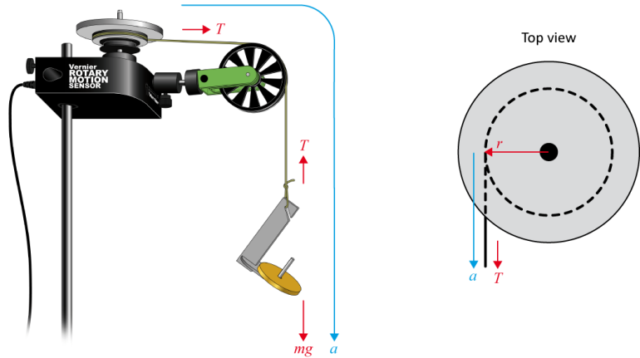

Figure 1 – Force and torque diagram to determine the moment of inertia

### Part 2 – Conservation of angular momentum

In your study of linear momentum, you learned that, in the absence of an unbalanced external force, the momentum of a system remains constant. In this experiment, you will examine how the angular momentum, $L=Iω$, of a rotating system responds to changes in the moment of inertia, $I$.

In this experiment, you will measure the angular momentum of a rotating disc and you will measure it one more time after dropping another disc on top of the rotating one. This situation is analogous to a completely inelastic collision between a moving cart (the rotating disc) and a stationary cart (the dropped disc).

Since the sensor used for this experiment gives us the angular speed, it is simple to measure the angular speed before, $ω$, and after, $ω^{'}$, the collision. The prime notation refers to quantities after the collision. The angular momentums are then calculated as

$$\underset{before the collision}{\underbrace{L=I_{1}ω}}=\underset{after the collision}{\underbrace{L^{'}=I_{1}ω^{'}+I_{2}ω^{'}}} ,$$

where $I_{1,2}$ are the moments of inertia of the two discs. Note that before the collision, only the first disc is rotating and the second disc is not contributing to the total angular momentum of the system.

### Suggested reading

|  |  |  |
| --- | --- | --- |
| **Students taking** | **Suggested reading** | |
| PHY 1121 | Chapter 9 and 10 | Young, H. D., Freedman, R. A., *University Physics with Modern Physics, 13th edition*. Addison-Wesley (2012). |
| PHY 1321-1331 | Chapter 10 and 11 | Serway, R. A., Jewett, J. W., *Physics for Scientists and Engineers with Modern Physics, eight edition*. Brooks/Cole (2010). |
| PHY 1124 | Chapter 10 and 11 | Halliday, D., Resnick, R., Walker, J., *Fundamentals of Physics, 9th edition*. Wiley (2011). |

## Objectives

### Part 1 – Measuring the moment of inertia

* Collect angular acceleration data for objects subjected to a torque.
* Experimentally measure the moment of inertia of an object.

### Part 2 – Conservation of angular momentum

* Collect angle vs. time and angular velocity vs. time data for freely rotating systems.
* Analyse the $θ$ vs. $t$ and $ω$ vs. $t$ graphs both before and after changes in the moment of inertia.
* Determine the effect of changes in the moment of inertia on the angular momentum of the system.

## Materials

* Computer equipped with *Logger Pro* and a Vernier computer interface
* Rotary motion sensor and accessories (pulley, discs, rod)
* Electronic balance (one per classroom)
* String and lightweight hooked mass set
* Vernier caliper

## References for this manual

* Dukerich, L., *Advanced Physics with Vernier – Mechanics*. Vernier software and Technology (2011).
* *Rotary Motion Sensor, Instruction Manual*. PASCO scientific.

## Procedure

### Part 1 – Measuring the moment of inertia

1. Turn on your computer and launch the Logger Pro program.
2. Attach a string to the edge of the large pulley on the sensor and attach the other end to the mass hanger for the lightweight masses as in Figure 1. Make sure to hang the string over the green pulley and that the hanger/hook can hang freely without touching the floor. Adjust the green pulley in order to horizontal string between the two pulleys.
3. Record the diameter of the largest pulley using the vernier caliper.
4. Find the mass and diameter of the first solid aluminum disc (no cork padding) then attach it to the 3-step pulley on the sensor. Use the longer machine screw.
5. The angle of the rotation sensor should be displayed on the bottom left of your screen. You will use the default data-collection rate in Logger Pro. Reduce the length of the experiment to 5 seconds (click Experiment 🡪 Data collection…).
6. Your first run will be without any additional mass on the hanger. Wind the string onto the largest pulley on the rotary motion sensor.
7. Start data collection then release the hanger. Catch the hanger when the string has completely unwound.
8. To determine the angular acceleration of the disc, perform a linear fit on the appropriate portion of the angular velocity vs. time graph. Record this value in Table 1 along with the mass of the hanger and weight for each value you use.
9. Repeat Step 6 to 8, increasing the mass of the hanging weight by 5 g to complete the first two columns of Table 1.
10. Find the mass of the second solid aluminum disc (the one with cork padding). Using the longer machine screw and sleeve, attach both discs to the 3-step pulley on the sensor. Repeat Step 6 to 9 and complete the first two columns of Table 2.
11. Remove the discs from the sensor. Find the masses of the rod and each of the weights (see figure below). Attach each of the weights to opposite sides of the rod at the ends of the rod.

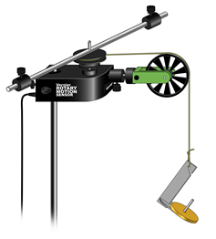

1. Increase the length of the experiment to 20 seconds (click Experiment 🡪 Data collection…).
2. Attach the rod and weights to the sensor. Repeat Step 6 to Step 9 and complete the first two columns of Table 3.
3. Prepare one graph (Graph 1) of the torque vs. the angular acceleration for the three data sets collected. You will need to calculate the torque for each data point. To do so:

* Click Data/New Manual Column… to create a column for the mass.
* Click Data/New Manual Column… to create a column for the angular acceleration.
* Fill these new columns with the data from Table 1.
* Click Data/New Calculated Column… to create a column for the torque.
* Enter a formula for the torque.
* Click Data/New Data Set.
* Enter your values from Table 2 in this new data set.
* Click Data/New Data Set.
* Enter your values from Table 3 in this new data set.
* Prepare one graph of the torque vs. the angular acceleration for the three data sets.
* Complete the third column of your tables.

1. Perform three linear regressions. Save your Graph 1 to a pdf file. Save your experiment file.

### Part 2 – Conservation of angular momentum

1. Mount your first aluminum disc to the pulley using the longer machine screw sleeve as illustrated below. This is the same setup that you used in the first section of Part 1 (but with no string).

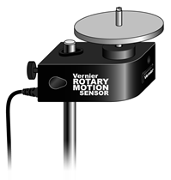

1. Set the data collection time to 10 seconds. Spin the aluminum disc so that it is rotating reasonably rapidly then begin data collection. Observe how the angular velocity gradually decreases while you are collecting data.
2. Position the second aluminum disc (cork pads down) over the sleeve of the screw holding the first disc to the pulley. Practice dropping the second disc onto the first (as illustrated below) to minimize any torque you might apply to the system. You should try this with both a stationary as well as a spinning bottom disc.

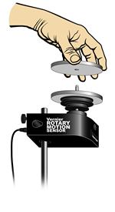

1. Begin the first disc rotating rapidly as before and begin collecting data. After a few seconds, drop the second disc onto the rotating disc and observe the change in both the $θ$ vs. $t$ and $ω$ vs. $t$ graphs.
2. Examine the $ω$ vs. $t$ graph. Determine the rate of change of $ω$ before you dropped the second disc onto the first. Do a linear fit of the region before the collision.
3. Record the angular velocity just before and just after you increased the mass of the system. To do so, select the interval representing the collision and click Analyze/Statistics. The information box will give you the maximum and minimum values within that interval (one is $ω$ before the collision and the other one is $ω^{'}$ after the collision, it depends on the direction of rotation). Determine the time interval ($∆t$) between these two velocity readings (the $∆x$ in the lower left corner gives the value of $∆t)$.
4. Prepare one graph (Graph 2) of the $ω$ vs. $t$ for this collision. The linear regression result and the statistics of the collision region should appear on your graph.
5. Save your Graph 2 to a pdf file. Save your experiment file.

### Cleaning up your station

1. Submit your graphs in Blackboard Learn. If you locally saved your files, send them to yourself by email. Pick up your USB key if you used one to save your files. Turn off the computer.
2. Put back the weights, the discs and rod-masses system on the table. You can leave the mass hanger attached to the sensor for students of the next lab session.
3. Recycle scrap paper and throw away any garbage. Leave your station as clean as you can.
4. Push back the monitor, keyboard and mouse. Also please push your chairs back under the table.