# Physical optics

## Introduction

The true nature of light has been, and continues to be, an alluring subject in physics. While predictions of light behaviour can be made with great success and precision, the wave/particle duality of light continues to defy a concrete physical or qualitative interpretation. In today’s experiment, the wave-like properties of light are examined.

Other types of waves such as sound or water waves have long shown the ability to bend around obstacles (diffraction) and to constructively or destructively interfere with each other. The very short wavelength of visible light made these properties difficult to observe and it took until the early 19th century for both diffraction and interference to be experimentally observed. However, the wave-like nature of light was still widely disputed even when J. A. Fresnel developed a mathematical description of diffraction and interference that fit with observations. Another scientist of the day, S. Poisson, ridiculed Fresnel’s work and showed that it lead to the prediction that all diffracted waves from the edge of a circular obstacle should arrive “in phase” at the centre of the obstacle’s shadow. This would lead to a predicted observation that Poisson called “absurd”. Soon after, this “absurd” observation was indeed made (you will see it today!) and helped establish a widespread acceptance of the wave-like nature of light.

### Diffraction from a single-slit

Waves being blocked by an obstacle can bend around it as can be seen in Figure 1a. If a narrow aperture (slit width $<λ$) is placed in front of an incident wave, a new wave will spread out on the opposite side as if the aperture were a new source of waves (Figure 1b). This spreading is known as diffraction. If the wavelength is small compared to the aperture (slit width $>λ$, as it will be today), the spreading of the wave is only partial (i.e. most light continues along its original path through the aperture).

For light waves impinging on only one slit, it is not obvious why there should be any interference pattern observed on a distant screen. A qualitative explanation of this comes from Huygen’s Principle which states that any point within the slit acts as a new source of waves. We can arbitrarily imagine 3 points in the slit as new wave sources as shown in Figure 2c. One can see that every wave source in the bottom half has a counterpart in the top half which is a distance $a/2$ away. The path difference between two wave sources at the distant observing screen can be calculated for an angle $θ$. The path difference is $(a/2)\sin{θ}$. If this path difference is equal to $λ/2$ then the waves arrive out of phase and destructive interference occurs between the two chosen waves. Since all waves originating in the bottom half have a counterpart $a/2$ away, there should be an overall destructive interference and a dark fringe at that angle. At other angles where there is not a complete symmetry of pathways that are $180°$ out of phase, bright areas appear on the screen. When such diffraction of light occurs as it passes through a slit, the angle to the minima in the diffraction pattern is given by

|  |  |  |
| --- | --- | --- |
|  | $a\sin{θ}=mλ (m=1, 2, 3…)$, |  |

where $a$ is the slit width, $θ$ is the angle from the center of the pattern to the th minimum, $λ$ is the wavelength of the light, and $m$ is the order (1 for the first minimum, 2 for the second minimum, . . . counting from the center out). See Figure 2a,c. Since the angles are usually small, we can use the small angle approximation and it can be assumed that $\sin{θ≈\tan{θ}}$. From trigonometry, $\tan{θ=y/D}$, where $y$ is the distance on the screen from the center of the pattern to the th minimum and $D$ is the distance from the slit to the screen as shown in Figure 2a,c. The diffraction equation can thus be solved to find the slit width:

|  |  |  |
| --- | --- | --- |
|  | $$a= \frac{mλD}{y} \left(m=1, 2, 3…\right).$$ |  |

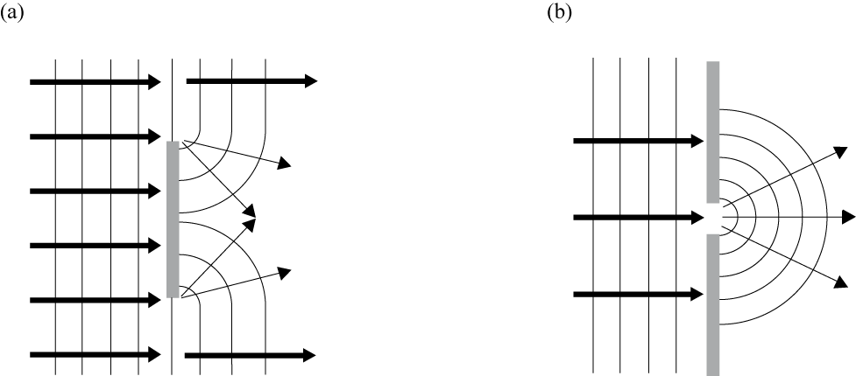

Figure 1 - The behaviour of light blocked by an obstacle (a) or a narrow aperture (b).

### Interference from a double-slit

As two waves cross each other, we expect to see interference in the region of the crossing where both waves are acting at once. Hence, the interference is the result of the linear superposition of two waves. At any specific point away from the source of waves, we will have constructive interference if two waves approach this point in phase and destructive interference if they approach this point out of phase.

To best observe diffraction and interference, a monochromatic and coherent light source is needed. All light waves emitted by a monochromatic light source have the same frequency and wavelength. Coherent light refers to light where all emitted waves begin with the same phase and travel together “in phase”. While most light sources are inherently incoherent, the laser provides an excellent source of coherent light which is also monochromatic.

An incident wave passing through a double-slit will spread out on the opposite side of each slit as two new sources of waves that can interact with each other. Looking at the interference produced by these two waves on a distant observation screen, we see that the path lengths to any point on the screen are unequal (except at the center of the screen). Thus, when light passes through a double-slit, the two light rays emerging from the slits interfere with each other and produce interference fringes on a screen. The angle to the maxima (bright fringes) in the interference pattern is given by

|  |  |  |
| --- | --- | --- |
|  | $d\sin{θ}=mλ (m=0, 1, 2, 3…)$, |  |

where $d$ is the slit separation, $θ$ is the angle from the center of the pattern to the th maximum, $λ$ is the wavelength of the light, and $m$ is the order (0 for the central maximum, 1 for the first side maximum, 2 for the second side maximum, . . . counting from the center out). See Figure 2b,d.

Again, since the angles are usually small, it can be assumed that $\sin{θ≈\tan{θ}}$ with $\tan{θ=y/D}$, where $y$ is the distance on the screen from the center of the pattern to the th maximum and $D$ is the distance from the slits to the screen as shown in Figure 2b,d. The interference equation can thus be solved to find the slit separation:

|  |  |  |
| --- | --- | --- |
|  | $$d= \frac{mλD}{y} \left(m=0, 1, 2, 3…\right).$$ |  |

While the interference fringes are created by the interference of the light coming from the two slits, there is also a diffraction effect occurring at each slit due to single-slit diffraction. This causes the envelope pattern as seen in Figure 2b,d (grey pattern).

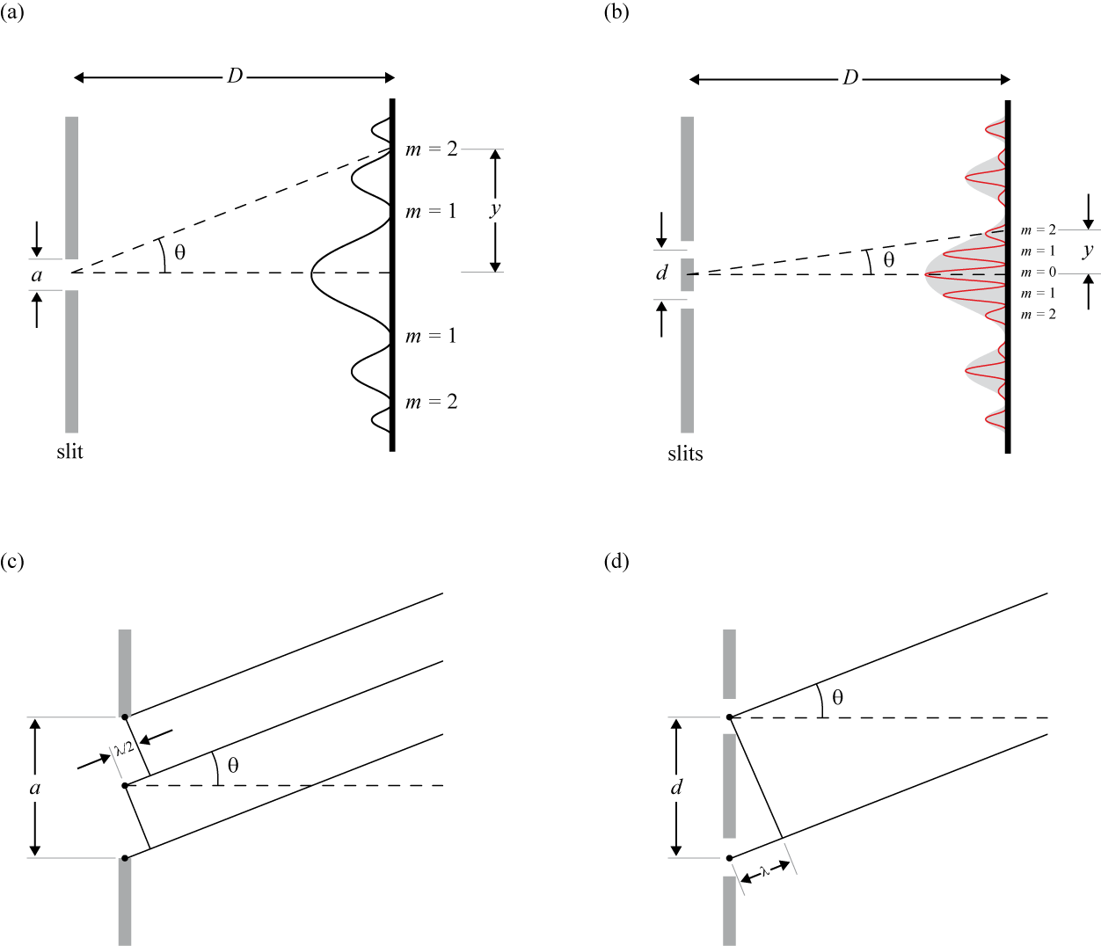

Figure 2 – (a) The single-slit diffraction pattern. (b) Interference fringes from a double-slit.   
(c) Diffraction geometry. (d) Interference geometry.

### Diffraction grating

Diffraction gratings are used to make very accurate measurements of the wavelength of light. In theory, they function much the same as two slit apertures but a diffraction grating has many slits, rather than two, and the slits are very closely spaced. By using closely spaced slits, the light is diffracted to larger angles and the spacing between areas of constructive interference can be measured more accurately. However, in spreading out the available light to large angles, brightness is lost. By using many slits, many sources of light are provided, and brightness is preserved.

The narrow apertures in a diffraction grating are separated by an equal distance, $d$. This breaks the incoming waves into numerous new waves spreading out and interacting with each other. Similar to double-slit interference, if the path difference is $λ$ or a multiple of $λ$, there will be constructive interference and a bright region on your screen. Therefore, we have:

|  |  |  |
| --- | --- | --- |
|  | $d\sin{θ}=mλ (m=0, 1, 2, 3…)$, |  |

for bright fringes.

### Polarization

A polarizer only allows light which is vibrating in a particular plane to pass through it. This plane forms the “axis” of polarization. Unpolarized light vibrates in all planes perpendicular to the direction of propagation. If unpolarized light is incident upon an “ideal” polarizer, only 50% of the light will be transmitted through the polarizer. Since in reality no polarizer is “ideal”, less than 50% of the light will be transmitted. The transmitted light becomes polarized in the “axis” of the polarizer. If this polarized light is incident upon a second polarizer (sometimes called an analyzer) whose axis is oriented perpendicular to the plane of polarization of the incident light, there will be no light transmitted through the analyzer.

However, if the analyzer is oriented at an angle so that its axis is not perpendicular to that of the first polarizer, there will be some component of the electric field of the polarized light that lies in the same direction as the axis of the second polarizer. Therefore some light will be transmitted through the second polarizer (see Figure 3). The component, $E$, of the polarized electric field, $E_{0}$, is found by:

|  |  |  |
| --- | --- | --- |
|  | $E=E_{0}\cos{φ}$. |  |

Since the intensity of the light varies as the square of the electric field, the light intensity transmitted through the second filter is given by Malus’s law:

|  |  |  |
| --- | --- | --- |
|  | $I=I_{0}\cos^{2}{φ}$ |  |

where $I_{0}$ is the intensity of the light passing through the first filter and $φ$ is the angle between the polarization axes of the two filters.

Consider the two extreme cases illustrated by this equation:

* If $φ=0$, the second polarizer is aligned with the first polarizer, and the value of $\cos^{2}{φ}=1$. Thus the intensity transmitted by the second filter is equal to the light intensity that passes through the first filter. This case allows a maximum intensity, $I=I_{0}$, to pass through.
* If $φ=90°$, the second polarizer is oriented perpendicular to the plane of polarization of the first filter, and $\cos^{2}{φ}=0$. Thus no light is transmitted through the second filter. This case allows minimum intensity, $I=0$, to pass through.

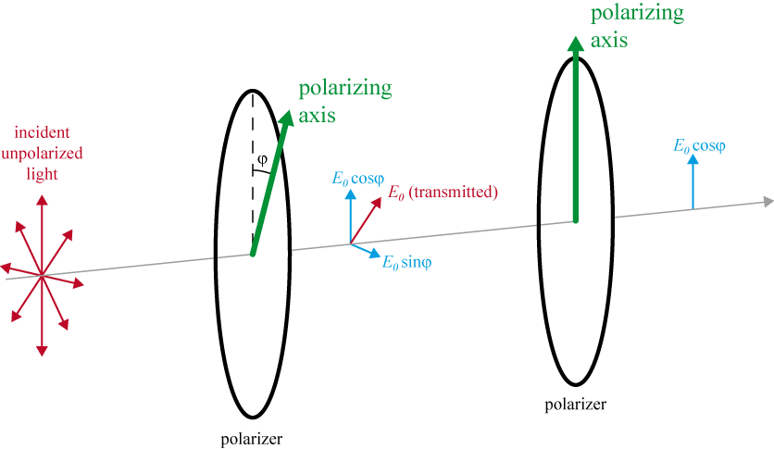

Figure 3 - Analyzing the polarization of light.

### Suggested reading

|  |  |  |
| --- | --- | --- |
| **Students taking** | **Suggested reading** | |
| PHY 1122 | Section 35.1-35.3, 36.1-36.5, 35.3 | Young, H. D., Freedman, R. A., *University Physics with Modern Physics, 13th edition*. Addison-Wesley (2012). |
| PHY 1322 | Section 37.1-37.3, 38.1-38.4, 38.6 | Serway, R. A., Jewett, J. W., *Physics for Scientists and Engineers with Modern Physics, eight edition*. Brooks/Cole (2010). |

## Objectives

### Single-slit vs. double-slit

* Examine the diffraction pattern formed by laser light passing through a single-slit and verify that the positions of the minima in the diffraction pattern match the positions predicted by theory.
* Examine the diffraction and interference patterns formed by laser light passing through two slits and verify that the positions of the maxima in the interference pattern match the positions predicted by theory.
* Compare the interference patterns formed by laser light passing through various combinations of slits.

### Diffraction grating

* Observe the diffraction pattern created using a diffraction grating and understand how it changes as we change the spacing of lines in the grating.
* Determine the wavelength of a monochromatic laser using a diffraction grating.

### The spectrum of white light

* Observe the dispersion of colours that compose the visible spectrum using a diffraction grating.

### The spectrum of the mercury lamp

* Use a diffraction grating to observe the spectrum of a mercury lamp.
* Determine the wavelengths that compose the spectrum of a mercury lamp.

### Diffraction around an obstacle

* Observe diffraction around a spherical obstacle.

### Polarization

* Determine the relationship between the intensity of the transmitted light through two polarizers and the angle, $φ$, between the axes of the two polarizers.

## Materials

* Computer equipped with *Logger Pro* and a Vernier computer interface
* Optical track
* Accessories to be used with the optical track:
  + white light source
  + laser
  + lens (10 cm double convex)
  + slit assembly
  + diffraction grating
  + large screen
  + series of 25 cm rulers printed on paper to be attached on the large screen
  + light sensor and light sensor holder
  + 2 polarizers

## Safety warnings

The intensity of the laser light is enough to cause eye damage if proper care is not taken. DO NOT look directly into the beam or point it at others. Brief accidental exposure to the eye should not cause damage but try to avoid ANY exposure. Turn the laser off when you are not using it.

## References for this manual

* Dukerich, L., *Advanced Physics with Vernier – Beyond mechanics*. Vernier software and Technology (2012).
* *Introductory optics system*. PASCO scientific.
* *Slit accessory for the basic optics system*. PASCO scientific.

## Procedure

### Single-slit vs. double-slit

1. Prepare the following setup on your optical bench:
   * The laser (red or green) already installed at one end of your bench (do not try to move the laser, it can stay there for the whole lab).
   * The diffraction slit assembly holder mounted $≈20$ cm away from the laser.
   * The screen at the 60 cm mark on the bench. Use the back page of the set of 25 cm rulers as a white screen.
2. Have a look at the slit assembly to understand what it is exactly. Look towards a window or a bright light to clearly see the different slits and apertures.
3. Turn the laser on and take a minute to understand how the back screws can be used to align the laser (one for vertical adjustment and one for horizontal adjustment). The laser should already be fairly well centered. **Do not overturn the adjustment screws**.
4. Put back the slit assembly on the bench and select the 0.04 mm single-slit. Align the laser using the adjustment screws to maximise the light intensity through the slit. You should be able to see several clear fringes on the screen.

1. Switch the slit assembly from the 0.04 mm single-slit to the 0.08 mm single-slit and observe the pattern on the screen. Describe how the pattern is changing as you increase the slit width. If possible, be quantitative in your description of what is changing.
2. Find the following double-slits on the slit assembly:
   * 0.04 mm (width) – 0.25 mm (separation);
   * 0.04 mm (width) – 0.50 mm (separation).

Align the laser with the first double-slits and switch back and forth between the two double-slits. Describe how the pattern is changing as you increase the distance between the slits. If possible, be quantitative in your description of what is changing.

1. Select the **Comparison Slits A**. You will now compare single-slit with a double-slits interference patterns. All slits have the same width of 0.04 mm. The two slits of the double slit are 0.25 mm apart. Using the adjustment screw, vertically adjust the laser to switch back and forth between the single-slit and the double slits. You can even try to see both patterns at the same time on the screen by centering the laser between the two.
2. Sketch the two patterns side-by-side roughly to scale. Describe how the pattern changes as you add a second slit of the same width.
3. For the double slit pattern, count how many bright fringes are in the center peak of the diffraction envelope. How many did you expect? Explain.

### Diffraction grating

The provided diffraction gratings (100, 300 and 600 lines/mm) have very fine lines, which have a small distance, $d$, between each slit.

1. Prepare the following setup on your optical bench:
   * The laser.
   * The diffraction gratings $≈20$ cm away from the laser (simply replace the slit assembly with the gratings assembly).
   * The screen with the series of 25 cm rulers at the 60 cm mark on the bench.
2. Select the 600 lines/mm grating. Slide the diffraction assembly towards the laser and align the rulers in order to see the fringes of order $m=0$ and $m=1$ on a single ruler. Make sure the pattern is aligned vertically with one of the rulers. Adjust the grating position in order to use as much of the ruler as possible. Adjust the angle of the screen in order to get a symmetric pattern.
3. Compare with the pattern when you switch to the 300 lines/mm grating. Explain how the pattern is changing. Repeat for the 100 lines/mm grating.
4. Switch back to the 600 lines/mm grating. You will now calculate the wavelength of the laser you are working with. Make sure the pattern is still aligned with one of the rulers.
5. Measure the length $y$ for the $m=1$ bright fringes. Measure the distance $D$ between the diffraction grating and the screen.
6. Since you know the distance between the lines of the grating (600 lines/mm), and since you also know that $d\sin{θ}=mλ$, find $λ$, the wavelength of the laser. You can use the small angle approximation: $\sin{θ}≈tan{θ}=y/D$.

### The spectrum of white light

1. Prepare the following setup on your optical bench:
   * The white light source mounted 10 cm away from the laser (do not try to remove the laser). Use the power supply of the laser to power the white light. The light source should have been left at the other end of the bench by the previous students.
   * The 10 cm double convex lens mounted 10 cm away from the light source.
   * The white screen at the 60 cm mark on the optical bench (use the back of the 25 cm rulers sheet).
2. Turn on the white light and set the rotating plate to the circular hole.
3. Adjust the position of the lens in order to focus the light on the screen.
4. Install the 600 lines/mm diffraction grating in the path of the light, about 20 cm away from the screen.
5. You should be able to observe the first order of diffraction of the white light. What do you observe? What is the relationship between the diffraction angles and the wavelengths? Note that the typical visible spectrum of wavelengths detected by the human eye goes from 400 to 700 nm (from violet to red).

### The spectrum of the mercury lamp

Now that you know how to calculate the wavelength of a monochromatic light source (your laser) and how to observe the different wavelengths present in a light source, you will now evaluate the specific wavelengths emitted by a mercury lamp.

1. Go see the setup showing the spectrum of a mercury lamp (only one in the classroom). This setup is similar to the one you use with your laser. The difference is that you should see the first order of diffraction for several different wavelengths (colours).
2. Make sure the setup is well aligned. Ask the TA to make sure you are observing the right thing.
3. Note the distance $D$ between the grating and the screen. Note the length $y$ for the first yellow, green and blue fringes.
4. Calculate the three wavelengths.

### Diffraction around an obstacle

1. This section is qualitative. Find the setup with the bead and the laser (only one in the classroom). The equipment used is a laser, a diverging lens, an alligator clip with a bead, and a white screen. The lens is used to diverge the laser light. The bead represents a spherical obstacle. As discussed in the introduction section, you should see the “absurd” result: a bright dot that Fresnel mathematically predicted in the center of the bead’s shadow which proved the wave nature of light.
2. Describe and explain your observations.

### Polarization

For this part, you will use the other portion of the optical bench. Two rotatable polarizers and a light sensor (connected to your computer) should be already installed on the bench.

1. Take the two polarizers off the optical track. Place one polarizing filter in front of the second so you have to look through both of them. Slowly rotate one of the polarizers. What do you notice?
2. Prepare the following setup on your optical bench:
   * The white light source mounted 10 cm away from the end of the track.
   * One polarizer 10 cm away from the light source.
   * The second polarizer and the light sensor about 20 cm away from the first polarizer. This polarizer should be as close as possible to the light sensor to reduce the amount of ambient light entering the sensor.
3. Set the principal axis of both polarizers to $0°$. The axis is marked by a small white line. You will rotate only the first polarizer to change the transmission. The second polarizer, the light source, and the light sensor must not move. Turn on the light source.
4. Make sure the light sensor is set to the **600 lux range**. This is done using the small box attached to the light sensor. Turn on your computer and **download the Logger Pro template from Brightspace**. The template enables you to quickly begin data collection.
5. First, set the analyzer (the first polarizer) to $90°$ so that the polarizing axes are at a right angle to each other. Very little light should get through the pair of filters. You will define this light level as zero by zeroing the light detector (click Experiment 🡪 Zero…). The intensity reading should now be near zero.
6. Return the analyzer to the parallel position ($0°$). Click Collect to begin data collection. Click Keep to take the first point and enter 0 for the angle. Click OK to complete the entry.
7. Rotate the analyzer by $15°$, click Keep, and enter 15 for the angle. Repeat this process, entering 30 for the next angle, and so forth, until you have rotated the analyzer through one full revolution, or $360°$. Click Stop to end data collection.
8. The transmitted light intensity vs. the angle between two polarizers is predicted by Malus’s law: $I=I_{0}\cos^{2}{φ}$. The top graph (Graph 1) shows the light intensity (Illumination) plotted against $\cos^{2}{φ}$. The bottom graph shows the intensity as a function of angle. Notice the sinusoidal shape.
9. Perform a linear regression in Graph 1. **Print** your Graph 1 to a pdf file. Make sure you use the printer CutePDF to print the graph.
10. We strongly recommend that you save all the work you do during the lab in case you need to review it later. Click File 🡪 Save As… to save your experiment file (suggested name: *polarization_YOUR_NAMES.cmbl*). You can either send the file to yourself by email or save it on a USB key.
11. Record the slope and the Y-intercept of your Graph 1. Are your results consistent with Malus’s law?

### Cleaning up your station

1. Submit your graph in Brightspace. If you locally saved your files, send them to yourself by email. Pick up your USB key if you used one to save your files. Turn off the computer.
2. Make sure the white light source is turned off. Leave the white light source, the polarizers and the light sensor on the optical track (as they were for the polarization part of the experiment).
3. Make sure the laser is turned off. Leave diffraction grating holder on the optical bench.
4. You can push the bench towards the middle of the table. Leave the diffraction slit assembly and the 10 cm double convex lens nearby the bench.
5. Recycle scrap paper and throw away any garbage. Leave your station as clean as you can.
6. Push back the monitor, keyboard and mouse. Also please push your chairs back under the table.