# Motion on a linear air track

### Identification page

**Instructions:** Print this page and the following ones before your lab session to prepare your lab report. Staple them together with your graphs at the end. If you forgot to print it before your lab, you can reproduce it by hand but you have to follow the exact format (same number of pages, same items on each page, same space to answer question).   
  
Complete all the identification fields below or 10% of the lab value will be deduced from your final mark for this lab.   
  
For in-lab reports, hand in your report to your demonstrator at the end of the sessions or you will receive a zero for this lab.   
  
For take-home reports, drop your report in the right box or 10% of the lab value will be deduced from your mark. Refer to the *General information* document for the details of the late report policy.

|  |  |
| --- | --- |
| Experiment title: | Motion on a linear air track |
|  |  |
|  |  |
| Name: |  |
| Student number: |  |
| Lab group number: |  |
| Course code: | PHY |
|  |  |
| Demonstrator: |  |
|  |  |
| Date of the lab session: |  |
|  |  |
| Partner’s name: |  |

## Data sheet

**Instructions:** Use a pen to complete this section before the end of the lab session. Ask your TA to initialize your data before you leave the laboratory.

### Preliminary manipulations (simple motion on an incline)

[6] Prepare Graphs 1 and 2. Print them to a pdf file. Send the file to yourself by email or save it on a USB key. Print the graphs and attach them at the end of your report.

[1] What are the values of the $A$ and $B$ parameters in the quadratic equation in Graph 1? Provide the units.

|  |  |
| --- | --- |
| $A= ( ____________________ ± ____________________ )$ | $B= ( ____________________ ± ____________________ )$ |

[1] What are the values of $m$ (slope) and $b$ (Y-intercept) in Graph 2? Provide the units.

|  |  |
| --- | --- |
| $m= ( ____________________ ± ____________________ )$ | $b= ( ____________________ ± ____________________ )$ |

### Part 1 - Determining $g$ on an incline

[1] Record the thicknesses of the 3 discs using the vernier caliper. Provide the units.

|  |
| --- |
| Thickness of disc 1 = $( ___________________________ ± ___________________________ )$ |
| Thickness of disc 2 = $( ___________________________ ± ___________________________ )$ |
| Thickness of disc 3 = $( ___________________________ ± ___________________________ )$ |

[5] Fill the following table (you do not have to provide uncertainties for this table):

Table 1 - Acceleration of a glider sliding down various inclines

|  |  |  |  |  |  |  |  |
| --- | --- | --- | --- | --- | --- | --- | --- |
| **Track elevation** | **Measured height, $h$**  **(m)** | **Distance between the legs of the track, $d$**  **(m)** | $$\sin{θ} \\ \left(h/d\right)$$ | **Acceleration** | | | **Average acceleration (m/s2)** |
| **Trial 1 (m/s2)** | **Trial 2 (m/s2)** | **Trial 3 (m/s2)** |
| cm |  | 1.000 |  |  |  |  |  |
| $≈2$ cm |  | 1.000 |  |  |  |  |  |
| $≈3$ cm |  | 1.000 |  |  |  |  |  |
| $≈4$ cm |  | 1.000 |  |  |  |  |  |
| $≈5$ cm |  | 1.000 |  |  |  |  |  |

[4] Prepare Graph 3. Send the file to yourself by email or save it on a USB key. Print the graph and attach it at the end of your report.

### Part 2 - Investigating Newton’s second law

[1] Measure the mass of the glider with string attachment:

|  |
| --- |
| $M= ( ____________________ ± ____________________ )$ |

[5] Fill the following table (you do not have to provide uncertainties for this table):

Table 2 - Acceleration of a glider horizontally pulled by various forces

|  |  |  |  |  |  |  |
| --- | --- | --- | --- | --- | --- | --- |
| **Hanging mass description** | **Hanging mass, $m$**  **(g)** | $$m^{'}=\frac{m}{M+m}$$ | **Acceleration** | | | **Average acceleration (m/s2)** |
| **Trial 1**  **(m/s2)** | **Trial 2**  **(m/s2)** | **Trial 3**  **(m/s2)** |
| Empty hook |  |  |  |  |  |  |
| Hook + $≈5$ g |  |  |  |  |  |  |
| Hook + $≈10$ g |  |  |  |  |  |  |
| Hook + $≈15$ g |  |  |  |  |  |  |
| Hook + $≈20$ g |  |  |  |  |  |  |
| Hook + $≈25$ g |  |  |  |  |  |  |

[4] Prepare Graph 4. Send the file to yourself by email or save it on a USB key. Print the graph and attach it at the end of your report.

## Questions

**Instructions:** You can finish this section at home. We encourage you to start answering these questions while you are still in the lab and the TA is available to help you.

### Preliminary manipulations (simple motion on an incline)

[2] On Graph 2, identify the moment(s) when the glider was:

* being pushed by your hand;
* moving freely up the ramp;
* farthest from its initial position;
* rolling freely down the ramp.

[2] The slope of a graph represents the rate of change of the variables that were plotted. What can you say about the rate of change of the velocity as a function of time while the cart was rolling freely? In your discussion, you will give a name to this quantity. What is the significance of the algebraic sign of the slope?

|  |
| --- |
|  |
|  |
|  |
|  |
|  |

[1] What is the relationship between $A$ and $m$? Between $B$ and $b$?

|  |
| --- |
|  |
|  |
|  |

[2] Qualitatively sketch the position vs. time and velocity vs. time graphs you would get if the motion detector was placed at the other end of the track.

|  |
| --- |
|  |

### Part 1 - Determining $g$ on an incline

[1] Use the linear fit from Graph 3 to determine your experimental value for $g$ with uncertainty.

|  |
| --- |
| $g= ( ____________________ ± ____________________ )$ |

[1] Compare your value of $g$ with the accepted value of 9.81 m/s2. Calculate the percentage difference

$\%diff = \left|\frac{g_{accepted }- g_{experimental}}{g_{accepted }}\right|×100$,

and discuss.

|  |
| --- |
|  |
|  |
|  |

[1] In the linear fit of Graph 3, what is the physical meaning of the Y-intercept value?

|  |
| --- |
|  |
|  |
|  |

### Part 2 - Investigating Newton’s second law

[1] Use the linear fit from Graph 4 to determine your experimental value for $g$ with uncertainty.

|  |
| --- |
| $g= ( ____________________ ± ____________________ )$ |

[1] Compare your value of $g$ with the accepted value of 9.81 m/s2. Calculate the percentage difference

$\%diff = \left|\frac{g_{accepted }- g_{experimental}}{g_{accepted}}\right|×100$,

and discuss.

|  |
| --- |
|  |
|  |
|  |

[1] In the linear fit of Graph 4, what is the physical meaning of the Y-intercept value?

|  |
| --- |
|  |
|  |
|  |

[1] Do your results agree with Newton’s 2nd law?

|  |
| --- |
|  |
|  |
|  |

[2] Suppose that you have a situation with a combination of acceleration due to the inclined plane as well as the force of the weights as in Figure 1 bellow:

* Derive an equation that predicts the total acceleration of the glider.
* Derive an equation that will allow the system to be in equilibrium (i.e., glider is stationary) for a height, $h$.

|  |
| --- |
|  |

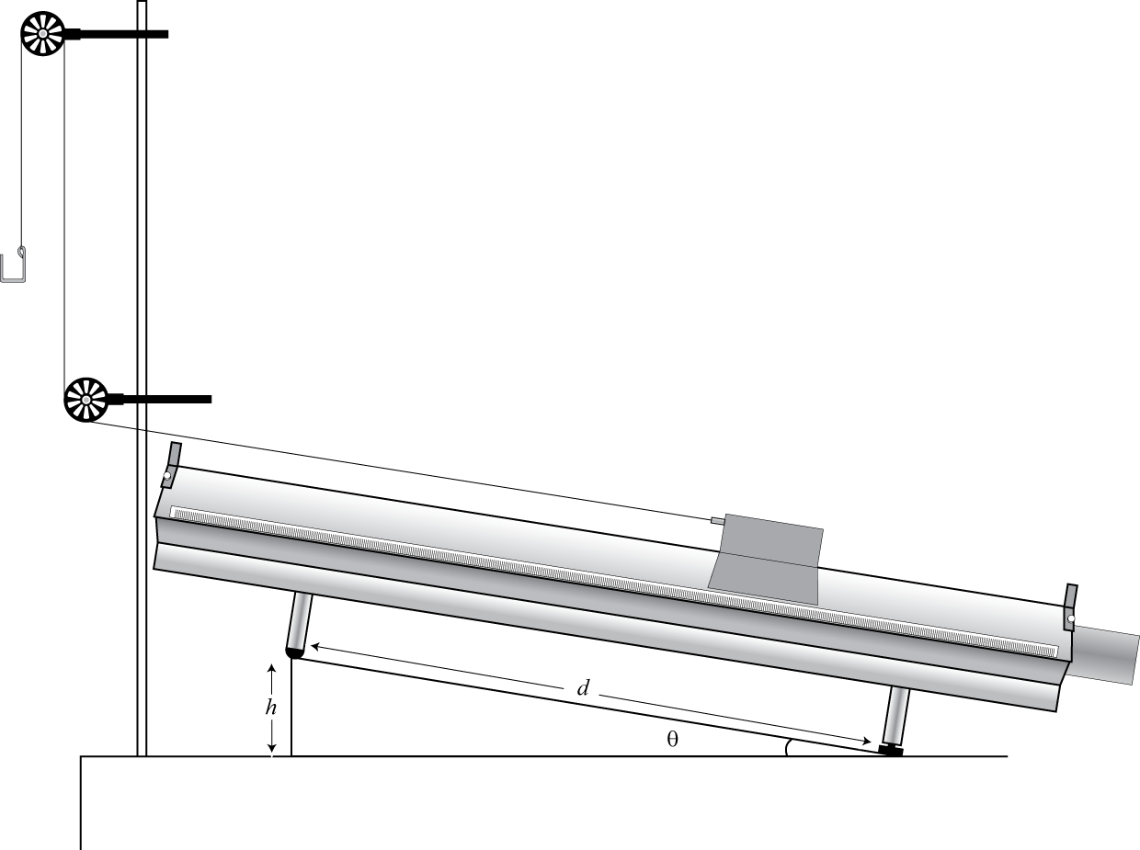

Figure 1 - Glider pulled by a constant force on an inclined air track.

Total : _______ / 44 (for the report)