# Motion on a linear air track

## Introduction

During the early part of the 17th century, Galileo experimentally examined the concept of acceleration. One of his goals was to learn more about freely falling objects. Unfortunately, his timing devices were not precise enough to allow him to directly study free fall. Therefore, he decided to limit the acceleration by using fluids, inclined planes, and pendulums. In this lab exercise, you will see how the acceleration of a cart sliding on a frictionless inclined plane depends on the ramp angle. Then, you will use your data to extrapolate the acceleration of the cart on a vertical “ramp”, that is, the acceleration of a body in free fall.

If the angle of an incline with the horizontal is small, a cart rolling down the incline moves slowly and its position can be easily measured. Using time and position data, it is possible to calculate the acceleration of the cart. As the angle of the incline is increased, the acceleration also increases. The acceleration is directly proportional to the sine of the incline angle, $θ$. A graph of acceleration versus $\sin{θ}$ can be extrapolated to a point where the value of $\sin{θ}$ is 1. When $\sin{θ}$ is 1, the angle of the incline is 90°. This is equivalent to free fall. The acceleration during free fall can then be determined from the graph.

Galileo was able to measure acceleration only for small angles. During the first part of this experiment, you will collect similar data. Can these data be extrapolated to experimentally determine a useful value for $g$, the acceleration of free fall? We will see how valid this extrapolation can be. Rather than measuring time, as Galileo did, you will use a motion detector to determine the position and velocity of a glider. You will make quantitative measurements of the motion of a glider sliding down inclines of various small angles. The incline you will use is a linear air-cushioned track producing almost frictionless one-dimensional motion. From these measurements, you should be able to decide for yourself whether the extrapolation to large angles is valid.

In the second part of the experiment, you will use the track to study the motion of a mass under a constant force to verify Newton’s second law of motion. Newton's first law of motion states that: if no net force acts on an object, the velocity of the object remains unchanged. The second law, on the other hand, deals with what happens when a net force does act on an object. This law of motion describes the behavior of everything that changes its motion due to a net force such as the trajectory of a baseball or the orbital motion of a planet.

While a net force acts on an object, the velocity of the object changes – in other words, it accelerates. When more force is applied, the greater force produces a greater acceleration. Newton's second law states that the acceleration is directly proportional to the net force acting on the object and is in the same direction as the net force. Newton's second law also states that the acceleration is inversely proportional to the mass ($\overset{⃑}{F}=m\overset{⃑}{a}$).

### Suggested reading

|  |  |  |
| --- | --- | --- |
| **Students taking** | **Suggested reading** | |
| PHY 1121 | Chapters 2 and 4, Section 5.2 | Young, H. D., Freedman, R. A., *University Physics with Modern Physics, 14th edition*. Addison-Wesley (2014). |
| PHY 1321-1331 | Chapters 2 and 5 | Serway, R. A., Jewett, J. W., *Physics for Scientists and Engineers with Modern Physics, 9th edition*. Brooks/Cole (2013). |

## Objectives

### Part 1 – Determining $g$ on an incline

* Use a motion detector to measure the speed and acceleration of a glider sliding down an incline.
* Determine the mathematical relationship between the angle of an incline and the acceleration of a glider sliding down the ramp.
* Determine the value of free fall acceleration, $g$, by extrapolating the acceleration vs. sine of track angle graph.
* Determine if an extrapolation of the acceleration vs. sine of track angle is valid.

### Part 2 – Investigating Newton’s second law

* Identify the forces acting on an object both when its change in velocity, $∆v$, is zero, and when it is accelerating.
* Collect force, velocity, and time data as a glider is accelerated along a track.
* Use graphical methods to determine the acceleration of the glider.
* Determine the relationship between the glider’s acceleration and the net force applied to it.
* Determine the effect of the mass on the relationship between acceleration and force.

## Materials

* Computer equipped with *Logger Pro* and a Vernier computer interface
* Motion detector
* Air track and accessories (air supply, hose, glider)
* Electronic balance (one per classroom)
* Spacers (one 1 cm and two 2 cm thick)
* Vernier caliper
* String and pulleys
* Table C-clamp with rod and clamp holders
* Lightweight hooked mass set

## Safety warnings

The air track is a fragile and expensive piece of equipment. Its surface must be free of defects in order to reduce the friction between the glider and the track to a minimum. Be careful to not hit the surfaces of the track with a hard object.

## References for this manual

* Gastineau, J., Appel, K., Bakken, C., Sorensen, R., Vernier, D., *Physics with Vernier*. Vernier software and Technology (2007).
* Dukerich, L., *Advanced Physics with Vernier – Mechanics*. Vernier software and Technology (2011).
* *Physics with the Xplorer GLX*. PASCO scientific (2006).

## Procedure

### Preliminary manipulations (simple motion on an incline)

1. Launch the Logger Pro program. When Logger Pro is launched, you should see two graphs: Position vs. Time and Velocity vs. Time. In the bottom left corner, you should see the position readout from the motion detector.
2. Turn on the air supply machine and adjust the power button so that your glider moves without friction. You are sharing your air supply with another team so make sure both teams are satisfied with the setting of the supply before moving forward with your experiment.
3. Level your track using the adjustable legs. Place the glider at the centre of the track. If the glider moves one way or the other, adjust the track to raise or lower one end. When the air track is properly leveled, the glider should be almost stationary (there is always a little bit of turbulence).
4. Make sure that the glider stopper (the velcro) is wrapped around the air track about 10 cm in front of the motion detector.
5. Make sure your motion detector is set to *track*: . The detector head pops up to allow this manipulation.
6. Align the motion sensor and make sure it is detecting the glider’s position wherever it is along the track.
   * Insert a 1 cm aluminum disc under the front leg of the air track.
   * In the *Logger Pro* menu, go to Experiment and then Data collection. Set the length of the measurement to 50 sec. Adjust the number of samples per second to 20 and then click Done.
   * Put the glider one meter in front of the sensor. Ensure the round disc attached to the glider is facing the motion detector. This disc is used to increase the surface area that the detector sees.
   * Hit Collect and release the glider. Make sure that the sensor is reading the position of the glider correctly as it accelerates down the track.
7. Keep the track tilted using the 1 cm aluminum disc. Starting with the glider at the bottom of the track, i.e., near the detector, practice launching the glider with your finger so that it slows to a stop at least 1 m from its initial position before it returns to the initial position. Once you are good at it, hit Collect and push the glider up the track. Be sure to catch it once it has returned to its starting position. Repeat, if necessary, until you get a trial with a smooth position-time graph.
8. Add the following titles to your graphs:

* Graph 1: Position vs. time on an incline
* Graph 2: Velocity vs. time on an incline

1. Perform a linear fit to the portion of the velocity vs. time graph where the cart was moving freely. Select the graph, click Analyze then Linear Fit. Move the cursors to select the free-motion portion of the graph.
2. The position-time graph of an object that is constantly accelerating should appear parabolic. Use the Curve Fit function of your data analysis program to fit a quadratic equation to that portion of the position vs. time graph where the cart was moving freely. Select the graph, click Analyze then Curve Fit and choose the quadratic equation ($Ax^{2}+Bx+C$). Arrange your graph with the fit results clearly displayed.
3. Adjust the time axis on both graphs in order to only show the free-motion section (plus a few seconds before and after).
4. **Print** your Graphs 1 and 2 to pdf files. Make sure to select CutePDF as the printer. We also strongly recommend that you save all the work you do during the lab in case you need to review it later. Click File/Save As… to save your experiment file (suggested name: *MotionOnAnIncline _YOUR_NAMES.cmbl*). You can either send these files to yourself by email or save them on a USB key.

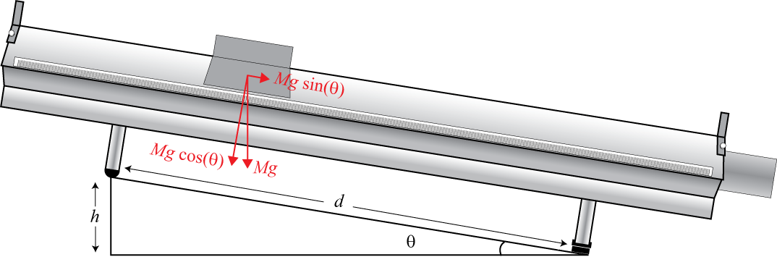

Figure 1 - Glider on an inclined air track

### Part 1 – Determining $g$ on an incline

This part of the experiment is illustrated in Figure 1. The vertical force due to the weight is $F=Mg$, where $M$ is the mass of the glider and $g$ is the gravitational acceleration. This force can be analyzed into a normal force on the plane, $N = Mg\cos{θ}$, and acceleration force, $Ma = Mg\sin{θ}$ (Eq. 1) where $θ$ is the angle between the normal vector and the gravitational acceleration vector. From Figure 1, we see that $\sin{θ}=h/d$ (Eq. 2). By substituting Eq. 2 into Eq. 1, we have $a={gh}/d$ (Eq. 3). We can use this relation to determine $g$ from the slope of a graph of $a$ vs. $h$ for a value of $d=1$ m. The friction force is neglected in the previous derivation.

1. Click File then New. In the *Logger Pro* menu, go to Experiment and then Data collection. Set the length of the measurement to 7 sec.
2. Measure the thickness of the 1 cm aluminum disc with the vernier caliper and put it back under the front leg of the air track. Measure the thicknesses of the 2 cm aluminum discs. Record these values. The thicknesses of the discs are used to calculate the elevation, $h$, of the track (see Figure 1).
3. Hold the glider at the top on the incline.
4. Click Collect to begin collecting data; release the glider after the motion detector is activated (you will hear soft clicking). You may have to adjust the position and aim of the detector several times before you get a smooth graph. Adjust and repeat this step until you get a good run showing approximately constant slope on the velocity vs. time graph during the free motion of the glider.
5. Logger Pro can fit a straight line to a portion of your data. First indicate which portion is to be used by dragging across the graph to indicate the starting and ending times. Click Analyze then Linear Fit to perform a linear regression of the selected data. Use this tool to determine the slope of the velocity vs. time graph, using only the portion of the data for times when the glider was freely moving. The correlation of the linear fit should be greater than 0.9800. To show uncertainty, double-click the information box of the slope and check Show Uncertainty. From the fitted line, find the acceleration of the glider. Record the value (with units) in Table 1.
6. Repeat the last two steps two more times (trials 2 and 3).
7. Raise the incline by 1 cm by switching the disc under the leg of the track and repeat the last three steps.
8. Repeat the last step for an elevation of $h$ = 3 cm, 4 cm and 5 cm.
9. Prepare a graph: Graph 3: Acceleration of the glider as a function of $\sin{θ}$ (of the incline).

* Select Page then Add Page… then click OK. Click Insert then Table.
* Add two manual columns (Data then New Manual Column…).
* Double click on your table and hide (uncheck) all columns except for the two new ones.
* Rename your columns and enter your values from your Table 1.
* Click Insert then Graph. Adjust the axes. Insert titles for the graph and the axes.
* Adjust the sizes of the table and graph windows in order to use as much space as possible.
* Perform a linear regression showing the slope along with its uncertainty.

1. **Print** your Graph 3 to a pdf file. Make sure to select CutePDF as the printer.   
   Save your experiment file (suggested name: *gOnAnIncline_YOUR_NAMES.cmbl*).

### Part 2 – Investigating Newton’s second law

In this part of the experiment illustrated in Figure 2, we will study the motion of a mass (glider) under a constant force. The constant force is provided by a small falling mass, $m$, (5 - 25 g). The force equation can be written as $F = mg = (M + m)a$ (Eq. 4), where $M$ is the mass of the glider. The gravitational acceleration can be determined from the slope of the graph of $a$ vs. $m/{\left(M+m\right)}$.

1. Remove the spacer under the leg of the track. For this part of the experiment, we will work with a leveled air track (see Figure 2).
2. Measure the mass of the glider together with the small string attachment. This is your value for $M$.
3. Put the glider on the air track at the pulleys’ end. Connect the string to the glider using the small attachment and loop the string up and down around the pulleys. Measure the mass of the hook then attach it to the end of the string. The hook must hang about 2 cm from the ground.
4. Bring the glider to the other end of the track (as far as the string will allow you to go).
5. Start collecting the data with only the empty hook pulling the glider. To do so, press Collect as your partner releases the glider. Repeat, if necessary, until you get a good run showing approximately constant slope on the velocity vs. time graph.
6. In the velocity vs. time graph, choose the linear area and fit it with a straight line like you did in the previous section. To show the uncertainty, double-click the information box of the slope and check Show Uncertainty. You can enlarge the graph so that the selected portion occupies the entire screen. From the fitted line, find the acceleration of the glider. Record the value in Table 2.
7. Repeat the last two steps two more times (trials 2 and 3).
8. Add 5 g to the hook and repeat the last three steps.
9. Repeat the last step until you reach a mass of 25 g on the hook.
10. Prepare a graph: Graph 4: Acceleration of the glider as a function of the dimensionless hanging mass, ${m^{'}=m}/{\left(m+M\right)}$.

* Select Page then Add Page…. Click Insert then Table.
* Add two manual columns (Data then New Manual Column…).
* Rename your columns and enter your values from your Table 2.
* Click Insert then Graph. Adjust the axes. Insert titles for the graph and the axes.
* Adjust the sizes of the table and graph windows in order to use as much space as possible.
* Perform a linear regression showing the slope along with its uncertainty.

1. Print your Graph 4 to a pdf file. Make sure to select CutePDF as the printer.   
   Save your experiment file (suggested name: *2ndLaw_YOUR_NAMES.cmbl*).

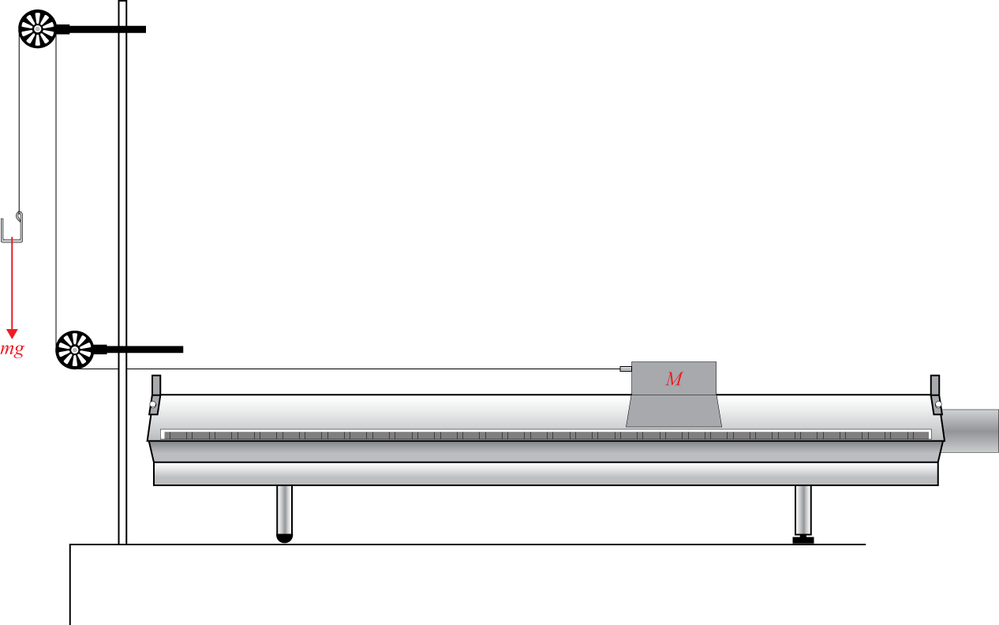

Figure 2 - Glider pulled by a constant force on a leveled air track

### Cleaning up your station

1. Turn off the air supply. If you locally saved your files, send them to yourself by email. Pick up your USB key if you used one to save your files.
2. Put back the spacers and the hooked mass set in the small plastic bin. You can leave the mass hanger attached to the string for students of the next lab session. If so, leave it nearby the C-clamp and the pulleys.
3. Please recycle scrap paper and throw away any garbage. Please leave your station as clean as you can.
4. Push back the monitor, keyboard and mouse. Also please push your chairs back under the table.