# Exp. 5 – Ideal gas law

## Introduction

We think of a gas as a collection of tiny particles in random, thermal motion. When they collide with the sides of a container, they exert a force on the container walls. The average force resulting from these collisions on each unit area of the container is called the pressure exerted by the gas. You are familiar with everyday units of pressure, such as psi (pounds per square inch) to describe tire pressure or inches of mercury to describe atmospheric pressure. For this experiment, we will use the SI unit of pressure, the Pascal (Pa), which is defined as one Newton of force acting on each square meter of surface. Since the Newton is smaller than a pound and a square meter is much larger than a square inch, we will use kilopascals, kPa, to describe the pressure of a gas.

In this experiment, you will develop quantitative relationships between pressure and the variables that are affecting the pressure of a gas in a container such as the temperature, the volume of the container and the number of gas molecules. One of Ludwig Boltzmann’s most remarkable achievements was the derivation of the equation of state, (from the principles of classical mechanics) that relates all these variable and describes the behaviour of an ideal gas:

$$PV = nRT ,$$

where $P$, $V$, and $T$ are the pressure, volume, and temperature of the gas, respectively. The amount of gas is given by the number of moles, $n$, and the constant of proportionality, $R$, is called the *Universal Gas Constant* ($R=$ 8.3145J/mol $∙$ K).

The reason that Boltzmann’s results were so startling is that most gases at low pressures, (i.e., $P≪$ 101.3kPa, the normal atmospheric pressure), exhibit the same physical behaviour. In this theory, it is assumed that the gas molecules are non-interacting spheres which collide elastically. Furthermore, one mole of most gases occupies approximately the same volume, $V_{0}$ = 22.4L, at atmospheric pressure of $P_{0}$ = 101.3kPa and at a temperature of $T_{0}$ = 273.15K (0 $℃$). The usefulness of these properties did not go unnoticed which is why gas thermometers are still presently among the most precise instruments for measuring temperature.

### Suggested reading

|  |  |  |
| --- | --- | --- |
| **Students taking** | **Suggested reading** | |
| PHY 1121 | Sections 17.2, 17.3 and 18.1 | Young, H. D., Freedman, R. A., *University Physics with Modern Physics, 13th edition*. Addison-Wesley (2012). |
| PHY 1321-1331 | Sections 19.3 and 19.5 | Serway, R. A., Jewett, J. W., *Physics for Scientists and Engineers with Modern Physics, eight edition*. Brooks/Cole (2010). |
| PHY 1124 | Sections 19.1, 19.2 and 19.3 | Halliday, D., Resnick, R., Walker, J., *Fundamentals of Physics, 9th edition*. Wiley (2011). |

## Objectives

* Collect pressure vs. volume, pressure vs. number of molecules, and pressure vs. temperature data for a sample of air in an enclosed container.
* Determine relationships between these pairs of variables.
* Determine a single expression relating these variables.
* Determine whether air behaves as an ideal gas.
* Determine the absolute zero temperature.

## Materials

* Computer equipped with *Logger Pro* and a Vernier computer interface
* Gas pressure sensor
* Temperature sensor
* Syringes (20ml and 60ml)
* Hot plate
* Beaker
* Flask assembly (with temperature sensor)
* Gloves

## Safety warnings

You will be working with boiling water during this experiment. The student manipulating the hot beaker should wear protective gloves.

## References for this manual

* Dukerich, L., *Advanced Physics with Vernier – Beyond mechanics*. Vernier software and Technology (2012).

## Procedure

### Pressure vs. temperature (constant volume and constant number of molecules)

1. Turn on your computer and launch the Logger Pro program.
2. Make sure your setup look like the setup schematic is presented in Figure 1. It consists of a sealed glass bulb connected to a pressure sensor and a temperature sensor. The bulb is partially immersed in room temperature water sitting on top of a hot plate. You should read a temperature around 22 $℃$ and a pressure around 100kPa.
3. During this experiment, you will slowly heat the water in order to measure the increase of pressure and temperature as a function of time. Before doing so, you must reduce the pressure inside the glass bulb to an initial pressure of between 50 and 60 kPa:   
    - Attach the 60 ml compressed syringe into the T-shape valve.   
    - Rotate the valve in order to connect the bulb, the pressure sensor, and the syringe.   
    - Pull out the syringe handle then rotate the valve to close off access to the syringe.   
    - Disconnect the syringe then read the pressure on the screen.

- Allow a few seconds for the pressure to stabilize. Repeat if pressure is not low enough.

1. Select Experiment/Data Collection…. Set the collection mode to Time Based and set the duration to 500 seconds and sampling rate to one.
2. From the menu Options/Graph Options…, go to Appearance, then select Point Symbols to see the data points on the graph and uncheck Connect Points to remove the lines connecting the points.
3. Choose the *Pressure* as the (Y-axis) vs. the *Temperature* as the (X-axis).
4. Turn the hot plate on (maximum power) and wait until the temperature has increased by 5 $℃$ then press on Collect to begin data collection.
5. 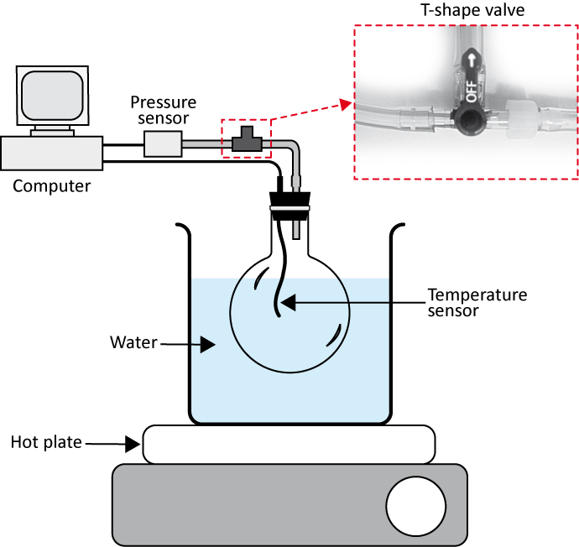Click Stop to end the data collection if your water is boiling before it automatically ends.

Figure - Pressure vs. temperature setup schematic

1. Turn off the hot plate and unplug it.
2. Prepare one graph (Graph 1) of the pressure vs. the temperature. Perform a linear regression. Save your file and print your graph.

### Pressure vs. volume (constant temperature and constant number of molecules)

The setup of this part is a syringe attached to the pressure sensor (see Figure 2). In this close system, when the volume of the syringe changes, the pressure changes too. The number of moles inside the syringe remains constant during all the experimentation even when the pressure changes because it is a closed system.

1. Record the room temperature.
2. Click Experiment/Data Collection… then select the mode Events With Entry. y. Check the small square at the bottom of the window, i.e. Use 10 s Average. When you click this square the computer will take 10 data points and average them each time you click Keep. In the table type the new title at Column Name: « volume », the Short Name: « V » and the Units: « L » (for litres). Click Done.
3. Obtain the 20ml syringe. With the syringe disconnected from the sensor, position the piston in the syringe so that the front edge of the inside black ring is at the 10mL line.
4. Gently connect the syringe to the pressure sensor and begin data collection (click Collect). Click Keep and enter the volume of the syringe.
5. Slowly pull on the piston until the volume is increased to 12mL and hold it there. When the pressure reading stabilizes, click Keep and enter the volume.
6. Repeat the last step for 14ml, 16ml, 18ml, and 20ml. Stop data collection and remove the syringe from the sensor. Click Experiment/Store Latest Run to save your data.
7. Position the piston in the syringe so that the front edge of the inside black ring is at the 20mL line. Connect the syringe to the pressure sensor and begin data collection. This time collect points while decreasing the volume from 20ml to 10ml.
8. Create a new column to calculate the inverse of the volume, $1/V$.
9. Prepare a graph (Graph 2) of the pressure vs. the inverse of the volume showing the results from the two runs (from 10ml to 20ml and from 20ml to 10ml). Perform linear regressions of both data sets. Save your file and print your graph.

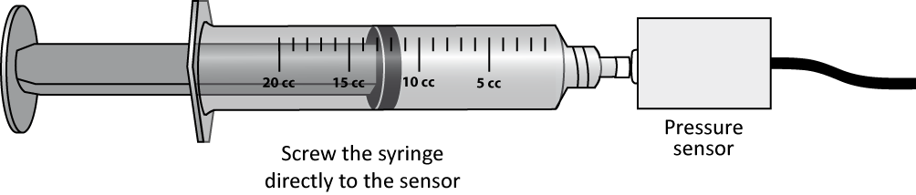

Figure - Pressure vs. volume setup schematic

### Pressure vs. number of molecules (constant volume and constant temperature)

In this part, you will vary the number of moles of air while keeping the temperature and the volume constant. You will use the same setup as in Figure 2.

1. As in the previous section, you will use the Events with Entry data-collection mode. Set the new title at Column Name: « number », the Short Name: « N » and the Units: « puffs » (for *puffs* of air).
2. Start data collection.
3. Disconnect the syringe and position the piston so that the syringe contains one *puff* (3mL) of air. Connect the syringe to the sensor and pull back on the piston until the volume reads 10mL. When the pressure reading stabilizes, click Keep and enter 1 as the number of *puffs* of air in the syringe.
4. Disconnect the syringe from the sensor and move the piston so that it now contains two puffs of air. Re-connect the syringe and move the piston until the volume again reads 10mL. When the pressure reading stabilizes, click Keep and enter 2 as the number of *puffs* of air in the syringe.
5. Repeat the last step four more times (up to 6 *puffs*) and stop data collection.
6. Prepare one graph (Graph 3) of the pressure vs. the number of *puffs* of air. Perform a linear regression. Save your file and print your graph.

### Cleaning up your station

1. Turn off the computer and pick up your USB key.
2. Make sure the hot plate is turned off and unplug it.
3. Throw away the water in your beaker in the sink in front of the classroom. Let you beaker dry near the sink.
4. Re-connect the pressure sensor to the flask assembly as it was at the beginning of your lab session.
5. Recycle scrap paper and throw away any garbage. Leave your station as clean as you can.
6. Push back the monitor, keyboard and mouse. Also please push your chairs back under the table.

# Laboratory report

### Identification page

**Instructions:** Print this page and the following ones before your lab session to prepare your lab report. Staple them together with your graphs at the end. If you forgot to print it before your lab, you can reproduce it by hand but you have to follow the exact format (same number of pages, same items on each page, same space to answer question).   
  
Complete all the identification fields below or 10% of the lab value will be deduced from your final mark for this lab.   
  
For in-lab reports, hand in your report to your demonstrator at the end of the sessions or you will receive a zero for this lab.   
  
For take-home reports, drop your report in the right box or 10% of the lab value will be deduced from your mark. Refer to the *General information* document for the details of the late report policy.

|  |  |
| --- | --- |
| Experiment title: | Exp. 5 – Ideal gas law |
|  |  |
|  |  |
| Name: |  |
| Student number: |  |
| Lab group number: |  |
| Course code: | PHY |
|  |  |
| Demonstrator: |  |
|  |  |
| Date: |  |
|  |  |
| Partner’s name: |  |
| Partner’s student number: |  |

### Pressure vs. temperature (constant volume and constant number of molecules)

[…] Prepare Graph 1 (one sheet attached at the end of your report).

[…] According to your results, explain how $P$ varies with $T$.

|  |
| --- |
| Answer here: |
|  |
|  |

[…] Is it correct to state that the pressure is proportional to the Celsius temperature; i.e., does a doubling of the temperature produce a doubling of the pressure?

|  |
| --- |
| Answer here: |
|  |
|  |

[…] Use the results from your fit to determine the temperature at which the pressure of the gas should drop to zero. Discuss.

|  |
| --- |
| Answer here: |

### Pressure vs. volume (constant temperature and constant number of molecules)

[…] Prepare Graph 2 (one sheet attached at the end of your report).

[…] Record the room temperature.   
  
*Troom* =

[…] According to your results, explain how $P$ varies with $V$.

|  |
| --- |
| Answer here: |
|  |
|  |

[…] Assuming that air is an ideal gas, calculate the number of moles of gas you had in your syringe when you started with a volume of 10ml? Repeat for the volume of 20ml.

|  |  |
| --- | --- |
| Answer here: | |
| *theo*(at 10ml) = | *theo*(at 20ml) = |

[…] Using the results from your fits in Graph 2, calculate how many moles of gas you had in your syringe during both parts of this experiment? Calculate the percentage differences with the calculated values.

|  |  |
| --- | --- |
| Answer here: | |
| *exp*(at 10ml) =  %diff = | *exp*(at 20ml) =  %diff = |

[…] Can you explain if there is any difference in your results obtained from the two methods (10 ml to 20 ml) or (20 ml to 10 ml)?

|  |
| --- |
| Answer here: |
|  |
|  |
|  |
|  |
|  |

### Pressure vs. number of molecules (constant volume and constant temperature)

[…] Prepare Graph 3 (one sheet attached at the end of your report).

[…] According to your results, explain how $P$ varies with $n$.

|  |
| --- |
| Answer here: |
|  |
|  |

[…] Why did you always bring the piston back to 10ml in this part of the experiment?

|  |
| --- |
| Answer here: |
|  |
|  |

### Conclusion

[…] Can we consider air as an ideal gas? If not, why? If so, under what condition?

|  |
| --- |
| Answer here: |
|  |
|  |
|  |