# Ideal gas law

## Introduction

We think of a gas as a collection of tiny particles in random, thermal motion. When they collide with the sides of a container, they exert a force on the container walls. The average force resulting from these collisions on each unit area of the container is called the pressure exerted by the gas. You are familiar with everyday units of pressure, such as psi (pounds per square inch) to describe tire pressure or inches of mercury to describe atmospheric pressure. For this experiment, we will use the SI unit of pressure, the Pascal (Pa), which is defined as one Newton of force acting on each square meter of surface.

In this experiment, you will develop quantitative relationships between pressure and the variables that are affecting the pressure of a gas in a container such as the temperature, the volume of the container and the number of gas molecules. One of Ludwig Boltzmann’s most remarkable achievements was the derivation of the equation of state, (from the principles of classical mechanics) that relates all these variable and describes the behaviour of an ideal gas:

$$PV = nRT ,$$

where $P$, $V$, and $T$ are the pressure, volume, and temperature of the gas, respectively. The amount of gas is given by the number of moles, $n$, and the constant of proportionality, $R$, is called the *Universal Gas Constant* ( $R=$ 8.3145 J/(mol $∙$ K) = 8.3145 Pam3/(molK) = 8.3145 kPa $∙$ L/(mol $∙$ K)).

The reason that Boltzmann’s results were so startling is that most gases at low pressures, (i.e., $P≪$ 101.3 kPa, the normal atmospheric pressure), exhibit the same physical behaviour. In this theory, it is assumed that the gas molecules are non-interacting point-like particles which collide elastically. Furthermore, one mole of most gases occupies approximately the same volume, $V_{0}$ = 22.4 L, at atmospheric pressure $P_{0}$ = 101.3 kPa and at a temperature of $T_{0}$ = 273.15 K (0 $℃$). The usefulness of these properties did not go unnoticed which is why gas thermometers are still presently among the most precise instruments for measuring temperature.

### Suggested reading

|  |  |  |
| --- | --- | --- |
| **Students taking** | **Suggested reading** | |
| PHY 1122 | Sections 17.2, 17.3 and 18.1 | Young, H. D., Freedman, R. A., *University Physics with Modern Physics, 13th edition*. Addison-Wesley (2012). |
| PHY 1321-1331 | Sections 19.3 and 19.5 | Serway, R. A., Jewett, J. W., *Physics for Scientists and Engineers with Modern Physics, eight edition*. Brooks/Cole (2010). |
| PHY 1124 | Sections 19.1, 19.2 and 19.3 | Halliday, D., Resnick, R., Walker, J., *Fundamentals of Physics, 9th edition*. Wiley (2011). |

## Objectives

* Collect pressure vs. volume, pressure vs. number of molecules, and pressure vs. temperature data for a sample of air in an enclosed container.
* Determine relationships between these pairs of variables.
* Determine a single expression relating these variables.
* Determine whether air behaves as an ideal gas.
* Determine the absolute zero temperature.

## Materials

* Computer equipped with *Logger Pro* and a Vernier computer interface
* Gas pressure sensor
* Temperature sensor
* Syringes (20 mL and 60 mL)
* Hot plate
* Beaker (600 mL)
* Flask assembly (with temperature sensor)
* Gloves

## Safety warnings

You will be working with boiling water during this experiment. The student manipulating the hot beaker should wear protective gloves.

## References for this manual

* Dukerich, L., *Advanced Physics with Vernier – Beyond mechanics*. Vernier software and Technology (2012).

## Procedure

### Part 1 - Pressure vs. temperature (constant volume and constant number of molecules)

1. Turn on your computer and launch the Logger Pro program.
2. Make sure your setup looks like the setup schematic as presented in Figure 1. It consists of a sealed glass bulb connected to a pressure sensor and a temperature sensor. Pick up a 600 mL beaker nearby the sink in front of the classroom and fill it with tap water (room temperature) up to the 350 mL mark (only if the laboratory staff did not do it for you already). Put the beaker on top of the hot plate and lower the glass bulb until the spherical part is almost covered with water. You should read a temperature around 22 $℃$ and a pressure around 100 kPa.
3. During this experiment, you will slowly heat the water in order to measure the increase of pressure and temperature as a function of time. Before doing so, you must reduce the pressure inside the glass bulb to an initial pressure of between 50 and 60 kPa:   
    - Attach the 60 mL compressed syringe into the T-shape valve (see Figure 1).   
    - Rotate the valve in order to connect the bulb, the pressure sensor, and the syringe.   
    - Pull out the syringe handle then rotate the valve to close off access to the syringe.   
    - Disconnect the syringe then read the pressure on the screen.

- Allow a few seconds for the pressure to stabilize. If the pressure is not stable, consult your T.A.   
- Repeat if the pressure is not low enough.

1. Select Experiment 🡪 Data Collection…. Set the collection mode to Time Based, set the duration to 600 seconds and sampling rate to one.
2. Choose the *Pressure* as the (Y-axis) vs. the *Temperature 1* as the (X-axis).
3. 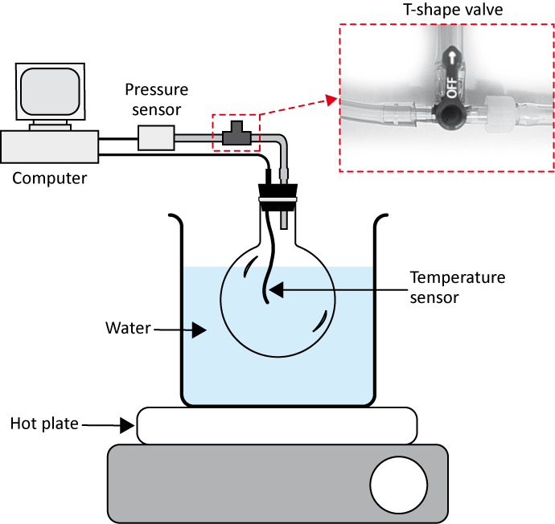From the menu Options 🡪 Graph Options…, go to Appearance, then select Point Symbols to see the data points on the graph and uncheck Connect Points to remove the lines connecting the points.
4. Turn the hot plate on (maximum power) and wait until the temperature has increased by 5 $℃$ then press on Collect to begin data collection.
5. If your water begins to boil before the data collection automatically ends, click Stop.
6. Turn off the hot plate and unplug it. Be cautious when working near the hot plate as it will remain hot for quite some time.

Figure 1 - Pressure vs. temperature setup schematic

1. We strongly recommend that you save all the work you do during the lab in case you need to review it later. Click File 🡪 Save As… to save your experiment file (suggested name: *P_vs_T_YOUR_NAMES.cmbl*). You can either send the file to yourself by email or save it on a USB key.
2. Prepare Graph 1 of pressure (in kPa) vs. temperature (in $℃$). Perform a linear regression. **Print** your graph to a pdf file. Make sure you use the printer CutePDF to print your graph. Make sure you are using the **print** function and not the save function in Logger Pro.

### Part 2 - Pressure vs. volume (constant temperature and constant number of molecules)

The setup for this part is a syringe attached to the pressure sensor (see Figure 2). In this closed system when the volume in the syringe changes, the pressure changes too. The number of moles inside the syringe remains constant during the experiment even when the pressure changes because it is a closed system.

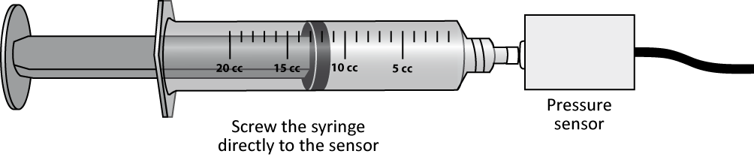

Figure 2 - Pressure vs. volume setup schematic

1. Click File 🡪 New. Record the room temperature (*Temperature 2*).
2. Click Experiment 🡪 Data Collection… then select the mode Events With Entry. Check the small square at the bottom of the window, i.e. Use 10 s Average. When you click this square, the computer will take 10 data points and average them each time you click Keep. In the table type the new title at Column Name: « Volume », the Short Name: « V » and the Units: « L » (for litres). Click Done.
3. Disconnect the pressure sensor from the hot plate setup. Simply unscrew the tube connection near the sensor.
4. Obtain the 20 mL syringe. With the syringe disconnected from the sensor, position the piston in the syringe so that the front edge of the inside black ring is at the 10 mL line.
5. Gently connect the syringe to the pressure sensor and begin data collection (click Collect). Click Keep and enter the volume in the syringe.
6. Slowly pull on the piston until the volume is increased to 12 mL and hold it there. When the pressure reading stabilizes, click Keep and enter the volume.
7. Repeat the previous step for 14, 16, 18, and 20 mL. Stop data collection and remove the syringe from the sensor. Click Experiment 🡪 Store Latest Run to save your data. Enter your results in your Table 1.
8. Position the piston in the syringe so that the front edge of the inside black ring is at the 20 mL line. Connect the syringe to the pressure sensor and begin data collection. This time collect points while decreasing the volume from 20 to 10 mL. Record the pressure at 20 mL as the initial atmospheric pressure for this data set. Complete your Table 1.
9. Create a new column to calculate the inverse of the volume, $1/V$, with proper units (1/L). From the menu Data 🡪 New Calculated Column, enter the name and units then in the Expression section type “1/” then click the button Variables (Columns) and select the volume column.
10. Prepare a graph (Graph 2) of pressure vs. inverse of the volume showing the results from the two runs (from 10 to 20 mL and from 20 to 10 mL). From the menu Options 🡪 Graph Options…, go to Appearance, then select Point Symbols to see the data points on the graph and uncheck Connect Points to remove the lines connecting the points.
11. Save your experiment file (suggested name: *P_vs_V_YOUR_NAMES.cmbl*). Perform linear regressions for both data sets. **Print** your Graph 2 to a pdf file (use the printer CutePDF).

### Part 3 - Pressure vs. number of molecules (constant volume and constant temperature)

In this part, you will vary the number of moles of air while keeping the temperature and the volume constant in your system. You will use the same setup as in Figure 2.

1. Click File 🡪 New. As in the previous section, you will use the Events with Entry data-collection mode. Set the new title at Column Name: « number », the Short Name: « N » and the Units: « puffs » (for *puffs* of air).
2. Start data collection.
3. Disconnect the syringe and position the piston so that the syringe contains one *puff* (3 mL) of air. Connect the syringe to the sensor and pull back on the piston until the volume reads 10 mL. When the pressure reading stabilizes, click Keep and enter 1 as the number of *puffs* of air in the syringe.
4. Disconnect the syringe from the sensor and move the piston so that it now contains two *puffs* (6 mL) of air. Re-connect the syringe and move the piston until the volume again reads 10 mL. When the pressure reading stabilizes, click Keep and enter 2 as the number of *puffs* of air in the syringe.
5. Repeat the last step four more times (up to 6 *puffs*) and then stop data collection. Enter your results in your Table 2.   
   N.B. For 4, 5, and 6 *puffs*, you will be pushing in on the syringe to reach a final volume of 10 mL.
6. Save your experiment file (suggested name: *P_vs_n_YOUR_NAMES.cmbl*). Prepare one graph (Graph 3) of pressure vs. the number of *puffs* of air. Perform a linear regression. Print your Graph 3 to a pdf file (use the printer CutePDF).

### Cleaning up your station

1. Submit your three graphs in Brightspace. If you locally saved your files, send them to yourself by email. Pick up your USB key if you used one to save your files. Turn off the computer.
2. Make sure the hot plate is turned off and unplugged. You can leave the water in the beaker for the next students.
3. Re-connect the pressure sensor to the flask assembly as it was at the beginning of your lab session.
4. Recycle scrap paper and throw away any garbage. Leave your station as clean as you can.
5. Push back the monitor, keyboard and mouse. Also please push your chairs back under the table.