# Conservation of momentum

## Introduction

You may have learned that a moving object possesses kinetic energy given by ${mv^{2}}/2$, where $m$ is the mass of the object and $v$ is its speed. Momentum is another property of a moving object, also related to its mass and velocity, which is useful to describe its behaviour. The momentum, $p$, is the product of the mass and velocity of an object, $p=mv$.

In the previous experiment you have examined the motion of a single object as it underwent a variety of motions on an air track. You learned that an object subject to no external forces moves at constant velocity. Suppose now that the system consists of two objects that undergo a collision. Clearly, the velocity of each object will change as a result of the collision. However, if you were to consider two gliders on the same air track as a single system, how would the centre of mass of this system change, if at all, after a collision? In one dimension, the position of the centre of mass of two objects, $x_{CM}$, is given by

$$x_{CM}=\frac{m_{1}x_{1}+m_{2}x_{2}}{m_{1}+m_{2}} ,$$

where the indices 1 and 2 refers to the first and second objects. In the first part of this experiment, you will analyse the motion of two gliders during a collision to examine the behaviour of their centre of mass.

You may also have learned that an external force produces a change in the momentum of an object. If we consider our system to be two gliders that undergo a collision, any force that each exerts on another are internal to the system. In the second and third part of this experiment, you will examine the momentum as well as the kinetic energy of both gliders before and after collisions to see what effect, if any, these forces have on the properties of a system. When two objects collide with each other (and there is no net force on the system), the total momentum ($p = p_{1}+p_{2}$) is conserved regardless of the type of collision. This translates as

$$\underset{before the collision}{\underbrace{p=p_{1}+p_{2}=m_{1}v_{1}+m_{2}v_{2}}}=\underset{after the collision}{\underbrace{p^{'}=p_{1}^{'}+p_{2}^{'}=m_{1}^{'}v_{1}^{'}+m_{2}^{'}v_{2}^{'}}} ,$$

where the primed notation refers to quantities after the collision.

We will be considering two types of collisions: elastic and inelastic. An elastic collision is one in which the two objects bounce off each other with no loss of kinetic energy. We will use elastic bumpers on the ends of the gliders to study elastic collisions and to minimize the energy losses due to friction during the collision. In reality, this *elastic* collision is slightly inelastic. A completely inelastic collision is one in which the two gliders hit and stick to each other. This type of collision will be studied in the final part of this experiment. This is accomplished using a pair of bumpers that are sticking together after a collision (a needle and a wax receptacle).

### Suggested reading

|  |  |  |
| --- | --- | --- |
| **Students taking** | **Suggested reading** | |
| PHY 1121 | Chapter 8 | Young, H. D., Freedman, R. A., *University Physics with Modern Physics, 14th edition*. Addison-Wesley (2014). |
| PHY 1321-1331 PHY 1124 | Chapter 9 | Serway, R. A., Jewett, J. W., *Physics for Scientists and Engineers with Modern Physics, 9th edition*. Brooks/Cole (2013). |

## Objectives

* Analyse the position-time graphs for the individual gliders and compare these to the position-time graph for the centre of mass of the system.
* Collect velocity-time data for two gliders experiencing different types of collisions.
* Compare the momentum of the system before and after collisions.
* Compare the kinetic energy of the system before and after collisions.

## Materials

* Computer equipped with *Logger Pro* and a Vernier computer interface
* Motion detectors
* Air track and accessories (air supply, hose, gliders, …)
* Electronic balance (one per classroom)

## Safety warnings

The air track is a fragile and expensive piece of equipment. Its surface must be free of defects in order to reduce the friction between the glider and the track to a minimum. Be careful to not hit the surfaces of the track with a hard object.

## References for this manual

* Gastineau, J., Appel, K., Bakken, C., Sorensen, R., Vernier, D., *Physics with Vernier*. Vernier software and Technology (2007).
* Dukerich, L., *Advanced Physics with Vernier – Mechanics*. Vernier software and Technology (2011).
* *ScienceWorkshop 750 Mechanics System*. PASCO scientific (2010).

## Procedure

### Part 1 – Centre of mass

1. Launch the Logger Pro template for the Conservation of momentum lab which you can download from Brightspace. You should see two position trackers in the bottom left hand corner and a position vs. time graph on the right.
2. Turn on the air supply machine and adjust the power button so that your two gliders move without friction. You are sharing your air supply with another team so make sure both teams are satisfied with the setting of the supply before moving forward with your experiment.
3. Level your track using the adjustable legs. Place one glider at the centre of the track. If the glider moves one way or the other, adjust the track to raise or lower one end. When the air track is properly leveled, the glider should be almost stationary (there is always a little bit of turbulence).
4. Make sure that the glider stoppers (the velcros) are wrapped around the air track about 10 cm in front of the motion detectors.
5. Make sure your motion detectors are set to *track*: .
6. In Logger Pro, press the Collect button and make sure each motion detector is detecting the position of the closest glider wherever it is along the track. Ensure the round black discs attached to the gliders are facing the motion detectors. These discs are used to increase the surface area that the detectors see.   
   **Note. The sensor for Position 1 is to the left, Position 2 is to the right.**
7. Go to Experiment 🡪 Set Up Sensors 🡪 LabQuest Mini. **Hold** both gliders close to the middle of the track and zero both motion detectors (click on the **picture** of the motion detector in the right column, see below, and select Zero). Also select Reverse Direction for **detector 2 (DIG/SONIC2)**.

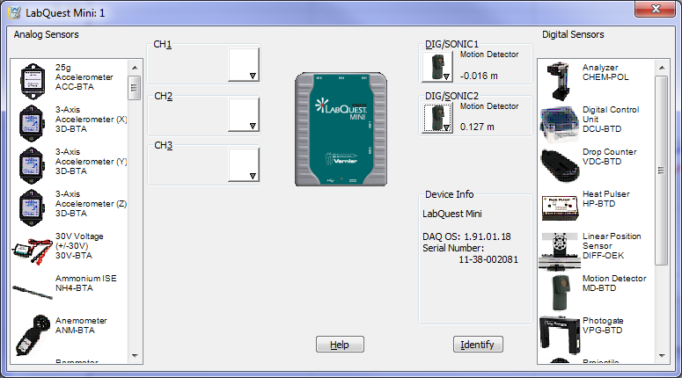

1. Install a pair of elastic bumpers on your gliders (see Figure 1).
2. Bring glider 1 close to its motion detector (left side) and leave glider 2 at rest at the centre of the track. Begin collecting data and then gently push the glider 1 towards glider 2. Be sure to keep your hands out of the way of the motion detectors. Repeat until you get a satisfactory run.
3. You will notice that the position of each glider is recorded in the two columns in your data table as a function of time. A third column indicating the centre of mass ($x_{CM}$) of the system is present but has no values. This column contains a formula (see pg. 1) that requires the mass of the two gliders.
4. Weigh both gliders with their bumpers attached using the digital balance. Click Data 🡪 User Parameters and enter the masses (m1 and m2) of each glider in the appropriate value entry then click ok. Note: the units are in kg. You will see the values of $x_{CM}$ appear in the column once you input your masses.
5. Add the $x_{CM}$ column to your position vs. time graph. To do so, simply left-click on the label of the y-axis and select More…. You should be able to select the appropriate columns from the list.
6. Perform the following six linear fits:
7. the position of glider 1 vs. time before the collision,
8. the position of glider 1 vs. time after the collision,
9. the position of glider 2 vs. time before the collision,
10. the position of glider 2 vs. time after the collision,
11. the position of the centre of mass vs. time before the collision,
12. the position of the centre of mass vs. time after the collision.

The slope of each linear fit gives you the velocity of the glider.

1. Adjust your page to be ready for printing. This should be your Graph 1. Make sure all fit results are clearly visible. Among other things, make sure to add a proper title to your graph and adjust your window to use as much space as possible.
2. Print your Graph 1 to a pdf file (use the printer CutePDF). Save your experiment file (use File 🡪 Save as…).

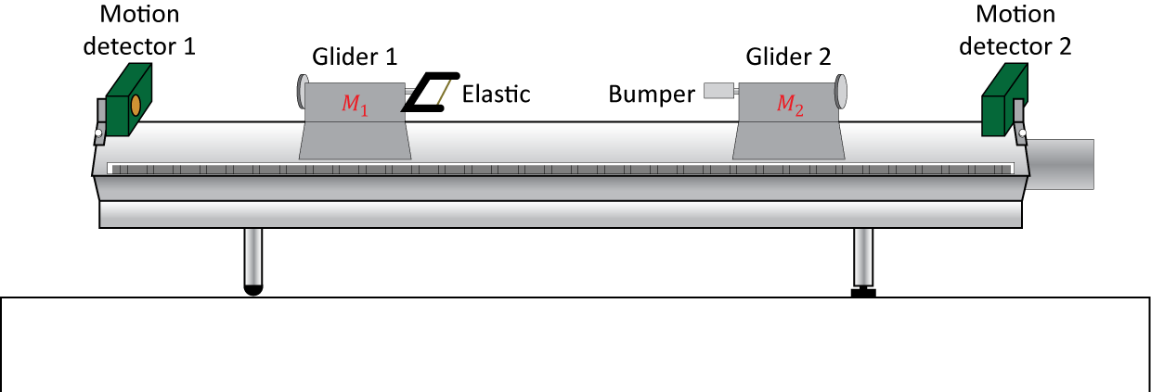

Figure 1 - Air-track setup to study collisions between two gliders

### Part 2 – Elastic collisions

You will now perform a series of elastic collisions in various conditions. You can use the Logger Pro template you had for the previous section or you can start over with a new file. If you do start with new file, remember to zero your detectors and to reverse the direction of one of them like you did in the previous section. For all the collisions below, you should always feel free to repeat your manipulations if you are not satisfied with the given collision results or data collection.

1. Run 1: With the same setup used in the previous section, record an elastic collision between a moving glider 1 and a stationary glider 2. You no longer need the centre of mass column to appear on your graph.
2. Using your position vs. time data, perform four linear regressions to obtain the velocities of both gliders before and after the collision. Record your results for this first run in Table 1.
3. Run 2: Add two weights on glider 2 (one on each side of the glider). Make sure glider 2 is still freely moving on the track (increase the air pressure if needed). Record a new collision between a moving glider 1 and a stationary (and heavier) glider 2. Record your results in Table 1.
4. **Prepare a graph example for the elastic collision using run 2**. This should be your **Graph 2**. Make sure all fit results are clearly visible. Print your Graph 2 to a pdf file (use the printer CutePDF).
5. Run 3: Keeping the extra weights on glider 2, record a new collision between a moving glider 2 and a stationary (and lighter) glider 1. Record your results in Table 1.

### Part 3 – Inelastic collisions

To perform inelastic collisions, you will use bumpers that are sticking together after a collision (a needle and a wax receptacle).

1. Remove the extra weights on glider 2. Switch the elastic bumpers for the needle and wax receptacle bumpers.
2. Run 4: Record a collision between a moving glider 1 and a stationary glider 2. Record your results for this run in Table 2.   
   **NB. Make sure the attached gliders are able to travel all the way to the other end of the track without stopping to ensure good results. If the gliders stop halfway down the track then you have a problem with friction. You can increase the air pressure slightly to see if this solves the problem.**
3. Run 5: Add two weights on glider 2. Record a new collision between a moving glider 1 and a stationary (and heavier) glider 2. Record your results in Table 2.
4. Run 6: Keeping the extra weights on glider 2, record a new collision between a moving glider 2 and a stationary (and lighter) glider 1. Record your results in Table 2.
5. **Prepare a graph example for the inelastic collision using run 6**. This should be your **Graph 3**. Make sure all fit results are clearly visible. Print your Graph 3 to a pdf file (use the printer CutePDF).

### Cleaning up your station

1. Turn off the air supply. Submit your graphs in Brightspace. If you locally saved your files, send them to yourself by email. Pick up your USB key if you used one to save your files.
2. Put back the gliders, bumpers and weights on the table.
3. Recycle scrap paper and throw away any garbage. Leave your station as clean as you can.
4. Push back the monitor, keyboard and mouse. Also please push your chairs back under the table.